SMT FGPA Manual

Version 1.5

이 문서는 사전에 공지나 예고 없이 변경될 수 있습니다.

REVISION HISTORY
Version | Detail | Name | Date
1.0 | First Version | SHMT SoC Team | 2007-03-14

Technical documents

Copyright © 2007 Shmt Limited. All rights reserved.

Confidentiality Status
This document is NOT OPEN ACCESS. The distribution is restricted to certified company.
This document is CONFIDENTIAL.

Feedback on this document
If you have any comments on this document, please contact your channel to our company.

Shmt Web address
http://www.shmt.com

Table of contents

1. Introduction 14
1.1. Overview 14
1.2. Features 15
2. ARM926EJ-S 16
2.1. Overview 16
2.1.1. Feature 16
2.1.2. Block diagram 17
2.1.3. Processor operating state 18
2.2. Switching operating state 18
2.3. Registers 18
2.3.1. ARM state에서의 register 19
2.3.2. Thumb state에서의 register 20
2.3.3. Status register 21
2.4. Exceptions 22
2.4.1. Exception vectors 22
2.4.2. Exception priorities 23
2.4.3. Entering an ARM exception 23
2.4.4. Leaving an ARM exception 23
2.4.5. Reset 23
2.4.6. Fast interrupt request 24
2.4.7. Interrupt request 24
2.4.8. Aborts 24
3. Programmer’s model 26
3.1. Overview 26
3.2. Memory Map 26
3.2.1. Memory Map 26
3.3. Peripherals 26
3.3.1. Peripheral Memory Map 26
3.4. Boot sequence 27
3.4.1. Boot mode configuration 27
3.4.2. Direct(CS0) boot mode 27
4. Power mamangement unit 28
4.1. Overview 28
4.1.1. Feature 28
4.1.2. Block Diagram 29
4.2. Operation 29
4.2.1. Clock Control Block 29
4.2.2. Power Manage State Machine 30
4.2.3. Reset Control Block 32
4.3. Register Description 33
4.3.1. Power Management Unit Registers 33
4.3.2. Power Management Control Register 33
4.3.3. Clock Divide Register 34
4.3.4. PLL Lock Wait Register 34
4.3.5. PLL Set Register 35
5. System control 36
5.1. Overview 36
5.2. Registers 37
5.2.1. System Configuration Register 37
5.2.2. DMA Resource Share Register 37
5.2.3. Information Register 38
5.2.4. Pin Mux Register 38
6. Static Memory Controller 42
6.1. Overview 42
6.1.1. Feature 42
6.1.2. Block Diagram 42
6.2. Signal Description 43
6.3. Address Map 43
6.4. Timing 43
6.5. Interface 44
6.5.1. Interface Example 45
6.6. Register Description 47
6.6.1. Registers 47
6.6.2. SMC_BANKx Register 47
7. DDR-SDRAM Scheduler 49
7.1. Overview 49
7.1.1. Feature 49
7.1.2. Block Diagram 50
7.2. Operation 50
7.2.1. AXI BUS Interface Block 50
7.2.2. DDR SDRAM Controller Block 53
7.2.3. DDR SDRAM Controller Timing Description 55
7.3. Register Description 57
7.3.1. DDR SDRAM Registers 57
7.3.2. DDR SDRAM TIMING Control Register 58
7.3.3. DDR SDRAM Control Register 58
7.3.4. DDR SDRAM Power Control Register 59
7.3.5. DDR SDRAM Refresh Control Register 59
7.3.6. DDR SDRAM Configuration Register 60
8. Vectored interrupt controller 61
8.1. Overview 61
8.1.1. Features 61
8.1.2. Block diagram 61
8.2. Interrupt Connection 63
8.3. Operation 64
8.3.1. Register와 Interrupt Source 64
8.3.2. Level/Edge detect logic 64
8.3.3. Masking & Demux logic 64
8.3.4. Arbiter 65
8.3.5. I_ISPR/F_ISPR and I_VECADDR/F_VECADDR 65
8.4. Programming Model 66
8.4.1. Enabling VIC 66
8.4.2. Disabling VIC 66
8.4.3. Enabling Each Interrupt Source(Unmasking Interrupt) 66
8.4.4. Disabling Each Interrupt Source(Masking Interrupt) 67
8.4.5. Acknowledge Interrupt 67
8.4.6. I_ISPR/F_ISPR, I_VECADDR/F_VECADDR 레지스터 접근 67
8.4.7. Interrupt Handler Example 68
8.5. Register Description 68
8.5.1. Registers 68
8.5.2. INTCON Register 69
8.5.3. INTPND Register 70
8.5.4. INTMOD Register 70
8.5.5. INTMSK Register 71
8.5.6. LEVEL Register 71
8.5.7. POLARITY Register 72
8.5.8. PSLV Register 72
8.5.9. PMST Register 73
8.5.10. CSLV Register 74
8.5.11. CMST Register 75
8.5.12. ISPR Register 76
8.5.13. ISPC Register 77
8.5.14. VECADDR Register 77
9. Enhanced-DMA 79
9.1. Overview 79
9.1.1. Features 79
9.1.2. Block diagram 80
9.2. DMA Channel 81
9.2.1. Channel Arbitration 82
9.3. Channel Operation 82
9.3.1. Basic Operation 82
9.3.2. Descriptor Loading 83
9.3.3. Interrupt 84
9.3.4. Trailing Bytes 85
9.3.5. Memory-to-Memory Transfer 85
9.4. Software Model 85
9.4.1. Enabling DMA Channel 85
9.4.2. Disabling DMA Channel 86
9.4.3. Restriction on Register Access 86
9.5. Register Description 86
9.5.1. Registers 87
9.5.2. Source Address Register 88
9.5.3. Destination Address Register 88
9.5.4. Control Register 89
9.5.5. Descriptor Register 90
9.5.6. Status Register 91
10. TIMER 93
10.1. Overview 93
10.1.1. Features 93
10.1.2. Block diagram 93
10.2. Operation 94
10.2.1. Interval Mode 94
10.2.2. Match&Overflow Mode 94
10.3. Register Description 95
10.3.1. Registers 95
10.3.2. Timer Data Register (T0_TDAT/T1_TDAT/T2_TDAT/T3_TDAT) 95
10.3.3. Timer Prescaler Register (T0_PRES/T1_PRES/T2_PRES/T3_PRES) 96
10.3.4. Timer Control Register (T0_CTRL/T1_CTRL/T2_CTRL/T3_CTRL) 96
10.3.5. Timer Counter Register (T0_CNT/T1_CNT/T2_CNT/T3_CNT) 97
11. Watch Dog Timer 98
11.1. Overview 98
11.1.1. Feature 98
11.1.2. Block Diagram 99
11.2. Operation 99
11.2.1. Clock Prescaler Block 100
11.2.2. Interrupt Generation Block 100
11.2.3. Reset Output Generation 100
11.3. Register Description 101
11.3.1. WDT Registers 101
11.3.2. WDT Control Register 101
11.3.3. WDT Prescale Register 102
11.3.4. WDT Load Register 102
11.3.5. WDT Count Register 102
11.3.6. WDT Interrupt Status Register 103
12. I2S 104
12.1. Overview 104
12.1.1. Features 104
12.1.2. Block diagram 104
12.2. Signals 105
12.3. Operation 105
12.3.1. Digital Oscillator 106
12.3.2. Master/Slave Configuration 107
12.3.3. Transmit 동작 : Audio Play 108
12.3.4. Receive 동작 : Audio Record 111
12.3.5. Interrupt 113
12.3.6. Left-justified Mode/I2S Mode Selection 113
12.3.7. WordLength와 FIFO data 114
12.4. Register Description 115
12.4.1. Registers 116
12.4.2. I2S_CLKCTRL Register 116
12.4.3. I2S_CTRL Register 117
12.4.4. I2S_STATUS Register 118
12.4.5. I2S_DATA Register 120
13. I2C Master 121
13.1. Overview 121
13.1.1. Feature 121
13.1.2. Block Diagram 121
13.2. Operation 122
13.2.1. Overview 122
13.3. Signal Description 122
13.3.1. I2C Module Signal 122
13.4. Register Description 122
13.4.1. Registers 122
13.4.2. I2CCON (I2C Control) Register 123
13.4.3. I2CSTA (I2C Status) Register 123
13.4.4. I2CDAT (I2C Data) Register 124
13.5. Operation Sequence 124
14. UART 127
14.1. Overview 127
14.1.1. Features 127
14.2. Register 128
14.2.1. Master Command Register 128
14.2.2. Status Register 130
14.2.3. Baudrate Gen Register 131
14.2.4. TxFIFO Write Register 131
14.2.5. RxFIFO Read Register 132
14.2.6. Receive Time Out Count Register 132
14.3. Operation 133
14.3.1. Baudrate Clock Generation 133
14.3.2. Low Pass Filter 133
14.3.3. DMA/Interrupt Water Level 134
14.3.4. Receive Time Out Interrupt 135
14.3.5. Loopback Mode 135
15. GPIO 137
15.1. Overview 137
15.1.1. Features 137
15.2. Operation 137
15.2.1. GPIO Operation 137
15.2.2. Interrupt Operation 138
15.3. Register Description 140
15.3.1. Registers 140
15.3.2. GPIO Output Enable Register (GPIO0_OE /GPIO1_OE) 140
15.3.3. GPIO Input Register (GPIO0_IN/GPIO1_IN) 141
15.3.4. GPIO Output Register (GPIO0_OUT/GPIO1_OUT) 141
15.3.5. GPIO Interrupt Status Register (GPIO0_INTSTAT/GPIO1_INTSTAT) 142
15.3.6. GPIO Interrupt Enable Register (GPIO0_INTEN/GPIO1_INTEN) 143
15.3.7. GPIO Interrupt Level/Edge Selection Register (GPIO0_INTLEVEL/GPIO1_INTLEVEL) 143
15.3.8. GPIO Interrupt Polarity Register (GPIO0_INTPOL/GPIO1_INTPOL) 144
15.3.9. GPIO Interrupt Both Edge Register (GPIO0_INTBEDGE/GPIO1_INTBEDGE) 144
16. SPI 146
16.1. Overview 146
16.1.1. Feature 146
16.1.2. Block Diagram 146
16.2. Operation 147
16.2.1. Overview 147
16.2.2. Timing 147
16.3. Signal Description 149
16.3.1. SPI BUS Signal 149
16.4. Register Description 149
16.4.1. Registers 149
16.4.2. SPI Control Register 150
16.4.3. SPI Prescaler Register 150
16.4.4. SPI Status Register 151
16.4.5. SPI Interrupt & DMA control Register 151
16.4.6. SPI Interrupt Status Register 152
16.4.7. SPI Tx Data Register 153
16.4.8. SPI RxData Register 153
17. MultiICE 155
17.1. Signals 155
17.2. JTAG 155
17.2.1. JTAG signals 155
17.2.2. JTAG State Machine 156
17.3. Using JTAG 157
18. ARM JTAG 160
18.1. Instruction Register 160
18.1.1. EXTEST 160
18.1.2. SAMPLE/PRELOAD 160
18.1.3. SCAN_N 160
18.2. Scan Chains 160
18.2.1. Scan chain 1 160
18.2.2. Scan chain 2 161
18.2.3. Scan chain 6 162
18.2.4. Scan chain 15 162
19. EmbeddedICE-RT 163
19.1. Overview 163
19.2. Registers 164
19.2.1. Debug control register 164
19.2.2. Debug status Register 165

Table of Figure

Figure 1-1 Block diagram 14
Figure 2-1 ARM926EJ-S Block Diagram 17
Figure 2-2 ARM state에서의 register 19
Figure 2-3 Thumb state에서의 register 20
Figure 2-4 Status register 21
Figure 4-1 Clock Distribution Block Diagram 29
Figure 4-2 Clock Control Block Diagram 30
Figure 4-3 Power Manage State Machine Block Diagram 31
Figure 4-4 Power On Configuration & PLL Lock Time Diagram 32
Figure 4-5 Power Management Control Register Bits 33
Figure 4-6 Clock Divide Register Bits 34
Figure 4-7 PLL Lock Wait Register Bits 34
Figure 4-8 PLL Set Register Bits 35
Figure 6-1 External IO Timing 44
Figure 6-2 Interface 8bit memory 45
Figure 6-3 Interface 8bit memory x2 45
Figure 6-4 Interface 8bit memory x4 45
Figure 6-5 Interface 16bit memory 46
Figure 6-6 Interface (byte enable이 있는)16bit memory 46
Figure 6-7 Interface (byte enable이 있는)16bit memoryx2 46
Figure 6-8 SMC_BANKx Register 47
Figure 7-1 AXI Interface DDR SDRAM Controller Top Block Diagram 50
Figure 7-2 DDR SDRAM AXI BUS Interface Block Diagram 52
Figure 7-3 DDR SDRAM Controller Block Diagram 54
Figure 7-4 DDR SDRAM Timing Control Register Bits 58
Figure 7-5 DDR SDRAM Control Register Bits 58
Figure 7-6 DDR SDRAM Power Control Register Bits 59
Figure 7-7 DDR SDRAM Refresh Control Register Bits 59
Figure 7-8 DDR SDRAM Configuration Register Bits 60
Figure 8-1 VIC Block Diagram 62
Figure 8-2 Arbiter Block Diagram 62
Figure 8-3 INTCON Register 69
Figure 8-4 INTPND Register 70
Figure 8-5 INTMOD Register 71
Figure 8-6 INTMSK Register 71
Figure 8-7 LEVEL Register 72
Figure 8-8 POLARITY Register 72
Figure 8-9 PSLV Register 73
Figure 8-10 PMST Register 74
Figure 8-11 CSLV Register 75
Figure 8-12 CMST Register 76
Figure 8-13 ISPR Register 76
Figure 8-14 ISPC Register 77
Figure 8-15 VECADDR Register 78
Figure 9-1 DMA Controller Block Diagram 80
Figure 9-2 4 Channel DMA Controller의 내부구조 81
Figure 9-3 DMA Operation State Machine 82
Figure 9-4 Source Address Register 88
Figure 9-5 Destination Address Register 88
Figure 9-6 Control Register 89
Figure 9-7 Descriptor Register 90
Figure 9-8 Status Register 91
Figure 10-1 Block Diagram 93
Figure 10-2 Timer Data Register 95
Figure 10-3 Timer Prescaler Register 96
Figure 10-4 Timer Control Register 96
Figure 10-5 Timer Counter Register 97
Figure 11-1 Watch Dog Block Diagram 99
Figure 11-2 WDT Control Register Bits 101
Figure 11-3 WDT Prescale Register Bits 102
Figure 11-4 WDT Load Register Bits 102
Figure 11-5 WDT Count Register Bits 102
Figure 11-6 WDT Interrupt Status Register Bits 103
Figure 12-1 I2S Controller Block Diagram 105
Figure 12-2 Left(MSB)-justified Mode and I2S compatible Mode 114
Figure 12-3 8 bit/sample data format 114
Figure 12-4 16 bit/sample data format 115
Figure 12-5 24 bit/sample data format 115
Figure 12-6 32 bit/sample data format 115
Figure 12-7 I2S_CLKCTRL Register 116
Figure 12-8 I2S_CTRL Register 117
Figure 12-9 I2S_STATUS Register 118
Figure 12-10 I2S_DATA Register 120
Figure 13-1 I2C Block Diagram 121
Figure 13-3 I2CCON Register Bits 123
Figure 13-4 I2CSTA Register Bits 123
Figure 13-5 I2CDAT Register Bits 124
Figure 14-1 Block Diagram 127
Figure 14-2 Master Command Register 128
Figure 14-3 Status Register 130
Figure 14-4 Baudrate Gen Register 131
Figure 14-5 TxFIFO Write Register 132
Figure 14-6 RxFIFO Read Register 132
Figure 14-7 Receive Time Out Count Register 132
Figure 14-8 Low Pass Filter at RxD 133
Figure 14-9 FIFO Water Level 134
Figure 14-10 DMA/Interrupt Generation Logic 135
Figure 15-1 GPIO Operation Block Diagram 138
Figure 15-2 Interrupt Operation Block Diagram 138
Figure 15-3 GPIO Output Enable Register 140
Figure 15-4 GPIO Input Register 141
Figure 15-5 GPIO Output Register 141
Figure 15-6 GPIO Interrupt Status Register 142
Figure 15-7 GPIO Interrupt Enable Register 143
Figure 15-8 GPIO Interrupt Level/Edge Selection Register 143
Figure 15-9 GPIO Interrupt Polarity Register 144
Figure 16-1 SPI Controller Block Diagram 146
Figure 16-2 SPI Timing (CPOL=0, CPHA=0) 147
Figure 16-3 SPI Timing (CPOL=0, CPHA=1) 147
Figure 16-4 SPI Timing (CPOL=1, CPHA=0) 148
Figure 16-5 SPI Timing (CPOL=1, CPHA=1) 148
Figure 16-6 SPI Control Register Bits 150
Figure 16-7 SPI Prescaler Register Bits 150
Figure 16-8 SPI Stauts Register Bits 151
Figure 16-9 SPI Interrupt & DMA Register Bits 151
Figure 16-10 SPI Interrupt Status Register Bits 152
Figure 16-11 SPI Tx Data Register Bits 153
Figure 16-12 SPI Rx Data Register Bits 154
Figure 17-1 JTAG signal standard wave 156
Figure 17-2 JTAG State Machine 156
Figure 17-3 JTAG interface 회로 157
Figure 17-4 ARM JTAG Waveform 158
Figure 19-1 EmbeddedICE-RT macrocell overview 163
Figure 19-2 Debug control register format 164
Figure 19-3 Debus status register format 165
Figure 19-4 Debug control and debug status register structure 165

Tables

Table 2-1 Status register의 bit 구성 21
Table 2-2 SPR mode bit별 mode설정 22
Table 2-3 Vector base address 23
Table 2-4 Exception vector addresses 23
Table 3-3-1 Memory Map at CS0 Boot 26
Table 3-3-2 Peripheral Memory MAP 26
Table 4-1 Power Management Unit Registers 33
Table 4-2 Power Management Control Register Description(Offset : 0000 0000h) 33
Table 4-3 Clock Divide Register Description(Offset : 0000 0004h) 34
Table 5-1 System Configuration Register Description (Offset : 0000 0000h) 37
Table 5-2 DMA Resource Share Register Description (Offset : 0000 0004h) 37
Table 5-3 Information Register Description(Offset : 0000 0008h) 38
Table 5-4 Function Pin-Mux Register Description(Offset : 0000 0010h) 38
Table 5-5 GPIO0 Pin-Mux Register Description(Offset : 0000 0014h) 39
Table 5-6 GPIO1 Pin-Mux Register Description(Offset : 0000 0018h) 40
Table 6-1 ESMC Signal 43
Table 6-2 Address Map 43
Table 6-3 Registers 47
Table 6-4 SMC_BANKx Register (Offset : 0000 0000h~0000 000ch) 47
Table 7-1 DDR SDRAM Registers 57
Table 7-2 DDR SDRAM Timing Control Register Description(Offset : 0000 0000h) 58
Table 7-3 DDR SDRAM Control Register Description(Offset : 0000 0004h) 58
Table 7-4 DDR SDRAM Power Control Register Description(Offset : 0000 0008h) 59
Table 7-5 DDR SDRAM Refresh Control Register Description(Offset : 0000 000Ch) 59
Table 7-6 DDR SDRAM Configuration Register Description(Offset : 0000 0010h) 60
Table 8-1 Interrupt Connection 63
Table 8-2 Registers 68
Table 8-3 INTCON Register Description(Offset : 0000h) 69
Table 8-4 INTPND Register Description(Offset : 0004h) 70
Table 8-5 INTMOD Register Description(Offset : 0008h) 71
Table 8-6 INTMSK Register Description(Offset : 000Ch) 71
Table 8-7 LEVEL Register Description(Offset : 0010h) 72
Table 8-8 POLARITY Register Description(Offset : 0074h) 72
Table 8-9 PSLV Register Description 73
Table 8-10 PMST Register Description 74
Table 8-11 CSLV Register Description 75
Table 8-12 CMST Register Description 76
Table 8-13 ISPR Register Description 76
Table 8-14 ISPC Register Description 77
Table 8-15 VECADDR Register Description 78
Table 9-1 Descriptor 83
Table 9-2 Registers 87
Table 9-3 Source Address Register Description 88
Table 9-4 Control Register Description 89
Table 9-5 Descriptor Register Description 90
Table 9-6 Status Register Description 91
Table 10-1 Registers 95
Table 10-2 Timer Data Register Description 95
Table 10-3 Timer Prescaler Register Description 96
Table 10-4 Timer Control Register Description 96
Table 10-5 Timer Counter Register Description 97
Table 11-1 WDT Registers 101
Table 11-2 WDT Control Register Description(Offset : 0000 0000h) 101
Table 11-3 WDT Prescale Register Description(Offset : 0000 0004h) 102
Table 11-4 WDT Load Register Description(Offset : 0000 0008h) 102
Table 11-5 WDT Count Register Description(Offset : 0000 000Ch) 102
Table 11-6 WDT Interrupt Status Register Description(Offset : 0000 0010h) 103
Table 12-1 External Signals 105
Table 12-2 Registers 116
Table 12-3 I2S_CLKCTRL Register Description(Offset : 0000h) 116
Table 12-4 I2S_CTRL Register Description(Offset : 0004h) 117
Table 12-5 I2S_STATUS Register Description(Offset : 0008h) 118
Table 12-6 I2S_DATA Register Description(Offset : 000Ch) 120
Table 13-1 I2C Module Signal 122
Table 13-2 Registers 122
Table 13-3 I2CCON Register Description (Offset : 0000 0000h) 123
Table 13-4 I2CSTA Register Description (Offset : 0000 0004h) 123
Table 13-5 I2CDAT Register Description (Offset : 0000 0008h) 124
Table 14-1 UART Register 128
Table 14-2 Master Command Register Description 128
Table 14-3 Status Register Description 130
Table 14-4 Baudrate Gen Register Description 131
Table 14-5 TxFIFO Write Register Description 132
Table 14-6 RxFIFO Read Register Description 132
Table 14-7 Receive Time Out Count Register 132
Table 15-1 Registers 140
Table 15-2 GPIO Output Enable Register Description 141
Table 15-3 GPIO Input Register Description 141
Table 15-4 GPIO Output Register Description 142
Table 15-5 GPIO Interrupt Status Register Description 142
Table 15-6 GPIO Interrupt Enable Register Description 143
Table 15-7 GPIO Interrupt Level/Edge Selection Register 144
Table 15-8 GPIO Interrupt Polarity Register Description 144
Table 15-9 GPIO Interrupt Both Edge Register 144
Table 15-10 GPIO Interrupt Both Edge Register Description 145
Table 16-1 SPI BUS Signal 149
Table 16-2 Registers 149
Table 16-3 SPI Control Register Description (Offset : 0000 0000h) 150
Table 16-4 SPI Precaler Register Description (Offset : 0000 0004h) 150
Table 16-5 SPI Status Register Description(Offset : 0000 0008h) 151
Table 16-6 SPI Interrupt & DMA Register Description(Offset : 0000 0008h) 151
Table 16-7 SPI Interrupt Status Register Description(Offset : 0000 0008h) 152
Table 16-8 SPI Tx Data Register Description(Offset : 0000 0008h) 153
Table 16-9 SPI Rx Data Register Description(Offset : 0000 0008h) 154
Table 18-1 JTAG Instructions 160
Table 18-2 Scan chains 160
Table 19-1 EmbeddedICE-RT Registers 164
Table 19-2 Debug control register bit functions 164

Introduction

  - Overview

ARM926을 내장하고 있으므로 다양한 어플리케이션에 효율적으로 대응을 할 수 있도록 구성되어 있다. 또한 JTAG 인터페이스를 사용하여 디버깅을 용이하도록 구성되어 있다.

Figure 1-1 Block diagram

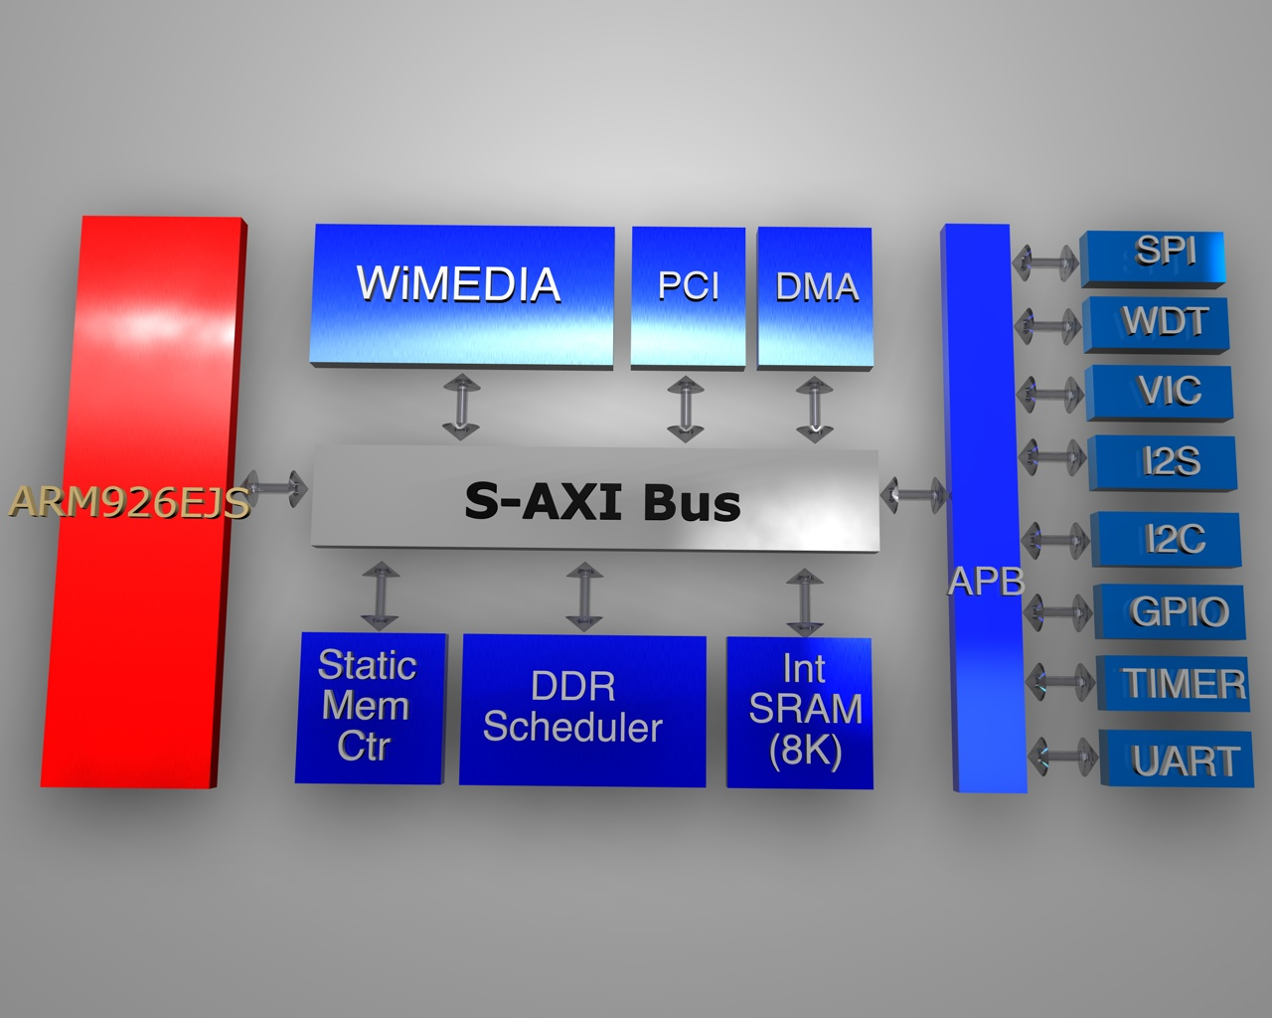

  - Features

- FPGA에서의 동작 주파수
• System : 50MHz
• DDR : 100MHz
• slow peripheral : 25Mhz
• fast peripheral : 50Mhz
Static memory controller, DDR Controller, DMA

- ARM 926 내장

- Internal SRAM
• 128 kByte

- DDR Controller
• 128/256/512 Mbit

- I2C
• Variable clock rate : 400kHz max.

- I2S
• Configurable Master/Slave.
• ADC(receive) & DAC(transmit) IF for audio Codec.
• IF mode : Standard I2S, MSB(=Left) justified mode(configurable).
• 8/16/24/32bit Word lengths.
• 16k/32k/44.1k/48kHz Sampling Frequency.
• Each 16 word FIFO entries for Transmit & Receive.

- Timer
• 4 channel

- Enhaned-DMA
• 8 chennel

- SPI
• SPI clock speed up to 12MHz.
• For transferring MP3 bit-stream.
• 160Byte/10mS @128k Sampling.
• Support DMA.

- UART
• Special UART (2ch)
- Baudrate : 115200 max
- Channel 0 : Tx 32bytes & Rx 32bytes FIFOs.
- Channel 1 : Tx 32bytes & Rx 8bytes FIFOs.

- WDT

- Vectored Interrupt Controller
• 32 interrupt source

ARM926EJ-S

  - Overview

    - Feature

- Base Core : ARM9EJ-S
  - ARM architecture 5TEJ
- Little/Big endian
- Seven operation mode
  - User mode
  - Fast interrupt mode
  - Interrupt mode
  - Supervisor mode
  - Abort mode
  - System mode
  - Undefined mode
- 37 registers
  - 31 general purpose 32bit registers
  - 6 32bit status register
- Cache Size
  - I-Cache : 4way, 8Kbyte
  - D-Cache : 4way, 8Kbyte
- MMU
- AMBA AHB interface
- Three Processor operating state
  - ARM state
  - Thumb state
  - Jazelle state
- Supported Instructions
  - 32bit ARM instruction
  - 16bit Thumb instruction
  - Java byte codes
- System control coprocessor(CP15)
  - With ID code register
  - With Cache and MMU control register

    - Block diagram

Figure 2-2 ARM926EJ-S Block Diagram
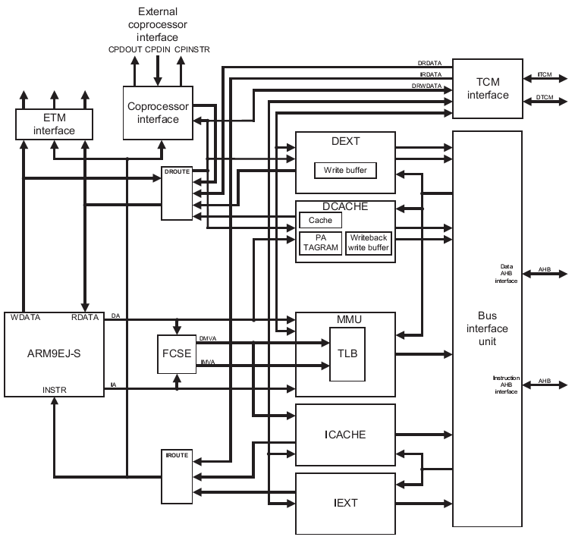

ARM9EJ-S processor core와 I/D cache, MMU, memory interface, coprocessor interface로 구성된다.
Debug를 위해서 ETM(Embedded Trace Macrocell) interface를 갖고 있다.

    - Processor operating state

ARM9EJ-S는 다음과 같이 세 가지의 operating state를 지원한다.
- ARM state : 32bit, word aligned instruction을 수행
- Thumb state : 16bit, half word aligned instruction을 수행
- Jazelle state : variable length, byte aligned instruction을 수행

  - Switching operating state

- ARM ↔ Thumb : BX, BLX 명령을 이용.
- ARM ↔ Jazelle : BXJ 명령을 이용

Exception이 발생하면 ARM state에서 service routine을 수행하고 원래 state로 전환한다.

  - Registers

ARM926EJ-S는 총 37개의 32bit register를 내장하고 있다.
Register들은 다음과 같이 두 가지로 구분할 수 있다.
- 31개의 general purpose register
- 6개의 status register
Register들은 processor operating state에 따라 access할 수 있는 register가 다르게 구성된다.

    - ARM state에서의 register

ARM state 에서는 모든 register를 각 mode에 따라 사용할 수 있다.

Figure 2-3 ARM state에서의 register
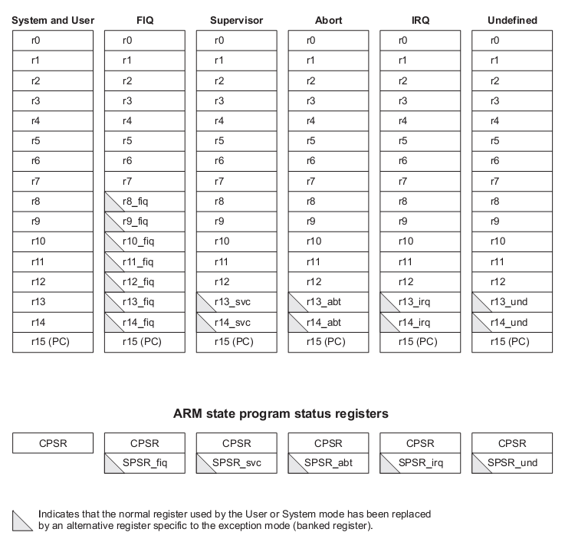

General registers

ARM state에서는 general register중 2개를 특수한 용도로 사용한다.
R15는 program counter로 사용되고, R14는 link register로 사용된다.
R13은 일반적으로 stack pointer로 사용된다.
R13, R14, R15를 제외한 나머지 register는 용도가 규정되어 있지 않다.
Stack pointer와 link register는 mode에 따라 별개의 register를 사용할 수 있도록 여분의 register가 존재한다.
FIQ mode에서는 좀더 빠른 interrupt 처리를 위해서 별도의 R8 ~ R12를 사용하도록 한다.

Status register

ARM9EJ-S는 mode전환시 사용하던 status register의 내용을 backup할 수 있도록 mode별로 별도의 SPSR을 가지고 있다.

    - Thumb state에서의 register

Figure 2-4 Thumb state에서의 register
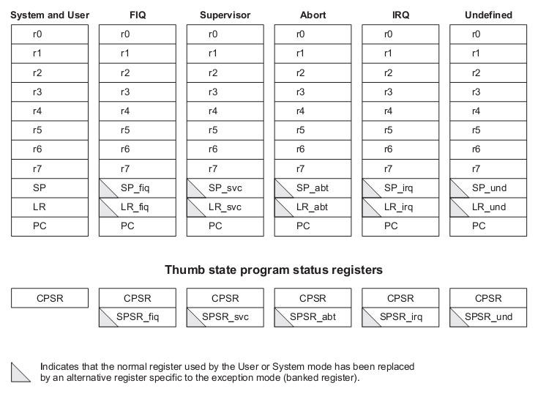

General registers

R0 ~ R7까지 총 8개의 general purpose register를 사용할 수 있다.
이 register들은 특별히 용도를 한정하지 않는다.
이 register는 ARM state에서 R0 ~ R7에 대응된다.

Special registers

총 4가지의 special purpose register가 있다.
- Program counter : ARM state의 R15에 대응.
- Link register : ARM state의 R14에 대응.
- Stack pointer : ARM state의 R13에 대응.
- Status register : 현재 mode의 status register와 각 mode에서 backup하는 SPSR로 구성.

    - Status register

Figure 2-5 Status register
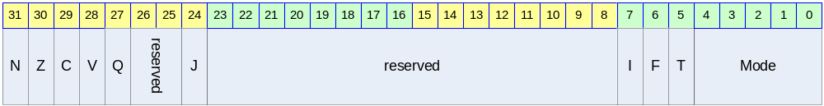

Table 2-1 Status register의 bit 구성
Bits | Name | R/W | Description | Init. value
[31] | N | RW | Negative/Less than | 0b
[30] | Z | RW | Zero | 0b
[29] | C | RW | Carry/Borrow/Extend | 0b
[28] | V | RW | Overflow | 0b
[27] | Q | RW | Sticky overflow | 0b
[25:26] |  |  | reserved
[24] | J | R | Jazelle state bit | 0b
[8:23] |  |  | reserved
[7] | I | RW | IRQ disable | 1b
[6] | F | RW | FIQ disable | 1b
[5] | T | RW | Thumb state bit | 0b
[4:0] | Mode | RW | Mode bits | 00000b

Condition code flags

N, Z, C, V bits.
가장 최근의 연산 결과를 반영한다.
Thumb state에서는 branch 명령만 참조한다.

Q flag

다음과 같은 certain multiply나 fractional arithmetic 명령어에서 사용된다.
- QADD
- QDADD
- QSUB
- QDSUB
- SMLAxy
- SMLAWy

J flag

Processor operating state가 Jazelle state임을 나타냄.

- J = 0 : ARM or Thumb state
- J = 1 : Jazelle state

CPSR의 J flag는 MSR로 변경할 수 없다.

Interrupt disable flags

IRQ와 FIQ를 en/disable한다.
- I = 1 : IRQ를 disable한다.
- F = 1 : FIQ를 disable한다.

T flag

Processor operating state를 Thumb state로 변경한다.

- T = 1 : Processor를 Thumb state로 동작시킨다.
- T = 0 : Processor를 ARM state나 Jazelle state로 동작시킨다.

CPSR의 T flag는 MSR 명령으로 변경해서는 안 된다. 만일 MSR 명령어로 변경하게 되면, processor는 예측할 수 없는 동작을 하게 된다.

Mode bits

Processor의 mode를 결정한다.

Table 2-2 SPR mode bit별 mode설정
M[4:0] | Mode
10000b | User
10001b | FIQ
10010b | IRQ
10011b | Supervisor
10111b | Abort
11011b | Undefined
11111b | System

  - Exceptions

    - Exception vectors

Exception vector의 base address는 CFGHIVECS signal에 의해서 다음과 같이 결정된다.

Table 2-3 Vector base address
Value of CFGHIVECS | Vector base address
0b | 0000 0000h
1b | FFFF 0000h

Table 2-4 Exception vector addresses
Exception | Offset | Mode on entry | I bit on entry | F bit on entry
Reset | 00h | Supervisor | Disabled | Disabled
Undefined instruction | 04h | Undefined | Disabled | Unchanged
Software interrupt | 08h | Supervisor | Disabled | Unchanged
Abort(prefetch) | 0Ch | Abort | Disabled | Unchanged
Abort(data) | 10h | Abort | Disabled | Unchanged
Reserved | 14h | Reserved | - | -
IRQ | 18h | IRQ | Disabled | Unchanged
FIQ | 1Ch | FIQ | Disabled | Disabled

    - Exception priorities

동시에 다수의 exception이 발생할 경우 다음과 같은 우선 순위에 따라 exception을 처리한다.
- Reset(highest priority)
- Data Abort
- FIQ
- IRQ
- Prefetch Abort
- BKPT, Undefined instruction, and SWI(lowest priority)

    - Entering an ARM exception

다음과 과정을 거쳐 exception service routine으로 진입한다.
- Next instruction의 주소를 LR에 저장한다.
- CPSR를 해당 mode의 SPSR로 복사.
- CPSR mode bit을 해당 mode로 설정.
- PC를 exception vector의 주소로 설정하여 다음 명령어를 fetch.

Thumb state나 Jazelle state에서 exception이 발생하면 자동으로 ARM state로 전환되어 exception vector address를 PC로 load한다.

    - Leaving an ARM exception

다음과 과정을 거쳐 exception service를 종료한다.
- LR을 PC로 복사한다.
- S bit이 1이고, rd=r15이면, SPSR을 CPSR에 복사한다. 그리고 interrupt disable flag를 clear한다.

    - Reset

nRESET 핀이 low로 driving 될 경우, processor는 reset 상태에 들어가게 된다.
Reset 상태에서 nRESET 핀이 high로 driving 되면 다음과 같은 동작을 수행하게 된다.
- CPSR의 mode bits을 supervisor mode(10011b)로 설정한다. I와 F flag를 set하여 interrupt를 disable한다. T와 J bit을 clear하여 ARM state로 설정한다.
- PC를 reset vector address로 설정한다.
- ARM state에서 명령어를 수행한다.

Reset후 PC와 CPSR을 제외한 다른 register는 undefined value를 갖는다.

    - Fast interrupt request

FIQ를 위해서 8개의 전용 register를 내장하여 interrupt 응답시간을 줄인다.
Privileged mode에서 F flag를 set하여 FIQ를 disable시킬 수 있다.
FIQ가 발생하면, IRQ와 FIQ 모두 disable된다.
Fast interrupt handler에서 본래 프로그램으로 되돌아 가려면 다음 명령을 수행하면 된다.

SUBS PC, R14_fiq, #4

    - Interrupt request

IRQ는 FIQ보다 우선순위가 낮다.
Privileged mode에서 I flag를 set하여 IRQ를 disable시킬 수 있다.
IRQ가 발생하면, IRQ는 disable된다.
Interrupt handler에서 본래 프로그램으로 되돌아 가려면 다음 명령을 수행하면 된다.

SUBS PC, R14_irq, #4

    - Aborts

Abort exception은 memory operation은 완료되지 못 할 경우 발생한다.
Abort는 다음과 같이 두 가지 경우에 발생하게 된다.
- Prefetch Abort
- Data Abort

Abort exception이 발생하면 IRQ는 diable된다.

Prefetch Abort

Instruction fetch의 마지막에 IABORT signal을 검사하여, prefetched instruction에 invalid라고 marking한 뒤, invalid instruction이 execution stage에 도착했을 때 exception에 진입한다.
만일 branch등에 의해서 invalid instruction이 수행되지 않는다면, exception은 발생하지 않는다.
Prefetch Abort exception에서 본래 프로그램으로 되돌아 가려면 다음 명령을 수행하면 된다.

SUBS PC, R14_abt, #4
위 명령어는 PC와 CPSR을 복원시킨다.

Data Abort

Data abort는 data access cycle의 마지막에 체크되며, read와 write 모두에서 발생할 수 있다.
ARM9EJ-S는 base restored Data Abort model을 사용하는데 이것은 ARM7TDMI-S의 base updated Data Abort model과는 다르다.
base restored Data Abort model은 memory access 명령을 수행하는 중 Data Abort가 발생했을 때, processor 하드웨어가 base register를 명령어가 실행되기 전의 값으로 복원시킨다. 따라서 Data Abort exception handler가 base register를 이전 값으로 복원시킬 필요가 없어지게 되어 handler를 간단하게 구성할 수 있게 된다.
Abort exception은 demand-paged virtual memory system을 사용할 수 있도록 해준다.

Access하는 address의 data가 유효하지 않다면, MMU는 Abort를 발생시킨다. 그러면 Abort exception handler는 abort의 원인을 분석하고, data를 유효하게 한 뒤, processor는 중단된 명령어를 재 시도한다.

Data Abort exception에서 본래 프로그램으로 되돌아 가려면 다음 명령을 수행하면 된다.

SUBS PC, R14_abt, #8
위 명령어는 PC와 CPSR을 복원시킨다.

Software interrupt instruction

SWI(Software interrupt instruction)은 supervisor mode로 진입하여 supervisor function의 수행을 요구하는데 사용된다.
SWI handler는 opcode를 이용하여 SWI function 번호를 구한다.
SWI가 발생하면, IRQ는 disable된다.

SWI는 다음 명령을 수행하여 SWI의 다음 명령어 주소로 되돌아 갈 수 있다.

MOVS PC, R14_svc
위 명령은 PC와 CPSR을 복원시킨다.

Undefined instruction

ARM의 명령어를 확장하는데 이 exception을 사용할 수 있다. 이 exception이 발생하면 IRQ는 disable된다.
다음 명령을 수행하여 emulated instruction의 다음 명령어로 되돌아 갈 수 있다.

MOVS PC, R14_und
위 명령은 CPSR도 복원시킨다.

Breakpoint instruction(BKPT)

Breakpoint instruction은 Prefetch Abort를 발생시킨다. 만일 branch등에 의해서 breakpoint instruction이 수행되지 않는다면 Prefetch Abort는 발생하지 않는다.

Breakpoint에 대한 처리가 끝나면 다음 명령을 수행하여 break point의 명령을 수행하게 된다.

SUBS PC, R14_abt, #4
위 명령어는 PC와 CPSR을 복원시킨다.

Programmer’s model

  - Overview

  - Memory Map

    - Memory Map

Table 3-3-5 Memory Map at CS0 Boot
 | Reserved | 7000 0000 ~ FFFF FFFF | 1.5GBytes
DDR | DDR Memory | 6000 0000 ~ 6FFF FFFF | 256MBytes
PERI | Peripheral Area | 4000 0000 ~ 5FFF FFFF | 512MBytes
 | Reserved | 3000 0000 ~ 3FFF FFFF | 256MBytes
ISMC | Internal SRAM | 2000 0000 ~ 2FFF FFFF | 256MBytes
 | Reserved | 1700 0000 ~ 1FFF FFFF | 144MBytes
CS8 | External Memory Chip Select 8 | 1600 0000 ~ 16FF FFFF | 16MBytes
CS7 | External Memory Chip Select 7 | 1500 0000 ~ 15FF FFFF | 16MBytes
CS6 | External Memory Chip Select 6 | 1400 0000 ~ 14FF FFFF | 16MBytes
CS5 | External Memory Chip Select 5 | 1300 0000 ~ 13FF FFFF | 16MBytes
CS4 | External Memory Chip Select 4 | 1200 0000 ~ 12FF FFFF | 16MBytes
CS3 | External Memory Chip Select 3 | 1100 0000 ~ 11FF FFFF | 16MBytes
CS2 | External Memory Chip Select 2 | 1000 0000 ~ 10FF FFFF | 16MBytes
CS1 | External Memory Chip Select 1 | 0800 0000 ~ 0FFF FFFF | 128MBytes
CS0 | External Memory Chip Select 0/  WaveROM Table | 0000 0000 ~ 07FF FFFF | 128MBytes

각각의 Memory bank는 ARM926EJS의 MMU 설정에 의해서 Cacheable 혹은 non cacheable 영역으로 설정될 수 있다.

  - Peripherals

    - Peripheral Memory Map

Table 3-3-6 Peripheral Memory MAP
Reserved | 5000 9000 ~ 5FFF FFFF
SPI Controller | 5000 8000 ~ 5000 8FFF
I2C Master | 5000 7000 ~ 5000 7FFF
I2S Controller | 5000 6000 ~ 5000 6FFF
UART | 5000 5000 ~ 5000 5FFF
System Controller | 5000 4000 ~ 5000 4FFF
Power Management Unit | 5000 3000 ~ 5000 3FFF
GPIO | 5000 2000 ~ 5000 2FFF
WatchDog Timer | 5000 1000 ~ 5000 1FFF
Timer | 5000 0000 ~ 5000 0FFF
Reserved | 4000 5000 ~ 4FFF FFFF
Vectored Interrupt Controller | 4001 4000 ~ 4001 4FFF
Reserved | 4001 0000 ~ 4001 0FFF
E-DMA Controller | 4000 C000 ~ 4000 CFFF
Reserved | 4000 8000 ~ 4000 8FFF
DDR Memory Controller | 4000 4000 ~ 4000 4FFF
Static Memory Controller | 4000 0000 ~ 4000 0FFF

  - Boot sequence

    - Boot mode configuration

Power On Configuration시 외부 핀의 설정에 의해서 Boot 모드를 설정할 수 있다.

Table 3-3 Boot Mode Configuration
Boot mode | Boot mode [1:0]
Direct(CS0) boot mode | 0
Reserved | 1
Reserved | 2

    - Direct(CS0) boot mode

ROM에서 직접 부팅한다. 이 모드로 부팅하기 위해서 외부 Boot mode[1:0] pin을 “00”으로 설정한 후 Reset 신호를 준다.

ROM이 어드레스 0x0000 0000으로 매핑이 되어 진행된다.

절차는 다음과 같다.

- Boot mode pin = 0설정
- Reset
- ROM에서 부팅
- 필요한 프로그램과 데이터를 Main Memory로 복사

Power mamangement unit

Overview

Clock Control Block과 Power Manage State Machine, Reset Control Block으로 나눌 수 있다.

Feature

- Support Slow Mode.
- Operate by External Clock divided or not
- Support CPU Idle Mode.
- Disconnect Only CPU Clock
- Wake Up From Any Interrupt
- Support Power Down Mode.
  - Disconnect All Clock
  - Wake Up From External Interrupt

Block Diagram

Figure 4-6 Clock Distribution Block Diagram
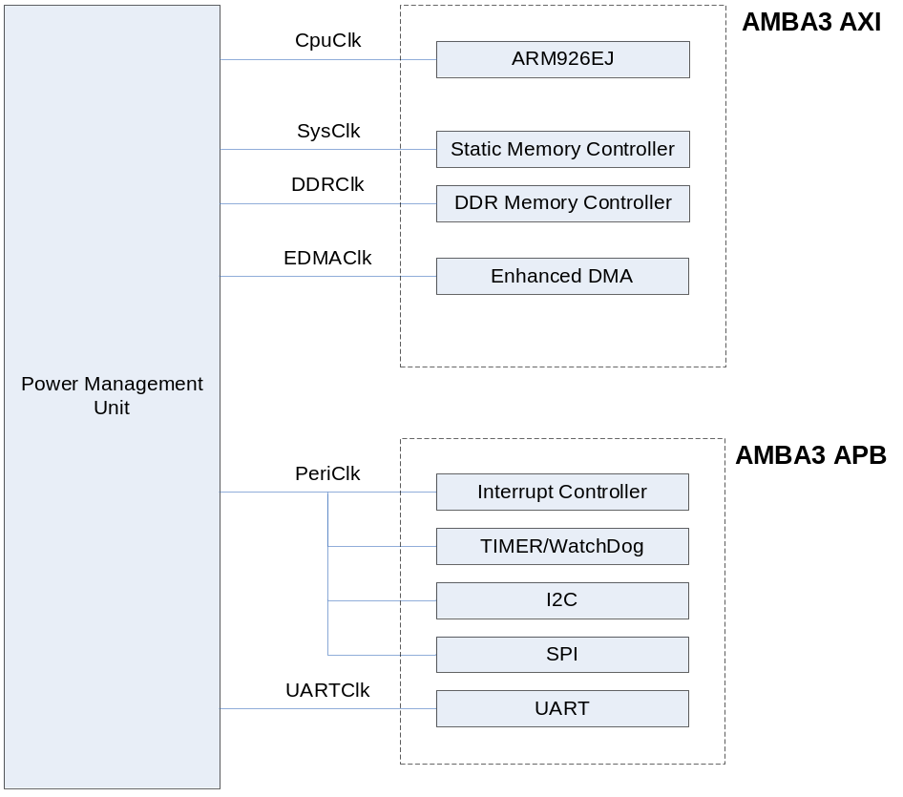

Operation

Clock Control Block

외부 27MHz Oscillator의 입력을 받은 MPLL에서 200MHz Clock을 만들어서 CpuClk, SysClk, PeriClk을 만든다.
정상 동작 모드의 예를 들면 200MHz Clock은 DDR SDRAM Data Control을 위해 사용되고, 버스나 DMA는 100MHz로 동작하고 Peripheral은 50MHz로 동작한다

FPGA에서는 DDR 100MHz, System 50MHz, slow peripheral 25Mhz, fast peripheral 50MHz로 동작한다.

Figure 4-7 Clock Control Block Diagram
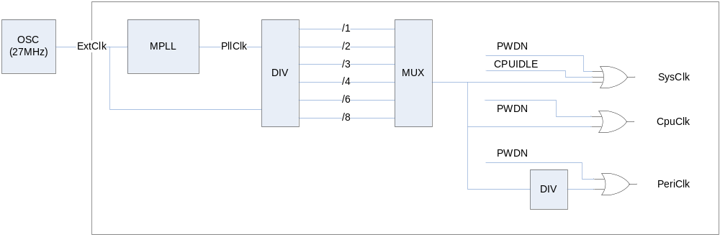

Power Manage State Machine

POC State
Power On Configuration
외부 Reset(ExtResetb)이 풀리면 이 State로 들어오게 되고, Pad 입력 쪽의 Pull-up이나 Pull-Down Resistor에 의해 Chip 초기 설정 Configuration이 가능하다.
16 Cycle 이상의 POC나 SlowEn Register가 Set 되면 SLOW State로 넘어 간다.

SLOW State
외부 Clock(ExtClk)에 의해 System이 동작 하는 상태이고, PLL이 Set 되거나(PllSetEnd) SlowEn Register가 Clear(SlowDis)되면 LOCK State로 넘어간다.

LOCK State
PLL이 Locking 될 때까지 기다리는 시간이다. 이 시간은 Register로 변경 가능하다.
PLL이 Locking 되면 NORMAL State로 넘어간다.

NORMAL State
System내의 모든 Clock이 동작하는 상태이다.
각 블록의 Clock Enable에 의해 각각의 Power Down이 가능하다.

CPUIDLE State
CPU Clock이 Disable 되는 상태이다.

PWDN State
각 블록의 Clock Enable과 상관 없이 System내의 모든 Clock이 Disable 되는 상태이다.
Figure 4-8 Power Manage State Machine Block Diagram
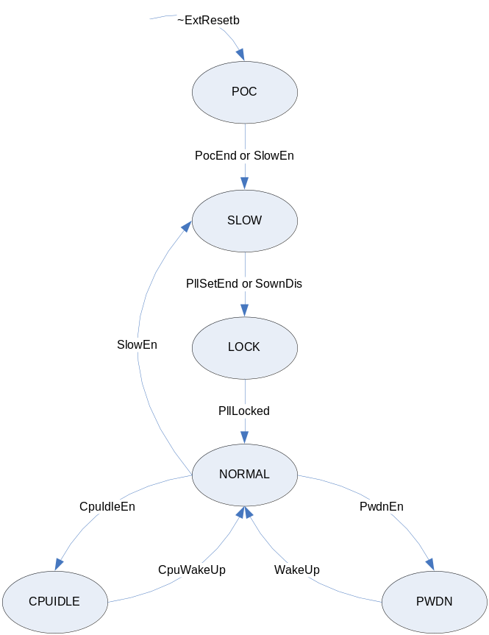

Reset Control Block

다음 그림과 같이 외부 클럭의 16 사이클 동안 Power On Configuration이 이루어 지고 약 500us의 PLL Lock Time이 지나면 Internal은 정상적인 PLL 클럭으로 동작 하게 된다.

Figure 4-9 Power On Configuration & PLL Lock Time Diagram
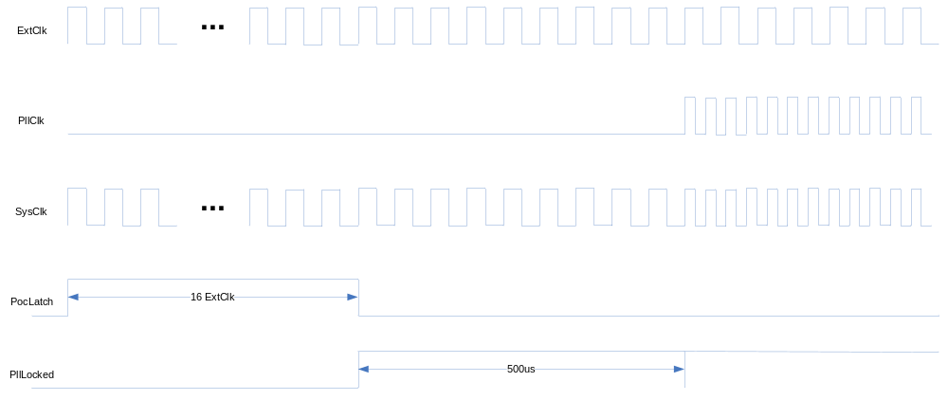

두가지의 Reset 방식을 사용한다. 하나는 외부 하드웨어에 의해서 Reset 핀을 지정된 시간 이상 Low로 설정을 하면 하드웨어 리셋이 발생한다. 이 방식을 Cold Reset으로 부른다.

S/W에 의해서 System Configuration Register의 비트 31번을 ‘1’로 기록하면 리셋이 발생한다. 이 방식을 Warm Reset으로 부른다.

Warm reset이 된 경우에는 모든 하드웨어의 설정은 변경이 없이 CPU만 다시 Reset이 걸린다.

Register Description

Power Management Unit Registers

Table 4-7 Power Management Unit Registers
Offset | Name | R/W | Description | Init. value
0000h | PMCON | RW | Power Manage Control Register | 0000 3004h
0004h | CLKDIV | RW | Clock Divide Register | 0000 0008h
0008h | LOCWAIT | RW | PLL Lock Wait Register | 0000 FFFFh
000Ch | PLLSET | RW | PLL Set Register | 0000 1952h

Power Management Control Register

Figure 4-10 Power Management Control Register Bits
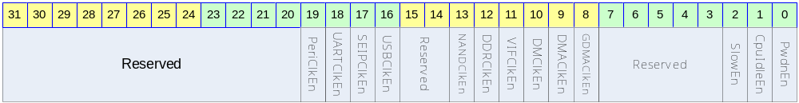

Table 4-8 Power Management Control Register Description(Offset : 0000 0000h)
Bits | Name | R/W | Description | Init. value
[31:20] |  |  | Reserved | 0
[19] | PeriClkEn | RW | TIMER/WDT/I2C/SPI Clock Enable  1 : Enable  0 : Disables | 0
[18] | UARTClkEn | RW | UART Clock Enable  1 : Enable  0 : Disable | 0
[17:13] |  |  | Reserved
[12] | DDRClkEn | RW | DDR Memory Controller Clock Enable  1 : Enable  0 : Disable | 1
[11:10] |  |  | Reserved
[9] | DMAClkEn | RW | DMA Module Clock Enable  1 : Enable  0 : Disable | 0
[8:3] |  |  | Reserved
[2] | SlowEn | RW | Slow Mode Enable  1 : Enable  0 : Disable | 1
[1] | CpuIdleEn | RW | CPU Idle Mode Enable  1 : Enable  0 : Disable | 0
[0] | PwdnEn | RW | Power Down Enable  1 : Enable  0 : Disable | 0

Clock Divide Register

Figure 4-11 Clock Divide Register Bits
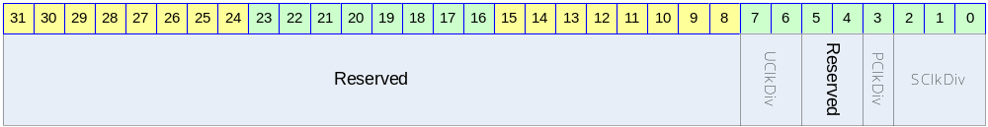

Table 4-9 Clock Divide Register Description(Offset : 0000 0004h)
Bits | Name | R/W | Description | Init. value
[31:4] |  |  | Reserved | 0
[3] | PClkDiv | RW | Peri. Clock Divide  0 : Bypass SysClk  1 : Divide By 2 SysClk | 1
[2:0] | SClkDiv | RW | System Clock Divide  0 : Bypass MPllClk  1 : Divide By 2 MPllClk  2 : Divide By 3 MPllClk  3 : Divide By 4 MPllClk  4 : Divide By 6 MPllClk  5 : Divide By 8 MPllClk | 0

PLL Lock Wait Register

Figure 4-12 PLL Lock Wait Register Bits
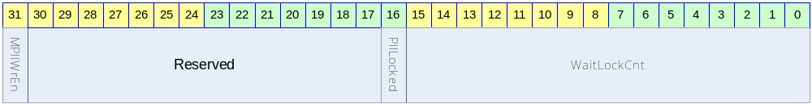

Table 5-4 PLL Lock Wait Register Description(Offset : 0000 0008h)
Bits | Name | R/W | Description | Init. value
[31] | MPllWrEn | RW | PLL Value Write Enable  이 값을 1 로 써야지만 PLL 값을 설정할 수 있다. | 0
[30:17] |  | RW | Reserved | 0
[16] | PllLocked | R | PLL is Locked  0 : UnLocked  1 : Locked | 0
[15:0] | WaitLockCnt | RW | PLL Lock Wait Value | ffffh

PLL Set Register

Figure 4-13 PLL Set Register Bits
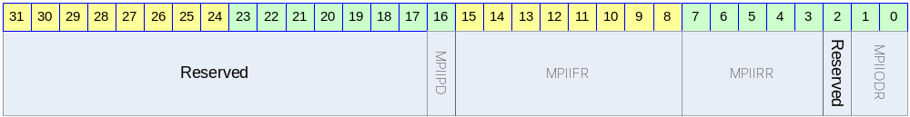

Table 5-5 PLL Set Register Description(Offset : 0000 000Ch)
Bits | Name | R/W | Description | Init. value
[30:17] |  | RW | Reserved | 0
[16] | MPllPD | RW | PLL Power Down Enable  0 : Enable  1 : Disable | 0
[15:8] | MPllFR | RW | FeedBack Divisor | 25d
[7:3] | MPllRR | RW | Input Divisor | 5h
[2] |  |  | Reserved | 0
[1:0] | MPllODR | RW | Output Divisor  ‘2’ 이상의 값을 가져야 PLL 출력 클럭의 duty가 50/50 에 근접하게 된다. | 2

FREF = FIN / NR
FVCO = FOUT * NO
FOUT = FIN * NF / (NR*NO), where FREF is the comparison frequency for the PFD.
For proper operation in normal mode, the following constraints must be satisfied:
2 MHz ≤ FREF ≤ 8 MHz
200 MHz ≤ FVCO ≤ 400 MHz
50 MHz ≤ FOUT ≤ 400 MHz

Example I: To synthesize a 200 MHz output clock with an input frequency FIN = 15 MHz.
1. Set MPllWrEn = 1.
2. Set NR to obtain FREF within the PFD comparison frequency range:
Let FREF = 5 MHz, Since FREF = FIN / NR,
NR = FIN / FREF = 15 MHz / 5 MHz = 3
3. MPllRR = NR = 3 = 000112
4. Set NO and ensure FVCO within the VCO operating range:
Set NO = 1
FVCO = FOUT * NO
FVCO = 200 MHz * 1 􀃆 within the VCO operating range
5. MPllODR = 012
6. Set NF to obtain the FOUT frequency:
NF = FOUT * NR * NO / FIN
NF = 200 MHz * 3 * 1 / 15 MHz = 40
6. MPllFR = NF/2 = 20 = 000101002

System control

  - Overview

시스템의 제어 및 관련 정보를 설정하거나 얻을 수 있는 레지스터의 모음
전원 관리등을 수행한다.

- Power On Configuration 정보.
- External IO Width
  - Boot Mode
  - NAND Flash Configuration
- DMA Resouce Share 정보.
- System Configuration.
- Pin-Mux Control

  - Registers

    - System Configuration Register

Table 5-10 System Configuration Register Description (Offset : 0000 0000h)
Bits | Name | R/W | Description | Init. value
[31] | SRST | R/W | Software Reset  0 : No Effect  1 : Warm reset  1을 기록할 경우 S/W에 의한 리셋이 발생한다.  레지스터의 값이나 다른 값은 변동이 없이 CPU Core의 리셋이 걸리게 된다.  해당 비트가 ‘1’인 경우 나머지 비트들은 영향 받지 않는다. | 0000 0000h
[30:0] |  |  | Reserved | 0

DMA Resource Share Register

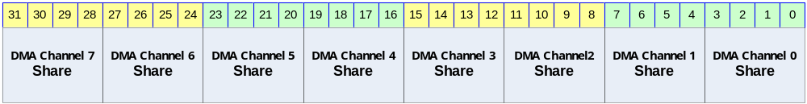

Table 5-11 DMA Resource Share Register Description (Offset : 0000 0004h)
Bits | Name | R/W | Description | Init. value
[31:28] | DMA Channel 7 Share | R/W | DMA Channel 7 Input selection | 0x0
[27:24] | DMA Channel 6 Share | R/W | DMA Channel 6 Input selection | 0x0
[23:20] | DMA Channel 5 Share | R/W | DMA Channel 5 Input selection | 0x0
[19:16] | DMA Channel 4 Share | R/W | DMA Channel 4 Input selection | 0x0
[15:12] | DMA Channel 3 Share | R/W | DMA Channel 3 Input selection | 0x0
[11:8] | DMA Channel 2 Share | R/W | DMA Channel 2 Input selection | 0x0
[7:4] | DMA Channel 1 Share | R/W | DMA Channel 1 Input selection | 0x0
[3:0] | DMA Channel 0 Share | R/W | DMA Channel 0 Input selection | 0x0

각 채널의 입력 값은 아래와 같이 설정된다.

Value | Selected Input
0 | Reserved
1 | Reserved
2 | Reserved
3 | I2S Tx DMA Req
4 | I2S Rx DMA Req
5 | SPI 0 Tx DMA Request
6 | SPI 0 Rx DMA Request
7 | UART Channel 0 Tx Dma Request
8 | UART Channel 0 Rx Dma Request
9 | Reserved
10 | Reserved

    - Information Register

Table 5-12 Information Register Description(Offset : 0000 0008h)
Bits | Name | R/W | Description | Init. value
[31:10] |  | R | Reserved | 0000 0000h
[9:8] | Boot Mode  PocCfg[1:0] | R | Boot mode  0 : Direct boot mode(Wave ROM/CS0)  1 : Reserved  2 : Reserved  Boot mode에 따른 설정 값이다.  외부 핀 2개를 할당하여 Reset시에 설정된 상태를 파악한 후 이 값이 그대로 읽혀진다
[7:0] | MAJOR | R | Major Number  첫번째 버전은 0x01이 된다. | 0x01

    - Pin Mux Register

GPIO 및 기타 기능을 위해서 Pin 하나에 복수의 기능을 부가하였다. 부가된 기능중에 하나를 선택하기 위해서 설정되는 레지스터이다.

Table 5-13 Function Pin-Mux Register Description(Offset : 0000 0010h)
Bits | Name | R/W | Description | Init. value
[31:6] |  | RW | Reserved | 0000 0000h
[5] |  | RW | 0 : Reserved  1 : I2C_SDA | 0
[4] |  | RW | 0 : Reserved  1 : I2C_SCL | 0
[3] |  | RW | 0 : Reserved  1 : I2S_MCLK | 0
[2] |  | RW | 0 : Reserved  1 : I2S_BCLK | 0
[1] |  | RW | 0 : Reserved  1 : I2S_LRCLK | 0
[0] |  | RW | 0 : Reserved  1 : I2S_SDOUT | 0

Table 5-14 GPIO0 Pin-Mux Register Description(Offset : 0000 0014h)
Bits | Name | R/W | Description | Init. value
[31] |  | RW | 0 : Reserved  1 : GPIO031 | 0
[30] |  | RW | 0 : Reserved  1 : GPIO030 | 0
[29] |  | RW | 0 : Reserved  1 : GPIO029 | 0
[28] |  | RW | 0 : Reserved  1 : GPIO028 | 0
[27] |  | RW | 0 : Reserved  1 : GPIO027 | 0
[26] |  | RW | 0 : Reserved  1 : GPIO026 | 0
[25] |  | RW | 0 : Reserved  1 : GPIO025 | 0
[24] |  | RW | 0 : Reserved  1 : GPIO024 | 0
[23] |  | RW | 0 : Reserved  1 : GPIO022 | 0
[22] |  | RW | 0 : Reserved  1 : GPIO022 | 0
[21] |  | RW | 0 : Reserved  1 : GPIO021 | 0
[20] |  | RW | 0 : Reserved  1 : GPIO020 | 0
[19] |  | RW | 0 : Reserved  1 : GPIO019 | 0
[18] |  | RW | 0 : Reserved  1 : GPIO018 | 0
[17] |  | RW | 0 : Reserved  1 : GPIO017 | 0
[16] |  | RW | 0 : Reserved  1 : GPIO016 | 0
[15] |  | RW | 0 : Reserved  1 : GPIO015 | 0
[14] |  | RW | 0 : SMC_ADDR26  1 : GPIO014 | 0
[13] |  | RW | 0 : SMC_ADDR25  1 : GPIO013 | 0
[12] |  | RW | 0 : SMC_ADDR24  1 : GPIO012 | 0
[11] |  | RW | 0 : SMC_nCS4  1 : GPIO011 | 0
[10] |  | RW | 0 : SMC_nCS3  1 : GPIO010 | 0
[9] |  | RW | 0 : SMC_nCS2  1 : GPIO09 | 0
[8] |  | RW | 0 : SMC_nCS1  1 : GPIO08 | 0
[7] |  | RW | 0 : Reserved  1 : GPIO07 | 0
[6] |  | RW | 0 : Reserved  1 : GPIO06 | 0
[5] |  | RW | 0 : Reserved  1 : GPIO05 | 0
[4] |  | RW | 0 : Reserved  1 : GPIO04 | 0
[3] |  | RW | 0 : Reserved  1 : GPIO03 | 0
[2] |  | RW | 0 : Reserved  1 : GPIO02 | 0
[1] |  | RW | 0 : Reserved  1 : GPIO01 | 0
[0] |  | RW | 0 : Reserved  1 : GPIO00 | 0

Table 5-15 GPIO1 Pin-Mux Register Description(Offset : 0000 0018h)
Bits | Name | R/W | Description | Init. value
[31:30] |  |  | Reserved
[29] |  | RW | 0 : Reserved  1 : GPIO129 | 0
[28] |  | RW | 0 : UART0_TXD  1 : GPIO128 | 0
[27] |  | RW | 0 : SPI_CLK  1 : GPIO127 | 0
[26] |  | RW | 0 : SPI_MOSI  1 : GPIO126 | 0
[25] |  | RW | 0 : SPI_MISO  1 : GPIO125 | 0
[24] |  | RW | 0 : SPI_nSS  1 : GPIO124 | 0
[23] |  | RW | 0 : Reserved  1 : GPIO123 | 0
[22] |  | RW | 0 : Reserved  1 : GPIO122 | 0
[21] |  | RW | 0 : Reserved  1 : GPIO121 | 0
[20] |  | RW | 0 : Reserved  1 : GPIO120 | 0
[19] |  | RW | 0 : Reserved  1 : GPIO119 | 0
[18] |  | RW | 0 : Reserved  1 : GPIO118 | 0
[17] |  | RW | 0 : Reserved  1 : GPIO117 | 0
[16] |  | RW | 0 : Reserved  1 : GPIO116 | 0
[15] |  | RW | 0 : Reserved  1 : GPIO115 | 0
[14] |  | RW | 0 : Reserved  1 : GPIO114 | 0
[13] |  | RW | 0 : Reserved  1 : GPIO113 | 0
[12] |  | RW | 0 : Reserved  1 : GPIO112 | 0
[11] |  | RW | 0 : Reserved  1 : GPIO111 | 0
[10] |  | RW | 0 : Reserved  1 : GPIO110 | 0
[9] |  | RW | 0 : Reserved  1 : GPIO19 | 0
[8] |  | RW | 0 : Reserved  1 : GPIO18 | 0
[7] |  | RW | 0 : Reserved  1 : GPIO17 | 0
[6] |  | RW | 0 : Reserved  1 : GPIO16 | 0
[5] |  | RW | 0 : Reserved  1 : GPIO15 | 0
[4] |  | RW | 0 : Reserved  1 : GPIO14 | 0
[3] |  | RW | 0 : Reserved  1 : GPIO13 | 0
[2] |  | RW | 0 : Reserved  1 : GPIO12 | 0
[1] |  | RW | 0 : Reserved  1 : GPIO11 | 0
[0] |  | RW | 0 : Reserved  1 : GPIO10 | 0

Static Memory Controller

Overview

Feature

- AXI Slave Interface
- Support 8-BANK
- Programmable access cycle
- Programmable device bus Width(8/16/32)
    - Support 8 Bit External Bus Width at CT500.
- Programmable address shift(1bit/2bit)

Block Diagram
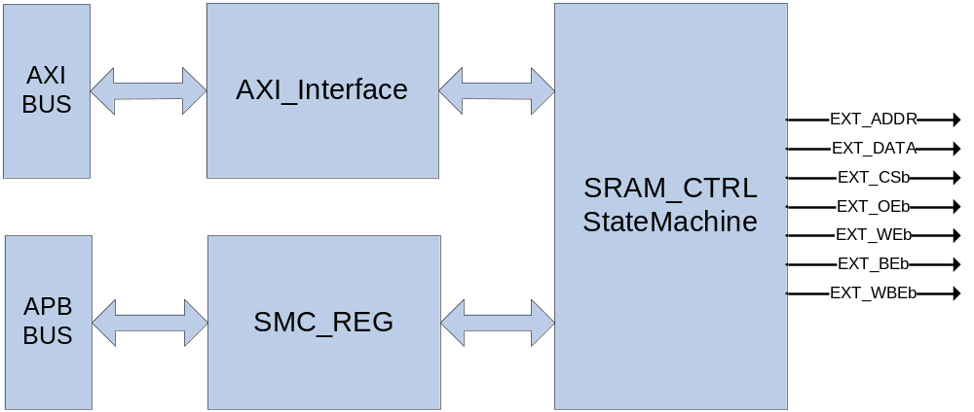

Signal Description

Table 6-16 ESMC Signal
Signal Name | Direction | Description | Init. value
EXT_ADDR[26:0] | Output | Address signal
EXT_DATA[7:0] | InOut | 8bit Data Input/Output signal
EXT_CSb[8:0] | Output | Chip select (active low)
EXT_OEb | Output | Output Enable signal(active low)
EXT_Web | Output | Write Enable signal(active low)
EXT_BEb[3:0] | Output | Byte Enable signal(active low)
EXT_WBEb[3:0] | Output | Write byte enable signal(active low)

EXT_BEb[0]은 EXT_DATA[7:0],EXT_BEb[1]은 EXT_DATA[15:8],EXT_BEb[2]는 EXT_DATA[23:16],EXT_BEb[4]는 EXT_DATA[31:24]을 Enable/Disable한다.
EXT_BEb는 ChipSelect 신호(EXT_CSb)와 같은 timing을 가지고 EXT_WBEb는 WriteEanble 신호 (EXT_WEb)와 같은 timing을 가진다.

Address Map

Table 6-17 Address Map
Name | Start Address | End Address
External SRAM(CS0:128M)  WaveROM과 공유 | 0x00000000 | 0x07FFFFFF
External SRAM(CS1:128M) | 0x08000000 | 0x0FFFFFFF
External SRAM(CS2:128M) | 0x10000000 | 0x17FFFFFF
External SRAM(CS3:64M) | 0x18000000 | 0x1BFFFFFF
External SRAM(CS4:64M) | 0x1C000000 | 0x1FFFFFFF

Timing

Figure 6-14 External IO Timing
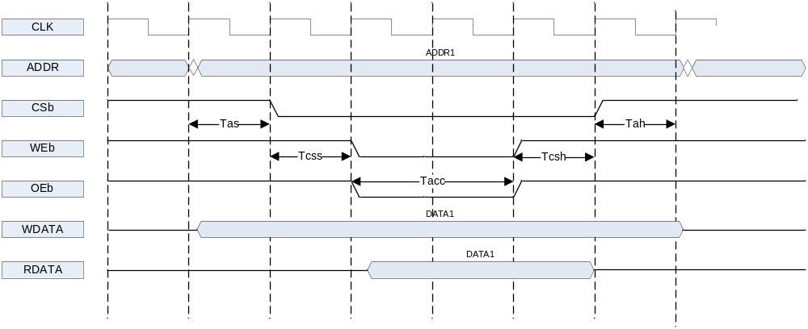

Timing diagram에 있는 time 정보에 대한 약자는 다음과 같다.
Tas : address setup time
Tcss : chip select setup time
Tacc : access time
Tcsh : chip select hold time
Tah : addrese hold time

기본적으로 address 출력이 제일 먼저 이루어 진다. Address setup time이 지난 다음에 CSb가 low가 되고 그 다음 Chip select setup time이 지나면 Output Enable 혹은 Write Enable신호가 low가 된다.
Access time이 지나면 RDATA를 latch하게 되고 그 다음 chip select hold time, address hold time이 지나면 모든 access가 끝나게 된다.
Tas, Tcss, Tacc, Tcsh, Tah를 system clock(정확하게는 AXI interface clock) cycle수로 정할 수 있는 register가 각 bank 별로 존재한다.

Interface

32bit SRAM의 경우 EXT_DATA의 32bit을 모두 사용하면 되고, 16bit SRAM의 경우 EXT_DATA[15:0]만, 8 bit SRAM의 경우 EXT_DATA[7:0]만 연결하여 사용한다.
EXT_ADDR은 0번 bit부터 연결한 후에 각 bank별 Address shift register를 조정하여도 되고 아니면 SRAM의 bit width에 맞추어 하위 1bit 혹은 2bit를 빼고 연결해도 된다.
EXT_CSb와 EXT_OEb, EXT_WEb는 SRAM의 각 pin에 연결하면 되고, SRAM이 byte enable
signal을 가지고 있으면 EXT_BEb에 연결한다.
여기서 주의할 사항이 하나 있는데, 외부의 device가 ByteEnable pin이 없는 device라면 Write Enable pin에 EXT_WEb를 연결하지 말고 EXT_WBEb를 연결해야 한다. 보통의 8bit SRAM도 byte enable pin이 없으므로 동일하다. AXI Write data channel에서 WSTRB가 모두 0으로 된 signal이 들어올 수 있는데 그런 경우에는 EXT_WEb는 low로 떨어지는데 EXT_WBEb는 high로 유지가 되기 때문이다.

Interface Example

EXT_ADDR[26:0]은 메모리 크기에 따라 붙여준다 아래 그림에서는 A[15:0]인 메모리를 예로 들었다.

Figure 6-15 Interface 8bit memory
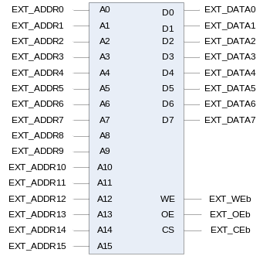

Figure 6-16 Interface 8bit memory x2
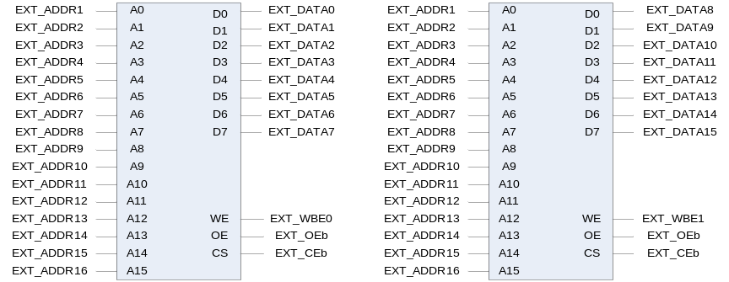

Figure 6-17 Interface 8bit memory x4
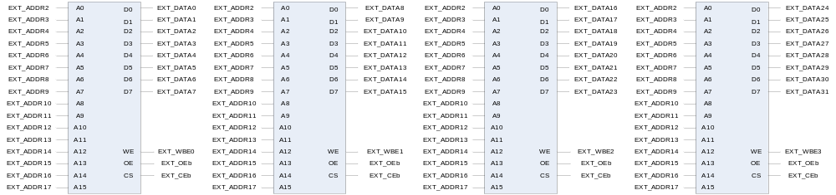

Figure 6-18 Interface 16bit memory
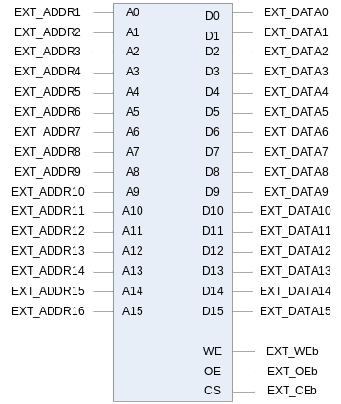

Figure 6-19 Interface (byte enable이 있는)16bit memory
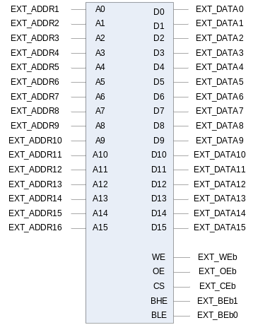

Figure 6-20 Interface (byte enable이 있는)16bit memoryx2
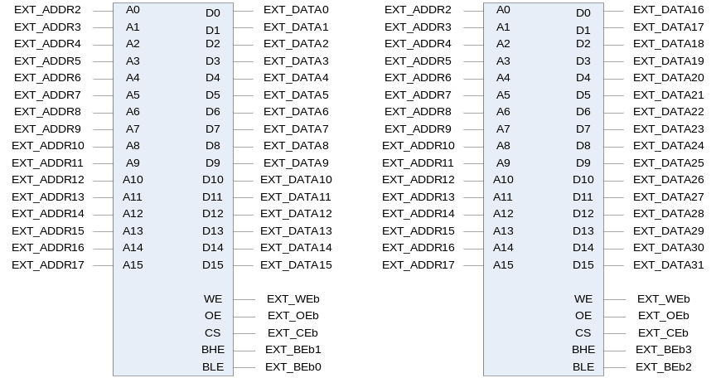

Register Description

Registers

External Sram Controller는 총 4개의 BANK를 가지고 있으며 각 BANK별로 Timing과 Bus Width, Address Shift여부를 셋팅 할수 있다.

Table 6-18 Registers
Offset | Name | R/W | Description | Init. value
0000h | SMC_BANK0 | R/W | BANK0 Control
0004h | SMC_BANK1 | R/W | BANK1Control
0008h | SMC_BANK2 | R/W | BANK2Control
000Ch | SMC_BANK3 | R/W | BANK3Control
0010h | SMC_BANK4 | R/W | BANK4Control

SMC_BANKx Register

각각의 BANK Register는 아래와 같은 구성을 가진다.

Figure 6-21 SMC_BANKx Register
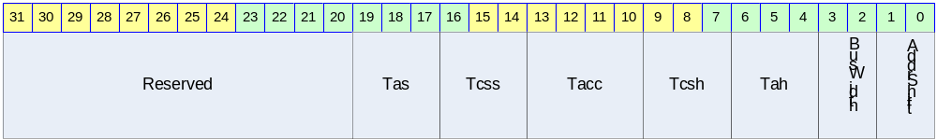

Table 6-19 SMC_BANKx Register (Offset : 0000 0000h~0000 000ch)
Bits | Name | R/W | Description | Init. value
[19:17] | Tacs | R/W | Address set-up time before csb  000 = 0clock 001 = 1clock  010 = 2clock 011 = 3clock  100 = 4clock 101 = 5clock  110 = 6clock 111 = 7clock
[16:14] | Tcos | R/W | Chip selection set-up time before oeb, web  000 = 0clock 001 = 1clock  010 = 2clock 011 = 3clock  100 = 4clock 101 = 5clock  110 = 6clock 111 = 7clock
[13:10] | Tacc | R/W | Access cycle  0000=1clock 0001=2clock  0010=3clock 0011=4clock  0100=5clock 0101=6clock  0110=7clock 0111=8clock  1000=9clock 1001=10clock  1010=11clock 1011=12clock  1100=13clock 1101=14clock  1110=15clock 1111=16clock
[9:7] | Tcoh | R/W | Chip selection hold time after oeb, web  000 = 0clock 001 = 1clock  010 = 2clock 011 = 3clock  100 = 4clock 101 = 5clock  110 = 6clock 111 = 7clock
[6:4] | Tcah | R/W | Address hold time after csb  000 = 0clock 001 = 1clock  010 = 2clock 011 = 3clock  100 = 4clock 101 = 5clock  110 = 6clock 111 = 7clock
[3 : 2] | BusWidth | R/W | SRAM Bus Width  00=8bit 01=16bit 10=32 bit 11= reserved
[1 : 0] | AddrShift | R/W | Address shift by right  00=0bit 01=1bit 10=2bit 11= reserved

DDR-SDRAM Scheduler

Overview

Feature

- Support Maximum 16 Wrap/Increment Burst.
- Support Up to 4 Physical Memory Banks
- Up to 4 Simultaneous Open Banks
- Self-Refresh, DDR SDRAM Power Save Feature
- Programmable Timing latencies and refresh rates.
- Support Up to 128MBytes DDR SDRAM.
- Support 16 Bit DDR SDRAM Interface.
- Configurable Data FIFO Depth.
- Maximum 80% Data Bandwidth
  - Maximum 425MBytes/Sec, if Full Bandwidth is 532MBytes/Sec at 133MHz Memory Clock and 32Bit Memory Width
  - Condition is Consecutive Incremental Read Burst 8
  - If Random Read or Write Applied then Data Bandwidth is Maximum 60%

Block Diagram

Figure 7-22 AXI Interface DDR SDRAM Controller Top Block Diagram
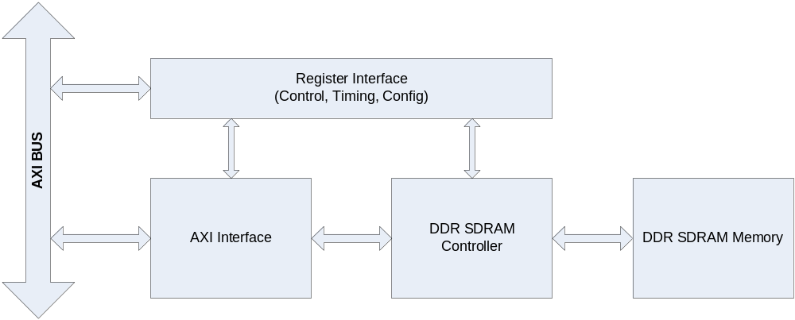

Operation

AXI Interface DDR SDRAM Controller는 3개의 Block으로 나눌 수 있다.
DDR SDRAM의 Configuration, Timing 및 Control에 필요한 Register 인터페이스 블록과 AXI BUS 인터페이스 블록 및 실제 Memory의 Timing에 맞게 Read나 Write할 Data, Address 및 Command를 생성하는 블록이다.

AXI BUS Interface Block

AMBA3 AXI BUS는 Write Command Channel, Write Data Channel, Write Response Channel, Read Command Channel, Read Data Channel 등의 5 채널로 나눌 수 있다.
DDR SDRAM 메모리는 Read나 Write를 동시에 처리할 수 없으므로 이 블록에서 Read와 Write에 대한 Command를 Arbitration 해야 한다.

Write Control FSM
Memory Controller에 보낼 Write Command와 Address, Data 및 부가 정보를 Control하는 메인 Finite State Machine이다.

Read Control FSM
Memory Controller에 보낼 Read Command와 Address 및 부가 정보를 Control하는 메인 Finite State Machine이다.

Address/Control Mux
Read/Write 각 FSM에 의해 생성된 Command, Address 및 부가 정보를 Multiplexing하여 DDR SDRAM Memory Controller에 전달하는 역할을 한다.

Write Data Control
Write Control FSM과 DDR SDRAM Memory Controller에서 생성된 Memory Write Data Valid에 의해 Write Buffer의 Data Management를 담당한다.

Write Buffer

FIFO 구조이고 Configuration 가능하다.

Read Data Control
DDR SDRAM Memory Controller에서 생성된 Memory Read Data Valid에 의해 Read Buffer의 Data Management를 담당한다.

Read Buffer

FIFO 구조이고 Configuration 가능하다.

Wrap, Increment Miss Calculation
DDR SDRAM의 Wrap Burst Mode를 사용하므로 Data의 Increment Burst에서 Data의 Miss의 처리를 담당한다. 즉, DDR SDRAM의 Wrap Burst Boundary를 넘으면, Burst를 Split 시켜준다.

다음 그림은 AXI BUS Interface Block을 나타낸다. AXI Write Channel과 Read Channel을 Arbitration하여 메모리에 전달할 Address와 Control 및 부가정보를 만들고, Data는 FIFO에 저장하여 처리하여 AXI BUS의 Wrap Burst 처리가 가능하며, FIFO Depth를 늘릴 수 있어Latency가 긴 DDR SDRAM 메모리의 효율을 높일 수 있다.

Figure 7-23 DDR SDRAM AXI BUS Interface Block Diagram
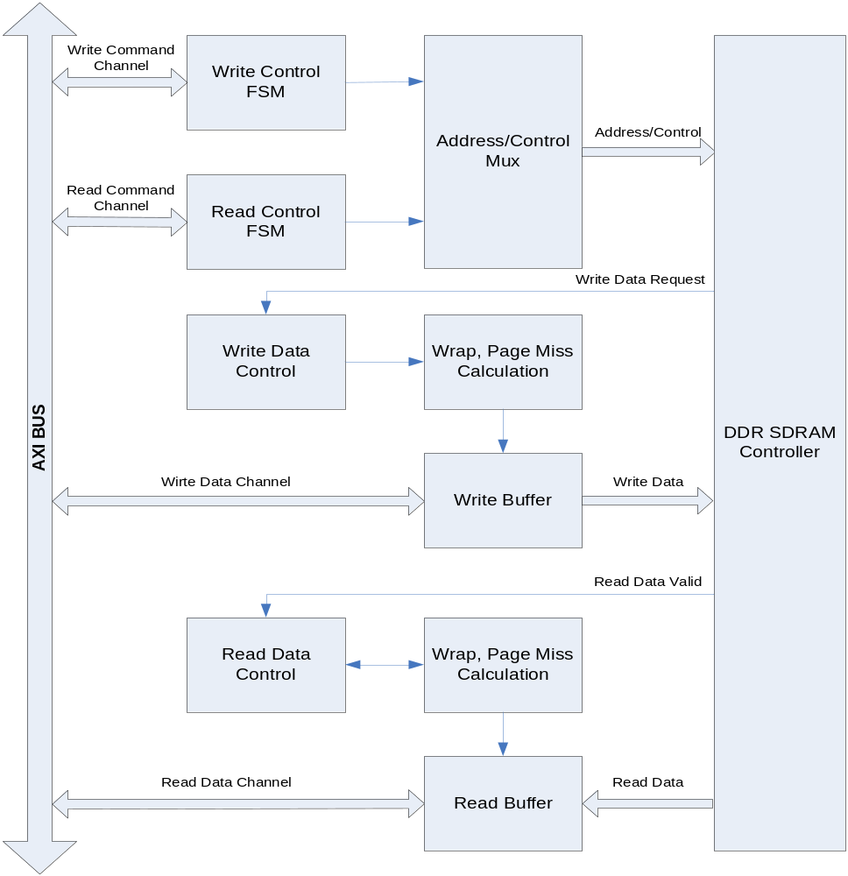

DDR SDRAM Controller Block

Initialize & Refresh & Power Down FSM
DDR SDRAM의 초기화에 필요한 Timing을 생성하고, Refresh Count에 의해 Auto Refresh Command Timing을 만들며, Power Down을 위한 Self Refresh Mode 진입에 필요한 Timing을 만드는 역할을 한다.

Master FSM
DDR SDRAM Controller의 Main State Machine으로써 DDR SDRAM 동작의 Timing을 제어한다.

Bank/Time FSM
DDR SDRAM의 Timing에 맞게 각 Bank의 Row를 Open하는 역할과 Data Read/Write Timing을 생성한다.

RAS Machine
AXI BUS Interface에서 보내온 Row Address를 FSM에서 생성한 적절한 Timing에 내 놓는다.

Cas Machine
AXI BUS Interface에서 보내온 Column Address를 FSM에서 생성한 적절한 Timing에 내 놓는다.

Write Data
AXI BUS Interface에서 보내온 Data를 FSM에서 생성한 적절한 Timing에 내 놓는다.

Read Data
DDR SDRAM Memory에서 보내온 Data를 FSM에서 생성한 적절한 Timing에 AXI BUS Interface에 보낸다.

DDR SDRAM Controller는 다음 그림과 같이 Initialize & Refresh & Power Down FSM, Master FSM, Bank/Time FSM, RAS Machine, Cas Machine, Address/Control Mux. 및 Read/Write Data 부분으로 나눌 수 있다.

Figure 7-24 DDR SDRAM Controller Block Diagram
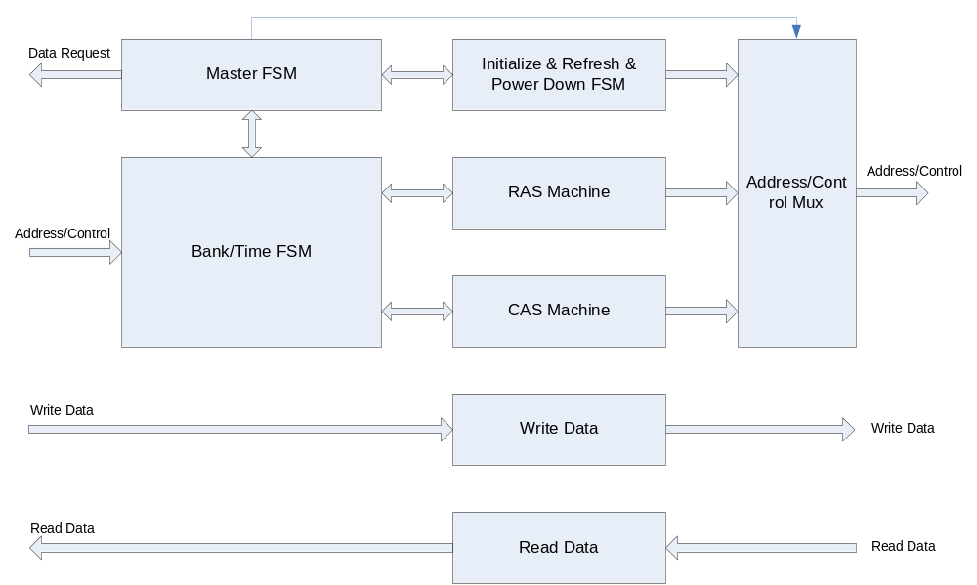

DDR SDRAM Controller Timing Description

그림에서 Row/Bank Open은 생략되어 있고, RAS Buffer가 채워져 있으면 꺼내서 미리 Row와 Bank를 열어 놓는 구조이므로 일단 열린 Row/Bank(Same Row at Different Bank나 Different Row at Same Bank)에서 연속적으로 Read/Write가 가능하다. Row/Bank를 Open하는 시간과 FIFO 상황과 Auto Refresh Time을 고려하면, 80% 이상의 Memory BandWidth가 가능하다.
DDR SDRAM은 Burst 8 Mode와 Read/Write Without Auto Precharge Mode를 사용한다.

다음에서 n=7, 즉 DDR SDRAM의 Burst 8을 사용할 경우의 예제이다.

Read to Read
Same Row at Different Bank or Different Row at Same Bank
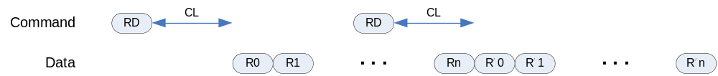

Same Row at Same Bank Read → PreCharge
Ras/Cas Queue Empty Read → PreCharge All Bank
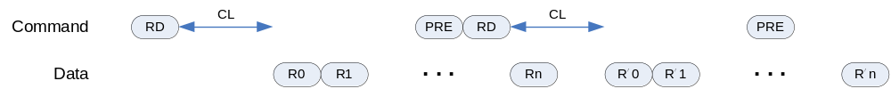

Read to Write
Same Row at Different Bank or Different Row at Same Bank
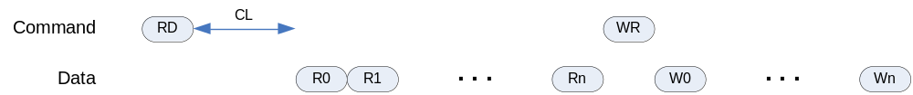
Same Row at Same Bank Read → PreCharge
Ras/Cas Queue Empty Read → PreCharge All Bank

Write to Write
Same Row at Different Bank or Different Row at Same Bank

Same Row at Same Bank Write → PreCharge All Bank after tWR
Ras/Cas Queue Empty Write → PreCharge All Bank after tWR
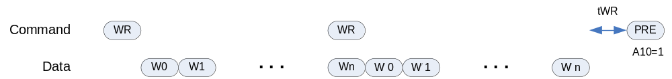

Write to Read
Same Row at Different Bank or Different Row at Same Bank
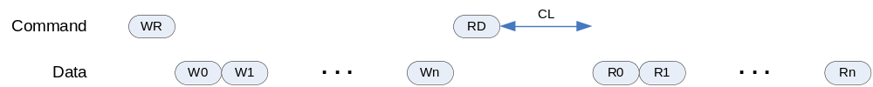

Same Row at Same Bank Write → PreCharge All Bank after tWR
Ras/Cas Queue Empty Write → PreCharge All Bank after tWR
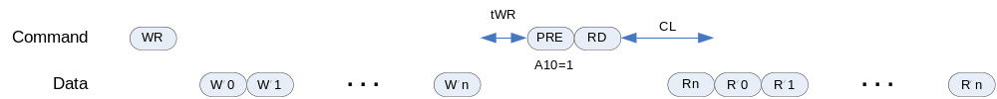

Register Description

DDR SDRAM Registers

Table 7-20 DDR SDRAM Registers
Offset | Name | R/W | Description | Init. value
0000h | DDRTCON | RW | DDR SDRAM Timing Control Register | 0003 B93Ah
0004h | DDRCON | RW | DDR SDRAM Control Register | 0000 0000h
0008h | DDRPCON | RW | DDR SDRAM Power Control Register | 0000 FFFFh
000Ch | DDRREF | RW | DDR SDRAM Refresh Control Register | 0000 0410h
0010h | DDRCFG | RW | DDR SDRAM Configuration Register | 0000 0024h

DDR SDRAM TIMING Control Register

Figure 7-25 DDR SDRAM Timing Control Register Bits
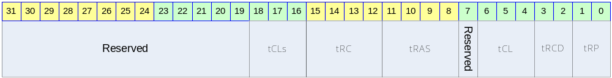

Table 7-21 DDR SDRAM Timing Control Register Description(Offset : 0000 0000h)
Bits | Name | R/W | Description | Init. value
[31:16] |  |  | Reserved | 0
[18:16] | tCLs | RW | Cas Latency For Read State Machine | 3h
[15:12] | tRC | RW | Row Cycel Time | Bh
[11:8] | tRAS | RW | Minimum Row Active Time | 8h
 |  |  | Reserved
[6:4] | tCL | RW | Cas Latency For Read Data | 3h
[3:2] | tRCD | RW | Ras to Cas Delay | 2h
[1:0] | tRP | RW | Precharge Time | 2h

DDR SDRAM Control Register

Figure 7-26 DDR SDRAM Control Register Bits
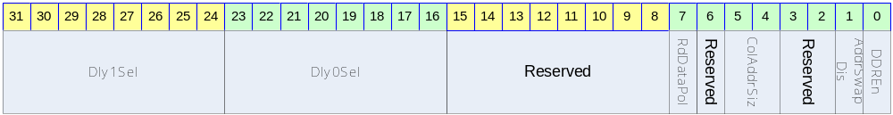

Table 7-22 DDR SDRAM Control Register Description(Offset : 0000 0004h)
Bits | Name | R/W | Description | Init. Value
[31:24] | Dly1Sel | RW | Upper Read Data Latch Delay Select | 0
[23:16] | Dly0Sel | RW | Lower Read Data Latch Delay Select | 0
[15:8] |  |  | Reserved
[7] | RdDataPol | RW | Read Data Latch Polarity  0 : Latch at Rising Edge  0 : Latch at Falling Edge | 0
[6] |  | RW | Reserved | 0
[5:4] | ColAddrSiz | RW | Column Address Size  0 : 8 Bit, 16MB  1 : 9 Bit, 32MB  2 : 10 Bit, 64MB  3 : 11 Bit, 128MB | 0
[3:2] |  |  | Reserved | 0
[1] | AddrSwapDis | RW | Address Swap Disable  0 : Swap : RA-BA-CA  1 : Normal : BA-RA-CA | 0
[0] | DDREn | RW | DDR SDRAM Enable  0 : Disable  1 : Enable | 0

DDR SDRAM Power Control Register

Figure 7-27 DDR SDRAM Power Control Register Bits
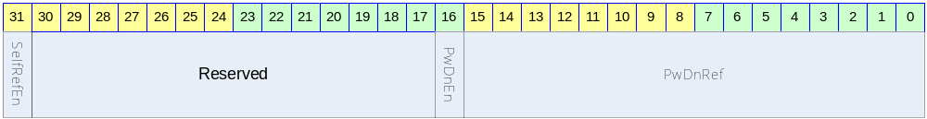

Table 7-23 DDR SDRAM Power Control Register Description(Offset : 0000 0008h)
Bits | Name | R/W | Description | Init. value
[31] | SelfRefEn | RW | DDR SDRAM Self Refresh Enable  0 : Disable  1 : Enable | 0
[30:17] |  |  | Reserved | 0
[16] | PwDnEn | RW | Auto Power Down Enable  0 : Disable  1 : Enable | 0
[15:0] | PwDnRef | RW | Auto Power Down Count  PwDnEn이 Enable 되었고, Master에서 메모리 요구가 없을 때부터 설정된 값만큼 Down Counting이 시작 되며, 이 Zero 가 되면 자동으로 DDR의 Power Down Mode로 진입한다. | ffffh

DDR SDRAM Refresh Control Register

Figure 7-28 DDR SDRAM Refresh Control Register Bits
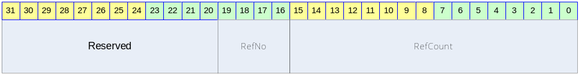

Table 7-24 DDR SDRAM Refresh Control Register Description(Offset : 0000 000Ch)
Bits | Name | R/W | Description | Init. value
[30:20] |  | RW | Reserved | 0
[19:16] | RefNo | RW | Refresh Number  Refresh cycle 마다 수행되는 Refresh 개수 | 0
[15:0] | RefCount | RW | Refresh Count  7.8usec Refresh time  RefNo가 7일 경우에는 2080h 값을 넣어 준다.  즉, 8320 cycle마다 8번의 Refresh를 한꺼번에 한다는 의미이다. | 0410h

DDR SDRAM Configuration Register

Figure 7-29 DDR SDRAM Configuration Register Bits
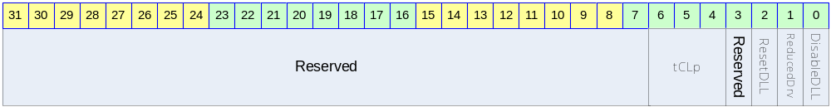

Table 7-25 DDR SDRAM Configuration Register Description(Offset : 0000 0010h)
Bits | Name | R/W | Description | Init. value
[30:7] |  | RW | Reserved | 0
[6:4] | tCLp | W | 2 : DDR SDRAM CL2 설정  6 : DDR SDRAM CL2.5 설정 | 2
[3] |  |  | Reserved
[2] | ResetDLL | W | DDR SDRAM DLL Reset Enable | 1
[1] | ReducedDrv | W | DDR SDRAM Reduced Drive Mode Enable | 0
[0] | DisableDLL | W | DDR SDRAM DLL Disable | 0

Vectored interrupt controller

Overview

ARM Processor는 기본적으로 IRQ와 FIQ, 두 개의 interrupt line을 가지고 있을 뿐이고, 여러 개의 interrupt source에 대한 처리는 Interrupt Controller를 사용하여야 한다. 간단한 Interrupt Controller의 경우 Pending된 Interrupt bit를 나타내는 레지스터만 있어, interrupt handle software에서 해당 bit를 loop을 돌며 어떤 bit가 pending되어 있는지를 찾아야 한다. Pending된 interrupt를 찾는 순서는 software가 결정하고 그 순서에 따라서 interrupt source에 대한 priority가 달라지게 된다. 하지만 이렇게 software가 loop을 돌며 interrupt를 arbitration하는 것은 상당한 시간이 걸리는 일로, 이로 인해 interrupt latency가 증가하여 real time system의 제약 조건이 될 수 있다.
Vectored Interrupt Controller(이하 VIC)는 여러 개의 interrupt source에 대한 arbitration을 하드웨어로 처리하는 구조를 가지고 있어, software가 별도로 priority에 따른 arbitration을 수행할 필요가 없어 interrupt handle software의 overhead를 줄여준다.

Features

- 32 interrupt source
- Interrupt arbitration logic
  - Fixed priority arbitration mode
  - Round-robin arbitration mode
- Interrupt vector table offset address generation
- Each interrupt source can be mapped to either IRQ or FIQ
- Programmable Level/edge triggered mode for each interrupt source
- Programmable polarity for each interrupt source

Block diagram

전체적인 하드웨어 구성은 다음 그림과 같다.

Figure 8-30 VIC Block Diagram
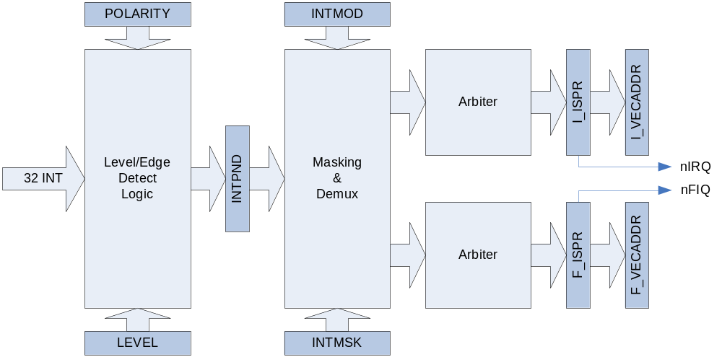

총 32개의 interrupt line을 가지고 있다. 32개의 interrupt line은 Level/Edge detect logic을 지나 INTPND 레지스터에 저장된다. 그 이후 INTMSK 레지스터에 의해 masking되고 INTMOD에 따라서 FIQ와 IRQ를 demux하여 각각 별도의 arbiter을 통해 하나의 interrupt가 선택되어 최종적으로 I_ISPR/F_ISPR 레지스터에 저장되고 I_VECADDR/F_VECADDR에 address가 저장된다.
Arbiter block은 FIQ/IRQ 마다 하나씩 존재하고 다음과 같은 구조를 가지고 있다.

Figure 8-31 Arbiter Block Diagram
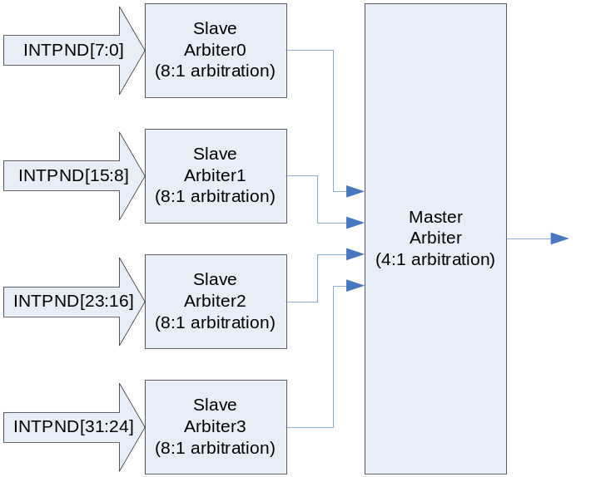

전체 32개의 pending interrupt source를 8개씩 묶어 4개의 slave arbiter를 통과하여 8개 중에 가장 높은 priority를 가지는 interrupt를 선택한 다음, 선택된 4개의 interrupt를 master arbiter가 selection을 하도록 되어 있다.

Interrupt Connection

Interrupt 연결은 다음과 같다.

Table 8-26 Interrupt Connection
Interrupt Line | Device | Level/Edge
0 | DMA Channel 0 | Active High Level
1 | DMA Channel 1 | Active High Level
2 | DMA Channel 2 | Active High Level
3 | DMA Channel 3 | Active High Level
4 | DMA Channel 4 | Active High Level
5 | DMA Channel 5 | Active High Level
6 | DMA Channel 6 | Active High Level
7 | DMA Channel 7 | Active High Level
8 | UART Channel 0 | Active Low Level
9 | Reserved
10 | UART Channel 1 | Active Low Level
11 | Reserved
12 | Timer Channel 0 | Active High Edge
13 | Timer Channel 1 | Active High Edge
14 | Timer Channel 2 | Active High Edge
15 | Timer Channel 3 | Active High Edge
16 | Watch Dog Timer | Active High Edge
17 | Reserved
18 | Reserved
19 | Reserved
20 | I2C Controller | Active High Level
21 | I2S Controller | Active High Level
22 | Reserved
23 | GPIO0 | Active High Level
24 | GPIO1 | Active High Level
25 | Reserved
26 | SPI Channel0 | Active High Level
27 | SPI Channel1 | Active High Level
28 | NOT ASSIGNED
29 | NOT ASSIGNED
30 | NOT ASSIGNED
31 | NOT ASSIGNED

위의 Interrupt Connection은 별도의 공지 없이 변경될 수 있음을 유의하라.

Operation

Register와 Interrupt Source

모든 설명에 앞서 다음의 레지스터의 bit는 해당 interrupt source에 영향을 주게 된다.
INTPND/INTMOD/INTMSK/LEVEL/I_ISPR/I_ISPC/F_ISPR/F_ISPC/POLARITY 등의 레지스터는 모두 32bit 레지스터로 각 bit는 32개의 interrupt source에 1:1 대응한다. 즉, INTPND[3]는 interrupt source 3번이 pending 되어 있음을 나타낸다.
위의 Block diagram에서 보았듯이 VIC 내부는 일정부분 IRQ쪽 path와 FIQ쪽 path가 분리되어 있고, 독립적으로 동작하게 된다. 레지스터 중에 “I_”라는 접두어로 시작되는 레지스터는 IRQ쪽에 해당하고 “F_”라는 접두어로 시작되는 레지스터는 FIQ쪽에 해당한다.

Level/Edge detect logic

Level/Edge detect logic은 LEVEL 레지스터와 POLARITY 레지스터에 의해 영향을 받는다. LEVEL 레지스터는 interrupt source가 level trigger인지 edge trigger인지 선택하는 레지스터이다. POLARITY 레지스터는 interrupt source가 active high인지 active low인지 선택하는 레지스터이다.
Level/Edge detect logic은 32개의 interrupt source signal을 모니터링하며 LEVEL/POLARITY 레지스터에 의해서 선택된 형태의 signal이 들어오면 INTPND 레지스터에 해당 bit를 1로 set한다.

Masking & Demux logic

Level/Edge Detect logic의 출력인 INTPND 레지스터는 masking되지 않은 interrupt 상태를 알려준다. Masking logic은 단순히 INTMSK 레지스터를 이용하여 INTPND 레지스터의 값을 masking하여 나머지 logic에 전달하는 일을 수행한다.
Demux logic은 masking된 interrupt를 INTMOD 레지스터 세팅에 따라 IRQ쪽 path와 FIQ쪽 path로 분리하여 전달하는 일을 수행한다.

Arbiter

이미 알아본 대로 Arbiter는 IRQ/FIQ path 각각 하나씩 존재한다. 단일 arbiter는 8개의 interrupt 입력을 받는 slave arbiter 4개와 slave arbiter의 결과를 arbitration하는 master arbiter 하나로 구성된다. Master arbiter, 4개의 slave arbiter 각각은 round robin mode혹은 fixed priority mode로 동작할 수 있다.
Fixed priority mode에서는 각 interrupt line의 priority가 결정되어 있고 그 priority가 변하지 않은 상태에서 arbitration이 일어나게 된다. Slave arbiter 각각에 대해서 8개의 interrupt line의 priority는 PSLV 레지스터를 이용하여 programming할 수 있고, master arbiter가 입력 받는 slave arbitration 결과 4 line에 대해서 PMST 레지스터를 통해 priority를 programming할 수 있다.
Master arbiter와 slave arbiter 4개가 cascading으로 연결되어 있으므로 master arbiter에 programming된 slave arbiter 4개의 priority가 각각의 slave arbiter 내부 priority보다 우선시 된다. 예를 들어 slave arbiter0에 연결되어 있는 interrupt line 0의 priority가 slave arbiter1에 연결된 interrupt line 8보다 높다고 하더라도 slave arbiter0의 priority가 slave arbiter1의 priority보다 낮으면 interrupt line 8이 선택된다. 즉 slave arbiter 내부의 priority setting은 다른 slave arbiter와는 아무런 연관 관계를 지니지 않는다.
Round robin mode에서는 매 arbitration마다 priority가 update되고 현재 priority 값은 CSLV/CMST 레지스터를 통해서 읽을 수 있다.

I_ISPR/F_ISPR and I_VECADDR/F_VECADDR

I_ISPR과 F_ISPR은 각각 IRQ/FIQ에 해당하는 interrupt가 detect되고 arbitration된 결과를 나타낸다. INTPND와 달리 masking되어 있어 enable되지 않은 interrupt source는 표시되지 않고, 또한 단 하나의 bit만 1로 세팅된다. 어떤 bit가 1로 세팅 되었는지 체크할 필요는 없고 그 대신 I_VECADDR/F_VECADDR 레지스터의 값을 읽으면 해당 bit가 어떤 bit인지 알 수 있도록 되어 있다.

Programming Model

Enabling VIC

VIC가 ARM processor로 nIRQ/nFIQ 신호를 전달할 수 있도록 하기 위해서는 INTCON 레지스터의 GIE, nENBIRQ, nENBFIQ가 올바른 값으로 세팅 되어야 한다. GIE bit가 1이면 INTPND 레지스터가 clear된 상태를 유지하고 따라서 nIRQ/nFIQ도 high인 상태를 유지한다. nENBIRQ bit가 1이면 nIRQ가 high로 유지되고 nENBFIQ bit가 1이면 nFIQ signal이 high로 유지되어 ARM processor의 IRQ/FIQ exception이 발생하지 않는다. GIE, nENBIRQ, nENBFIQ가 모두 0으로 세팅 되더라도 각 interrupt source를 enable시키기 전에는 해당 interrupt가 발생하지 않는다. 각 interrupt source를 enable 시키는 방법은 아래에 별도의 section을 참조하라.
Priority based arbiter의 동작을 변경하는 것은 VIC를 enable하고 수행해도 되지만, enable시키기 전에 수행하는 것을 권장한다.
참고로 VIC가 enable되어 있고 nIRQ/nFIQ 신호가 low로 떨어져 있다고 하더라도 ARM processor의 CPSR 레지스터의 세팅이 IRQ/FIQ disable mode라면 IRQ/FIQ exception이 발생되지 않음을 유념하라.

Disabling VIC

VIC를 disable시키기 위해서는 INTCON레지스터의 GIE, nENBIRQ, nENBFIQ를 모두 1로 세팅하면 된다. VIC를 다시 enable시키는 경우를 대비하여 INTMSK 레지스터의 모든 bit를 1로 write해 두는 것을 권장한다.

Enabling Each Interrupt Source(Unmasking Interrupt)

각 interrupt source를 enable 시키기 위해서는 우선 해당 interrupt source에서 발생시키는 interrupt signal이 level trigger인지 edge trigger인지, active high 인지 low인지를 알아야 한다. 그 값에 따라서 LEVEL 레지스터와 POLARITY 레지스터의 해당 bit를 알맞게 programming해 준다. 또한 그 interrupt source를 nIRQ에 연결할지 아니면 nFIQ에 연결할지 결정하여 INTMOD 레지스터의 해당 bit를 세팅을 해 준다. 그런 다음 INTMSK 레지스터의 해당 bit를 0으로 clear해 주면 된다.
모든 interrupt가 on chip device에서 발생되면 모든 interrupt signal의 level/edge 특성 및 active high/low 특성을 알고 있으므로 VIC를 enable시킬 때 LEVEL 레지스터와 POLARITY 레지스터를 미리 setting할 수도 있다.

Disabling Each Interrupt Source(Masking Interrupt)

각 interrupt source를 disable시키기 위해서는 INTMSK의 해당 bit를 1로 세팅하기만 하면 된다.

Acknowledge Interrupt

IRQ나 FIQ가 발생하면 handler software는 VIC의 INTPND의 해당 bit를 clear해 줄 필요가 있다. Edge trigger mode interrupt는 INTPND의 해당 bit가 clear되지 않으면 VIC hardware는 해당 interrupt가 처리된 것인지 알 수 없기 때문이다. 이것을 수행하는 방법은 간단하다. I_ISPC/F_ISPC 레지스터에 I_ISPR/F_ISPR 레지스터의 값을 읽어서 쓰면 된다. I_ISPR/F_ISPR 레지스터는 단 하나의 bit만 1인데, I_ISPC/F_ISPC에 값을 쓰면 INTPND 레지스터의 해당 bit가 clear된다.
Level trigger mode interrupt의 경우는 INTPND의 해당 bit를 clear하더라도 device에서 계속 interrupt signal을 high나 low로 보내고 있으므로 acknowledge를 하는 것이 의미가 없다. 따라서 acknowledge를 하지 말아야 하고, 해당 device의 interrupt handler에서 device가 더 이상 interrupt signal을 보내지 않도록 하는 것으로 대신할 수 있다.

I_ISPR/F_ISPR, I_VECADDR/F_VECADDR 레지스터 접근

Arbiter가 들어온 interrupt source중에 priority가 가장 높은 것을 선정하고, 그것을 I_ISPR/F_ISPR 레지스터에 write하게 되면, I_ISPR/F_ISPR의 값은 새로운 arbitration이 이루어지기 전까지는 변경되지 않는다. 새로운 arbitration이 이루어지는 때는 I_ISPR 혹은 F_ISPR 레지스터의 값과 INTPND 레지스터, INTMSK 레지스터를 bit-wise AND하여 0이 되는 경우이다.
이렇게 될 때는 사용자가 I_ISPC/F_ISPC에 I_ISPR/F_ISPR의 값을 write하여 INTPND의 해당 bit를 clear하는 경우 혹은 해당 interrupt source를 masking하는 경우, 그리고 해당 interrupt source가 level trigger interrupt signal을 assert하고 있다가 deassert하는 경우이다. 즉 acknowledge를 하거나 아니면 masking을 할 때 새로운 arbitration이 발생하게 된다.
이렇게 새로운 arbitration이 발생하면 I_ISPR/F_ISPR의 값이 update되므로 읽으면 새로운 interrupt source에 해당하는 값이 나오게 된다. I_VECADDR/F_VECADDR 레지스터의 경우도 마찬가지이다. 따라서 I_ISPR/F_ISPR 또는 I_VECADDR/F_VECADDR 레지스터의 값이 추후에 필요하면 새로운 arbitration이 일어나기 전에 읽어 둔 값을 저장하였다가 사용하여야 한다.

Interrupt Handler Example

IRQ에 해당하는 Interrupt Handler를 다음과 같이 작성할 수 있다.

void AckIRQ(int irq)
{
if(edge triggered) // DO NOT Ack if level triggered
I_ISPC = I_ISPR;
}

void InterruptHandler(void)
{
int irq;
while(1)
{
if(I_ISPR == 0)
break;
irq = I_VECADDR>>2;
// MUST DO AckIRQ before MaskIRQ
AckIRQ(irq); // write I_ISPR to I_ISPC only if edge triggered
MaskIRQ(irq); // write 1 to correspondent bit of INTMSK
// DO NOT read I_ISPR/I_VECADDR any more after AckIRQ or MaskIRQ
Call correspondent irq service routine;
UnmaskIRQ(irq); // write 0 to correspondent bit of INTMSK
}
}

Register Description

Registers

Table 8-27 Registers
Offset | Name | R/W | Description | Init. value
0000h | INTCON | RW | Interrupt Control Register | 0000 000Bh
0004h | INTPND | R | Interrupt Pending Register | 0000 0000h
0008h | INTMOD | RW | Interrupt Mode Register | 0000 0000h
000Ch | INTMSK | RW | Interrupt Mask Register | FFFF FFFFh
0010h | LEVEL | RW | Interrupt Level/Edge Selection Register | 0000 0000h
0014h | I_PSLV0 | RW | IRQ Slave Arbiter0 Priority Register | 00FA C688h
0018h | I_PSLV1 | RW | IRQ Slave Arbiter1 Priority Register | 00FA C688h
001Ch | I_PSLV2 | RW | IRQ Slave Arbiter2 Priority Register | 00FA C688h
0020h | I_PSLV3 | RW | IRQ Slave Arbiter3 Priority Register | 00FA C688h
0024h | I_PMST | RW | IRQ Master Arbiter Priority Register | 0000 1FE4h
0028h | I_CSLV0 | R | Current IRQ Slave Arbiter0 Priority Register | 00FA C688h
002Ch | I_CSLV1 | R | Current IRQ Slave Arbiter1 Priority Register | 00FA C688h
0030h | I_CSLV2 | R | Current IRQ Slave Arbiter2 Priority Register | 00FA C688h
0034h | I_CSLV3 | R | Current IRQ Slave Arbiter3 Priority Register | 00FA C688h
0038h | I_CMST | R | Current IRQ Master Arbiter Priority Register | 0000 1FE4h
003Ch | I_ISPR | R | IRQ Interrupt Service Pending Register | 0000 0000h
0040h | I_ISPC | W | IRQ Interrupt Service Clear Register | N/A
0044h | F_PSLV0 | RW | FIQ Slave Arbiter0 Priority Register | 00FA C688h
0048h | F_PSLV1 | RW | FIQ Slave Arbiter1 Priority Register | 00FA C688h
004Ch | F_PSLV2 | RW | FIQ Slave Arbiter2 Priority Register | 00FA C688h
0050h | F_PSLV3 | RW | FIQ Slave Arbiter3 Priority Register | 00FA C688h
0054h | F_PMST | RW | FIQ Master Arbiter Priority Register | 0000 1FE4h
0058h | F_CSLV0 | R | Current FIQ Slave Arbiter0 Priority Register | 00FA C688h
005Ch | F_CSLV1 | R | Current FIQ Slave Arbiter1 Priority Register | 00FA C688h
0060h | F_CSLV2 | R | Current FIQ Slave Arbiter2 Priority Register | 00FA C688h
0064h | F_CSLV3 | R | Current FIQ Slave Arbiter3 Priority Register | 00FA C688h
0068h | F_CMST | R | Current FIQ Master Arbiter Priority Register | 0000 1FE4h
006Ch | F_ISPR | R | FIQ Interrupt Service Pending Register | 0000 0000h
0070h | F_ISPC | W | FIQ Interrupt Service Clear Register | N/A
0074h | POLARITY | RW | Interrupt Polarity Register | 0000 0000h
0078h | I_VECADDR | R | IRQ Vector Address Register | 0000 0000h
007Ch | F_VECADDR | R | FIQ Vector Address Register | 0000 0000h

INTCON Register

INTCON 레지스터는 VIC의 전체 동작을 enable/disable 시키기 위한 레지스터이다.

Figure 8-32 INTCON Register
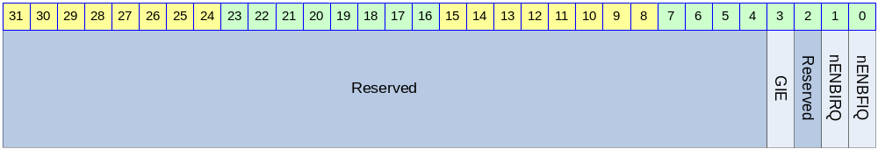

Table 8-28 INTCON Register Description(Offset : 0000h)
Bits | Name | R/W | Description | Init. value
[3] | GIE | RW | Global Interrupt Enable  0 : VIC Enable  1 : VIC Disable | 1b
[1] | nENBIRQ | RW | nIRQ Enable  0 : nIRQ generation enable  1 : nIRQ generation disable | 1b
[0] | nENBFIQ | RW | nFIQ Enable  0 : nFIQ generation enable  1 : nFIQ generation disable | 1b

VIC를 enable 시키기 위해서는 GIE bit를 ‘0’으로 세팅해야 한다. GIE bit가 ‘1’이면 INTPND가 0으로 clear되고 더 이상 interrupt가 발생하지 않게 된다. nIRQ/nFIQ에 대해서 각각 별도의 enable bit인 nENBIRQ, nENBFIQ가 있다.

INTPND Register

INTPND 레지스터는 Read Only 레지스터로 현재 Pending되어 있는 Interrupt 상황을 알 수 있다. INTPND는 masking이 이루어지기 전의 결과로, read하여 사용하는 것을 권장하지 않는다. Pending된 interrupt를 확인 하기 위해서는 I_ISPR/F_ISPR 혹은 I_VECADDR/F_VECADDR 레지스터를 읽는 것을 권장한다.
I_ISPC/F_ISPC에 값을 write하여 INTPND의 특정 bit를 clear할 수 있다.

Figure 8-33 INTPND Register
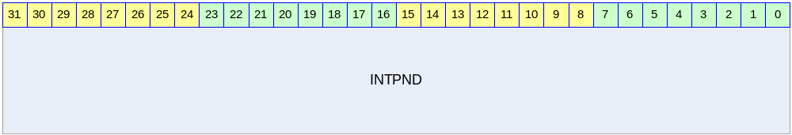

Table 8-29 INTPND Register Description(Offset : 0004h)
Bits | Name | R/W | Description | Init. value
[31:0] | INTPND | R | Interrupt Pending Status  0 : no interrupt pended  1 : interrupt pended  각 bit는 각 interrupt source에 대응한다. | 0000 0000h

INTMOD Register

INTMOD 레지스터는 각 interrupt source를 nIRQ에 연결할지 nFIQ에 연결할지를 나타내는 레지스터이다.

Figure 8-34 INTMOD Register
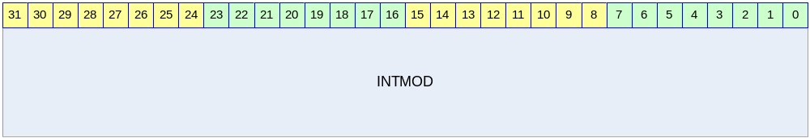

Table 8-30 INTMOD Register Description(Offset : 0008h)
Bits | Name | R/W | Description | Init. Value
[31:0] | INTMOD | RW | Interrupt Mode Register  0 : Interrupt를 nIRQ로 연결  1 : Interrupt를 nFIQ로 연결  각 bit는 각 interrupt source에 대응한다. | 0000 0000h

INTMSK Register

INTMSK 레지스터는 각 Interrupt를 masking하기 위해서 사용한다.

Figure 8-35 INTMSK Register
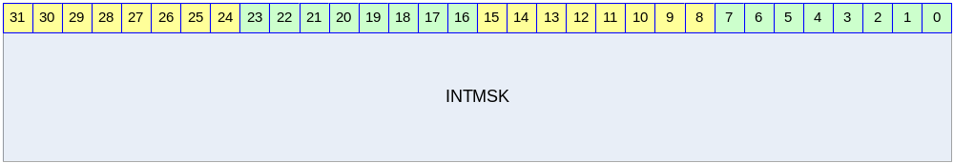

Table 8-31 INTMSK Register Description(Offset : 000Ch)
Bits | Name | R/W | Description | Init. Value
[31:0] | INTMSK | RW | Interrupt Mask Register  0 : Interrupt Unmasked(enabled)  1 : Interrupt Masked  각 bit는 각 interrupt source에 대응한다. | FFFF FFFFh

LEVEL Register

LEVEL 레지스터는 각 interrupt source가 level trigger interrupt signal을 사용하는지 아니면 edge trigger interrupt signal을 사용하는지 결정한다.

Figure 8-36 LEVEL Register
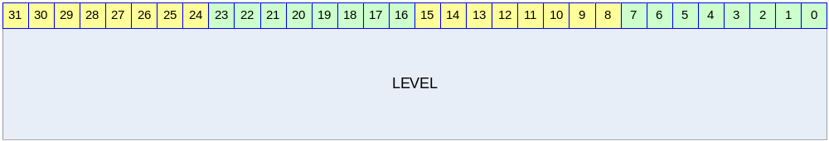

Table 8-32 LEVEL Register Description(Offset : 0010h)
Bits | Name | R/W | Description | Init. Value
[31:0] | LEVEL | RW | Interrupt Level Register  0 : Interrupt signal is edge triggered  1 : Interrupt signal is level triggered  각 bit는 각 interrupt source에 대응한다. | 0000 0000h

POLARITY Register

POLARITY 레지스터는 Interrupt signal의 polarity를 설정하는 레지스터이다.

Figure 8-37 POLARITY Register
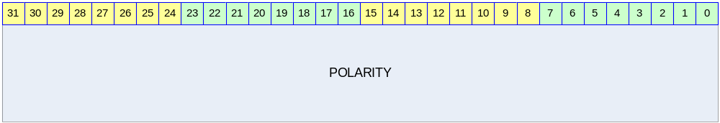

Table 8-33 POLARITY Register Description(Offset : 0074h)
Bits | Name | R/W | Description | Init. Value
[31:0] | POLARITY | RW | Interrupt Polarity Register  0 : Interrupt signal is active high  1 : Interrupt signal is active low  각 bit는 각 interrupt source에 대응한다. | 0000 0000h

PSLV Register

PSLV 레지스터는 Slave Arbiter에 대한 priority setting을 위한 레지스터이다. IRQ path에 총 4개의 slave arbiter가 있으므로, I_PSLV0, I_PSLV1, I_PSLV2, I_PSLV3 레지스터가 존재하고, FIQ쪽도 F_PSLV0, F_PSLV1, F_PSLV2, F_PSLV3 레지스터가 존재한다.

Figure 8-38 PSLV Register
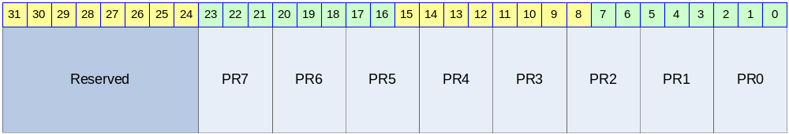

Table 8-34 PSLV Register Description
Bits | Name | R/W | Description | Init. Value
[23:21] | PR7 | RW | Interrupt Priority for Interrupt Source 7 | 111b
[20:18] | PR6 | RW | Interrupt Priority for Interrupt Source 6 | 110b
[17:15] | PR5 | RW | Interrupt Priority for Interrupt Source 5 | 101b
[14:12] | PR4 | RW | Interrupt Priority for Interrupt Source 4 | 100b
[11:9] | PR3 | RW | Interrupt Priority for Interrupt Source 3 | 011b
[8:6] | PR2 | RW | Interrupt Priority for Interrupt Source 2 | 010b
[5:3] | PR1 | RW | Interrupt Priority for Interrupt Source 1 | 001b
[2:0] | PR0 | RW | Interrupt Priority for Interrupt Source 0  여기서 Interrupt Source 0의 의미는 I_PSLV0/F_PSLV0는 Interrupt Source 0가 32개의 interrupt source중 0번을 의미하고, I_PSLV1/F_PSLV1은 interrupt source 8번, I_PSLV2/F_PSLV2는 interrupt source 16번, I_PSLV3/F_PSLV3은 interrupt source 24번을 의미한다.  Priority Setting은 가장 높은 priority는 000b이고 111b가 가장 낮은 priority를 의미한다. | 000b

PR0에서 PR7까지 8개의 priority는 모두 다른 값으로 세팅되어야 한다. 그렇지 않으면 VIC가 오동작을 하게 된다.

PMST Register

PMST 레지스터는 Master arbiter에 대한 priority를 세팅하고 arbitration mode를 바꾸기 위한 레지스터이다. IRQ/FIQ에 대해 레지스터가 각각 존재하고 I_PMST/F_PMST이다.

Figure 8-39 PMST Register
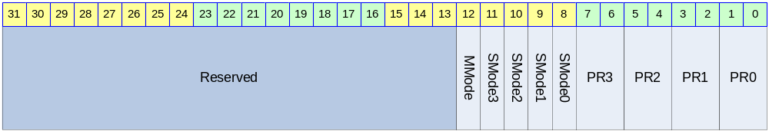

Table 8-35 PMST Register Description
Bits | Name | R/W | Description | Init. Value
[12] | MMode | RW | Master Arbiter Mode  0 : Round robin arbitration  1 : Fixed priority arbitration | 1b
[11] | SMode3 | RW | Slave Arbiter 3 Mode  0 : Round robin arbitration  1 : Fixed priority arbitration | 1b
[10] | SMode2 | RW | Slave Arbiter 2 Mode  0 : Round robin arbitration  1 : Fixed priority arbitration | 1b
[9] | SMode1 | RW | Slave Arbiter 1 Mode  0 : Round robin arbitration  1 : Fixed priority arbitration | 1b
[8] | SMode0 | RW | Slave Arbiter 0 Mode  0 : Round robin arbitration  1 : Fixed priority arbitration | 1b
[7:6] | PR3 | RW | Priority for Slave Arbitration Result 3 | 11b
[5:4] | PR2 | RW | Priority for Slave Arbitration Result 2 | 10b
[3:2] | PR1 | RW | Priority for Slave Arbitration Result 1 | 01b
[1:0] | PR0 | RW | Priority for Slave Arbitration Result 0  Master Arbiter는 4개의 Slave Arbiter의 결과에 대한 arbitration을 수행하는데 각 Slave Arbiter의 결과에 대해 priority를 setting할 수 있다.  Priority Setting은 가장 높은 priority는 00b이고 11b가 가장 낮은 priority를 의미한다. | 00b

PR0에서 PR3까지 4개의 priority는 모두 다른 값으로 세팅되어야 한다. 그렇지 않으면 VIC가 오동작을 하게 된다.

CSLV Register

CSLV 레지스터는 Slave Arbiter에 대한 priority가 어떻게 변하는지 볼 수 있는 Read Only 레지스터이다. Arbitration mode가 round robin인 경우 arbitration마다 priority가 변하게 되는데, 이것을 monitoring할 수 있는 레지스터이다. Fixed priority arbitration을 선택한 경우 CSLV의 값은 PSLV와 같은 값으로 변하지 않게 된다. 또한 PSLV 레지스터에 값을 쓰게 되면 CSLV는 해당하는 값으로 자동으로 update된다.
IRQ path에 총 4개의 slave arbiter가 있으므로, I_CSLV0, I_CSLV1, I_CSLV2, I_CSLV3 레지스터가 존재하고, FIQ쪽도 F_CSLV0, F_CSLV1, F_CSLV2, F_CSLV3 레지스터가 존재한다.

Figure 8-40 CSLV Register

Table 8-36 CSLV Register Description
Bits | Name | R/W | Description | Init. Value
[23:21] | PR7 | R | Interrupt Priority for Interrupt Source 7 | 111b
[20:18] | PR6 | R | Interrupt Priority for Interrupt Source 6 | 110b
[17:15] | PR5 | R | Interrupt Priority for Interrupt Source 5 | 101b
[14:12] | PR4 | R | Interrupt Priority for Interrupt Source 4 | 100b
[11:9] | PR3 | R | Interrupt Priority for Interrupt Source 3 | 011b
[8:6] | PR2 | R | Interrupt Priority for Interrupt Source 2 | 010b
[5:3] | PR1 | R | Interrupt Priority for Interrupt Source 1 | 001b
[2:0] | PR0 | R | Interrupt Priority for Interrupt Source 0  여기서 Interrupt Source 0의 의미는 I_PSLV0/F_PSLV0는 Interrupt Source 0가 32개의 interrupt source중 0번을 의미하고, I_PSLV1/F_PSLV1은 interrupt source 8번, I_PSLV2/F_PSLV2는 interrupt source 16번, I_PSLV3/F_PSLV3은 interrupt source 24번을 의미한다.  Priority Setting은 가장 높은 priority는 000b이고 111b가 가장 낮은 priority를 의미한다. | 000b

CMST Register

Master Arbiter가 round robin mode로 세팅되어 있는 경우에는 매 arbitration마다 priority가 변하게 되어 있는데 그것을 monitoring할 수 있는 Read Only 레지스터이다. IRQ/FIQ에 대해 레지스터가 각각 존재하고 I_CMST/F_CMST이다.

Figure 8-41 CMST Register
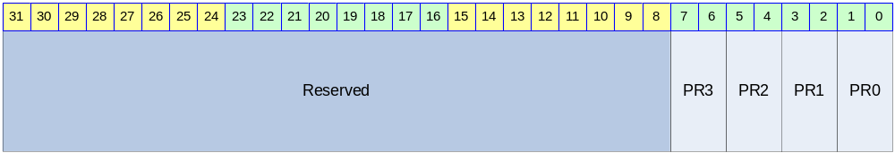

Table 8-37 CMST Register Description
Bits | Name | R/W | Description | Init. Value
[7:6] | PR3 | R | Priority for Slave Arbitration Result 3 | 11b
[5:4] | PR2 | R | Priority for Slave Arbitration Result 2 | 10b
[3:2] | PR1 | R | Priority for Slave Arbitration Result 1 | 01b
[1:0] | PR0 | R | Priority for Slave Arbitration Result 0  Master Arbiter는 4개의 Slave Arbiter의 결과에 대한 arbitration을 수행하는데 각 Slave Arbiter의 결과에 대해 priority를 setting할 수 있다.  Priority Setting은 가장 높은 priority는 00b이고 11b가 가장 낮은 priority를 의미한다. | 00b

ISPR Register

ISPR 레지스터는 arbitration 결과 선택된 interrupt source bit를 알 수 있는 Read Only 레지스터이다. 현재 pending되어 있는 interrupt 중에 priority가 가장 높은 interrupt가 선택되어 한 bit만 set되게 된다. 하지만 이 레지스터를 이용하여 interrupt source 번호를 찾을 필요는 없고 interrupt를 acknowledge하기 위해서 사용된다. IRQ/FIQ 각각에 대해서 I_ISPR/F_ISPR이 존재한다.

Figure 8-42 ISPR Register
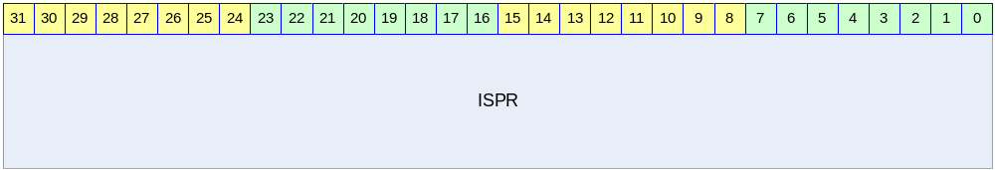

Table 8-38 ISPR Register Description
Bits | Name | R/W | Description | Init. Value
[31:0] | ISPR | R | Interrupt Service Pending Register  0 : Interrupt is not pended  1 : Interrupt is pended  각 bit는 각 interrupt source에 대응하고 단 하나의 bit만 set된다. | 0000 0000h

ISPC Register

ISPC 레지스터는 pending된 interrupt를 clear하기 위해서 사용하는 Write Only 레지스터이다. ISPC에 값을 쓰면 1 값을 가지는 bit 위치마다 INTPND 레지스터가 clear된다. 현재 service할 interrupt source에 acknowledge를 하기 위해서 사용하고 ISPR 레지스터의 값을 ISPC에 write하는 것이 보통이다. 현재 pending된 interrupt가 INTPND에서 clear되면 새로운 arbitration이 시작된다. IRQ/FIQ 각각 I_ISPC/F_ISPC 레지스터로 존재한다.

Figure 8-43 ISPC Register
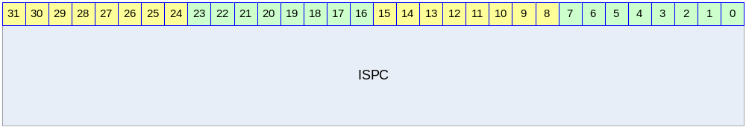

Table 8-39 ISPC Register Description
Bits | Name | R/W | Description | Init. Value
[31:0] | ISPC | W | Interrupt Service Pending Clear Register  Write 0 : No meaning  Write 1 : correspondent bit of INTPND cleared  각 bit는 각 interrupt source에 대응한다. | N/A

VECADDR Register

VECADDR 레지스터는 현재 arbitration된 결과 pending된 interrupt의 vector address를 찾기 위한 Read Only 레지스터이다. ISPR에 한 bit가 set되어도 software가 해당 bit를 찾기 위해서는 loop을 돌거나 많은 instruction을 수행해야 한다. – 참고로 ARM의 clz(counting leading zero)와 같은 instruction을 수행하면 쉽게 할 수 있기는 하다. Software는 ISPR 레지스터를 읽어서 현재 pending된 interrupt의 번호를 체크할 필요가 없이 VECADDR 레지스터를 읽어서 interrupt의 번호를 알 수 있다. 또한 interrupt service routine table address에 VECADDR에서 읽은 값을 더하기만 하더라도 해당 interrupt service routine을 찾아낼 수 있다.
IRQ/FIQ 각각 I_VECADDR/F_VECADDR 레지스터로 존재한다. 단, ISPR의 값이 0이면 VECADDR에서 읽은 값은 의미가 없음을 유의하라.

Figure 8-44 VECADDR Register
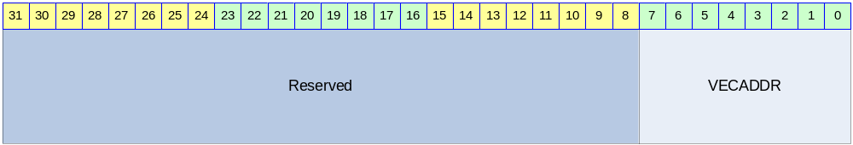

Table 8-40 VECADDR Register Description
Bits | Name | R/W | Description | Init. Value
[7:0] | VECADDR | R | Pending Interrupt Vector Address  Interrupt Source 0이 Pending이면 0x00,  Interrupt Source 1이 Pending이면 0x04,  Interrupt Source 2이 Pending이면 0x08,  Interrupt Source 3이 Pending이면 0x0C,  …  Interrupt Source 31이 Pending이면 0x7C의 값을 가진다. | 00h

Enhanced-DMA

Overview

DMA(Direct Memory Access) Controller는 기본적으로 Memory와 onchip Peripheral사이의 data 전송을 관장한다. Onchip peripheral은 data를 load할 필요가 있거나 store해야할 필요가 있는 경우에 DMA Controller에 request를 생성하고 DMA Controller는 해당 request를 받으면 memory와 peripheral사이의 data 전송을 service하게 된다. 설계된 DMA Controller는 총 8개의 channel이 존재하고, 4개의 Channel을 가지는 DMA Engine이 두 개 들어 있는 구조를 가지고 있어 2개의 독립적인 data 전송이 가능하다.

Features

- 8 Channel Support
  - 2 x 4 Channel DMA Engine
  - 2 independent data transfer at a time
- Round-robin arbitration
- Source BUS width : BYTE/HWORD/WORD support
- Destination BUS width : BYTE/HWORD/WORD support
- Byte 단위의 transfer count
- Automatic Pack/Unpack
- Unaligned address support
  - 단, Destination address가 unaligned인 경우에는 ByteEnable신호를 받을 수 있는 Slave이어야 한다.
- Descriptor를 이용한 Linked list scatter/gather DMA support
- Memory-to-Memory copy support
- Programmable data-burst size(1/2/4/8/16/32 byte)
- Up to (1M -1) bytes of data transfer per descriptor
- Only little endian support

Block diagram

전체적인 하드웨어 구성은 다음 그림과 같다.

Figure 9-45 DMA Controller Block Diagram
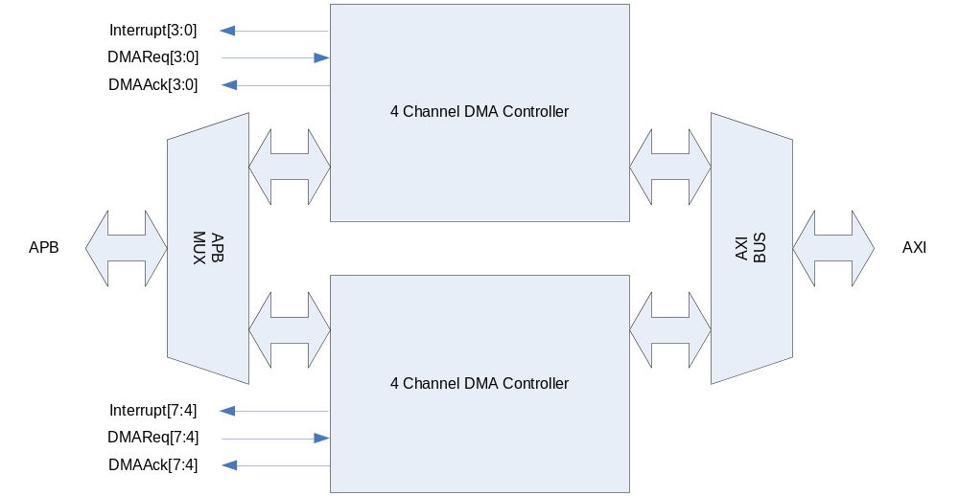
4 Channel DMA Controller가 두 개 들어 있고, 그것이 BUS MUX로 연결되어 있다. 각 Channel별로 DMA Request 신호를 받고 DMA service의 시작과 끝을 알리는 Acknowledge 신호가 peripheral로 출력된다. 각 channel의 동작의 시작과 끝 혹은 error 상황을 알려주기 위해서 8개의 interrupt line이 출력된다. 4 Channel DMA Controller의 내부 구조는 다음과 같다.
Figure 9-46 4 Channel DMA Controller의 내부구조
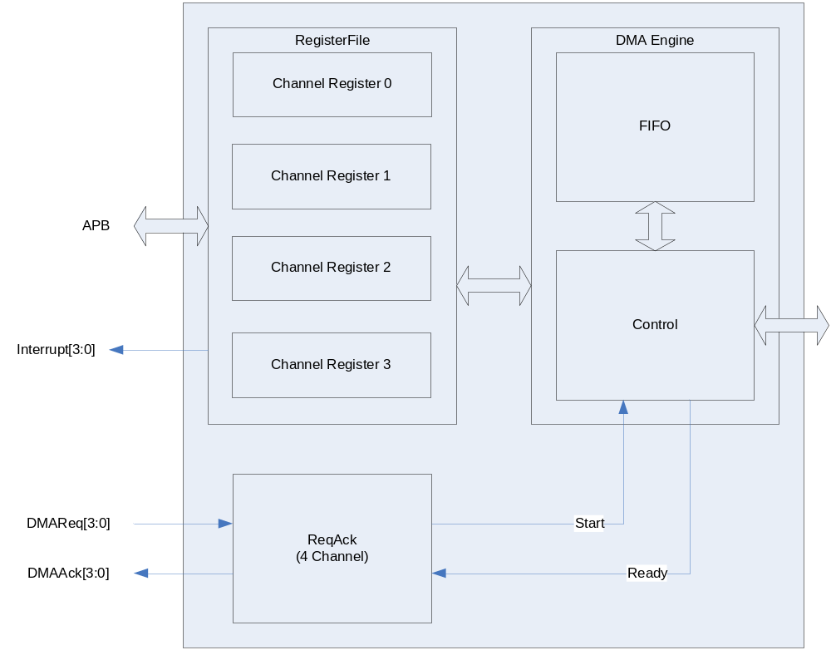

4 Channel DMA Controller는 4개의 channel마다 register set가 존재하고, DMA Request시에는 하나의 Channel register가 enable되어 DMA Engine이 동작하도록 되어있다. 각 channel별로 DMA Engine를 가지고 있는 것보다 하드웨어 복잡도가 낮아지지만 4 Channel의 DMA가 동시에 enable될 수는 없다.

DMA Channel

각 channel에 할당 된 onchip Peripheral은 System Register의 DMA Channel Mux. 부분을 참조 하면 된다.

Channel Arbitration

하나의 DMA Engine에 물려 있는 4개의 Channel에 동시에 request가 오는 경우에는 round-robin scheme을 이용하여 arbitration 하게 된다. 즉, request에 해당 하는 service가 끝난 DMA channel이 가장 low priority를 가지게 된다.
Channel 0/1/2/3를 처리하는 DMA Engine과 Channel 4/5/6/7을 처리하는 DMA Engine 사이에는 항상 Channel 0/1/2/3의 DMA Engine이 높은 우선 순위를 가지고 BUS를 점유하게 된다. 하지만 DMA Controller가 AXI BUS의 out-of-order transfer를 지원하기 때문에 BUS 점유가 data transfer의 순서와 큰 연관 관계를 맺지 않고 효율적인 data transfer가 일어나게 된다.

Channel Operation

Basic Operation

각 Channel의 기본적인 동작은 다음과 같은 state machine으로 설명할 수 있다.

Figure 9-47 DMA Operation State Machine
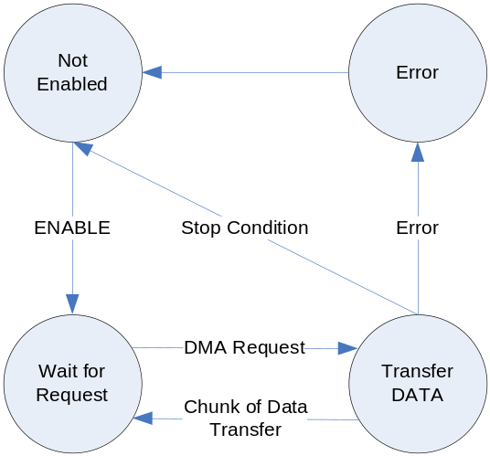

- Not Enabled State
초기 상태에서는 DMA가 Enable되지 않는다.

- Wait for Request State
DMA가 enable되면 외부의 DMA Request를 기다리게 된다.

- Transfer Data State
DMA request가 들어오면 Source Address 레지스터가 지정하고 있는 address에서 일정한 양의 data를 읽어 Destination Address 레지스터가 지정하고 있는 address에 복사를 한다. 복사후에 stop condition이 발생하면 Stop Interrupt 신호가 생성되고 Not Enabled State로 돌아가게 되고, 아니면 Wait for Request State로 돌아가게 된다. Data의 transfer는 source address에서 destination address로 일어나게 되며 한번에 전송되는 data size는 control 레지스터의 Size field에 의해 결정된다.

- Error State
레지스터 세팅이나 Data 전송 시에 오류가 발생하면 Error State가 되어 interrupt가 발생하고 Not Enabled State로 돌아가게 된다.

Channel Enable을 enable시키기 위해서는 Status 레지스터의 enable bit를 ‘1’로 setting해 주고 Pending interrupt를 모두 clear해 주면 된다.
DMA Channel의 stop condition은 Control register의 TransferCount field가 0이 되고 Descriptor 레지스터의 DescriptorEnd bit가 ‘1’인 경우이다.

Descriptor Loading

Transfer Data State에서 Control 레지스터의 TransferLength field가 0이 되면 일단 DMA Request에 대응하는 data transfer는 종료된다. Descriptor 레지스터의 DescriptorEnd bit가 ‘0’인 경우에는 종료된 후 새롭게 DMA Request 신호가 들어오면 Descriptor가 loading이 일어나고 새로운 data transfer가 발생하게 된다. Descriptor Loading이란 Memory에서 4개의 Word를 읽어서 Source Address 레지스터, Destination Address 레지스터, Control 레지스터, Descriptor 레지스터를 update하는 과정을 의미한다. 새로운 Descriptor의 위치는 Descriptor 레지스터의 상위 30bit로 addressing되는데, Descriptor의 내용은 다음과 같은 4 Word로 구성된다.

Table 9-41 Descriptor
Word | Name | Description
1번째 Word | SourceAddr | Source Address 레지스터를 update할 내용이다.
2번째 Word | DestAddr | Destination Address 레지스터를 update할 내용이다.
3번째 Word | Control | Control 레지스터를 update할 내용이다.  참고로 TransferLength가 0이 되도록 하면 안된다.
4번째 Word | Descriptor | Descriptor 레지스터를 update할 내용이다.

이렇게 새로운 Descriptor를 계속 Loading하여 사용자는 Scatter/gather DMA를 할 수 있다.

Interrupt

DMA Controller의 interrupt line은 각 channel 별로 존재하고 Active high level sensitive interrupt signal을 생성한다. 각 channel별로 발생하는 interrupt는 다음과 같은 4가지 상황에서 발생하게 된다.
(a) Error Interrupt
BUS Error를 detect하거나 사용자의 레지스터 세팅에 오류가 있는 경우, Status 레지스터의 ErrInt bit가 ‘1’로 set되고 interrupt가 발생한다. Error Interrupt가 발생하면 해당 채널의 state는 Not Enabled State로 변경되고 더 이상 data transfer가 일어나지 않는다. Not Enabled State로 변경되더라도 Status 레지스터의 Enable bit은 ‘0’으로 clear되지 않음을 유의하라.
(b) Stop Interrupt
Control 레지스터의 TransferLength field가 0이 되고 더 이상 load할 descriptor가 없는 경우(즉, Descriptor 레지스터의 DescriptorEnd bit가 ‘1’인 경우) Stop Interrupt가 발생한다. 이 interrupt는 Status 레지스터의 StopIntEn bit로 masking을 할 수 있는데 masking이 되어도 Stop Interrupt 상황이면 Status 레지스터의 StopInt bit가 ‘1’로 set되고 해당 채널의 state는 Not Enabled State로 변경되어 더 이상 data transfer가 일어나지 않는다. Not Enabled State로 변경되더라도 Status 레지스터의 Enable bit은 ‘0’으로 clear되지 않음을 유의하라.
(c) End Interrupt
Control 레지스터의 TransferLength field가 0이 되면 End Interrupt가 발생한다. 이 interrupt는 Control 레지스터의 EndIntEn bit로 masking이 가능하다. End Interrupt가 발생하면 Status 레지스터의 EndInt bit이 ‘1’로 set되지만 해당 채널의 data transfer는 계속 진행된다.
(d) Start Interrupt
새로운 Descriptor가 성공적으로 Loading된 경우 Start Interrupt가 발생한다. 이 interrupt는 Control 레지스터의 StartIntEn bit로 masking이 가능하다. Start Interrupt가 발생하면 Status 레지스터의 StartInt bit가 ‘1’로 set되지만 해당 채널의 data transfer는 계속 진행된다.

Trailing Bytes

Control 레지스터의 TransferLength field는 현재의 Descriptor를 이용하여 전송할 총 byte수를 세팅하게 되어 있다. DMA Engine은 매 전송마다 TransferLength field를 감소시키고, TransferLength field를 현재의 descriptor에서 전송을 기다리는 byte수로 인식하게 된다. 또한 Control 레지스터의 Size field를 이용하여 한번에 전송할 byte수를 결정할 수 있다. 어떤 시점에서 Size field로 결정된 byte수보다 TransferLength field로 결정된 byte수가 작으면 TransferLength field로 결정된 byte 수 만큼 전송하게 된다.
예를 들어 Size field로 한번의 전송으로 32byte씩 전송하도록 세팅되어 있고, TransferLength field의 값이 15 byte라고 하면 15 byte만 전송한다.

Memory-to-Memory Transfer

DMA Controller를 이용하여 memory에 있는 data를 memory로 빠르게 전송할 수 있다. 이런 기능을 하기 위해서는 Control 레지스터의 M2M bit를 ‘1’로 세팅하면 된다. 이 경우 peripheral에서 오는 DMA request는 무시되고, DMA Request가 항상 assert된 것처럼 동작하게 된다.

Software Model

Enabling DMA Channel

DMA Channel을 enable하기 위해서는 Status 레지스터의 Enable bit를 ‘1’로 세팅하고 StopInt bit과 ErrInt bit을 ‘0’으로 clear해 주면 된다. 당연히 해당 DMA Channel이 올바로 동작하려면 Source Address 레지스터, Destination Address 레지스터, Control 레지스터, Descriptor 레지스터가 올바르게 세팅된 후 enable하여야 한다.

Enabling DMA Channel(No Descriptor Mode)

Descriptor를 사용하지 않는 경우 다음과 같이 레지스터를 세팅하면 된다.
(a) Source Address 레지스터/Destination Address레지스터를 원하는 값으로 세팅한다.
(b) Control 레지스터를 세팅하는데 TransferLength는 반드시 0보다 큰 값을 가져야 한다.
(c) Descriptor 레지스터의 DescriptorEnd bit를 ‘1’로 세팅한다.
(d) Status 레지스터를 세팅하여 해당 channel을 enable 시킨다.

Enabling DMA Channel(Using Descriptor)

Descriptor를 사용하여 DMA를 동작시키기 위해서는 다음과 같이 레지스터를 세팅할 수 있다.
(a) memory의 특정 위치에 Descriptor를 Linked list로 연결되도록 4 word씩 write한다.
(b) Control 레지스터의 TransferLength를 0으로 write한다. Memory-to-Memory 전송이라면 M2M bit를 ‘1’로 세팅한다.
(c) Descriptor 레지스터에 첫 번째 Descriptor가 write된 address를 세팅한다. 이때 DescriptorEnd bit는 ‘0’으로 세팅한다.
(d) Status 레지스터를 세팅하여 해당 channel을 enable 시킨다.

당연히 첫 번째 Descriptor를 memory에 write하지 않고 직접 레지스터에 write해도 된다. 이때는 두 번째 Descriptor의 address를 Descript 레지스터에 세팅하면 된다.

Disabling DMA Channel

위에서 언급한 대로 Error Interrupt나 Stop Interrupt가 발생하면 해당 channel의 state는 Not Enabled State로 변경되고 자동으로 해당 채널이 Disable된다. 사용자가 강제로 동작하고 있는 DMA channel을 disable하기 위해서는 다음과 같은 절차를 거쳐야 한다.
(a) Status 레지스터의 Enable bit을 ‘0’으로 clear해 준다.
(b) Status 레지스터의 Active bit을 polling하여 ‘0’이 될 때까지 기다린다.
Active bit은 현재 data transfer가 진행중임을 나타내는 bit로, data transfer 중간에 다른 레지스터를 access하면 안되기 때문에 polling을 하여 data transfer가 끝났는지 detect하는 것이다.

Restriction on Register Access

Status 레지스터를 제외하고는 Channel이 enable된 상태에서 레지스터에 write를 시도하면 안된다. Data transfer가 일어나는 도중 레지스터를 write하게 되면 DMA Controller가 오동작 할 수 있기 때문이다.

Register Description

Registers

Table 9-42 Registers
Offset | Name | R/W | Description | Init. value
0000h | SRC_CH0 | RW | Source Address(Channel 0) | 0000 0000h
0004h | DEST_CH0 | RW | Destination Address(Channel 0) | 0000 0000h
0008h | CTRL_CH0 | RW | Control(Channel 0) | 0000 0000h
000Ch | DESC_CH0 | RW | Descriptor(Channel 0) | 0000 0000h
0010h | STAT_CH0 | RW | Status(Channel 0) | 0000 0000h
0020h | SRC_CH1 | RW | Source Address(Channel 1) | 0000 0000h
0024h | DEST_CH1 | RW | Destination Address(Channel 1) | 0000 0000h
0028h | CTRL_CH1 | RW | Control(Channel 1) | 0000 0000h
002Ch | DESC_CH1 | RW | Descriptor(Channel 1) | 0000 0000h
0030h | STAT_CH1 | RW | Status(Channel 1) | 0000 0000h
0040h | SRC_CH2 | RW | Source Address(Channel 2) | 0000 0000h
0044h | DEST_CH2 | RW | Destination Address(Channel 2) | 0000 0000h
0048h | CTRL_CH2 | RW | Control(Channel 2) | 0000 0000h
004Ch | DESC_CH2 | RW | Descriptor(Channel 2) | 0000 0000h
0050h | STAT_CH2 | RW | Status(Channel 2) | 0000 0000h
0060h | SRC_CH3 | RW | Source Address(Channel 3) | 0000 0000h
0064h | DEST_CH3 | RW | Destination Address(Channel 3) | 0000 0000h
0068h | CTRL_CH3 | RW | Control(Channel 3) | 0000 0000h
006Ch | DESC_CH3 | RW | Descriptor(Channel 3) | 0000 0000h
0070h | STAT_CH3 | RW | Status(Channel 3) | 0000 0000h
0080h | SRC_CH4 | RW | Source Address(Channel 4) | 0000 0000h
0084h | DEST_CH4 | RW | Destination Address(Channel 4) | 0000 0000h
0088h | CTRL_CH4 | RW | Control(Channel 4) | 0000 0000h
008Ch | DESC_CH4 | RW | Descriptor(Channel 4) | 0000 0000h
0090h | STAT_CH4 | RW | Status(Channel 4) | 0000 0000h
00A0h | SRC_CH5 | RW | Source Address(Channel 5) | 0000 0000h
00A4h | DEST_CH5 | RW | Destination Address(Channel 5) | 0000 0000h
00A8h | CTRL_CH5 | RW | Control(Channel 5) | 0000 0000h
00ACh | DESC_CH5 | RW | Descriptor(Channel 5) | 0000 0000h
00B0h | STAT_CH5 | RW | Status(Channel 5) | 0000 0000h
00C0h | SRC_CH6 | RW | Source Address(Channel 6) | 0000 0000h
00C4h | DEST_CH6 | RW | Destination Address(Channel 6) | 0000 0000h
00C8h | CTRL_CH6 | RW | Control(Channel 6) | 0000 0000h
00CCh | DESC_CH6 | RW | Descriptor(Channel 6) | 0000 0000h
00D0h | STAT_CH6 | RW | Status(Channel 6) | 0000 0000h
00E0h | SRC_CH7 | RW | Source Address(Channel 7) | 0000 0000h
00E4h | DEST_CH7 | RW | Destination Address(Channel 7) | 0000 0000h
00E8h | CTRL_CH7 | RW | Control(Channel 7) | 0000 0000h
00ECh | DESC_CH7 | RW | Descriptor(Channel 7) | 0000 0000h
00F0h | STAT_CH7 | RW | Status(Channel 7) | 0000 0000h

8개 Channel 전체 레지스터의 map은 위의 그림과 같다. 각 Channel 별 레지스터에 대해서 살펴보자.

Source Address Register

Source Address 레지스터는 말 그대로 복사가 일어날 Source의 address를 지칭하기 위한 레지스터이다.

Figure 9-48 Source Address Register
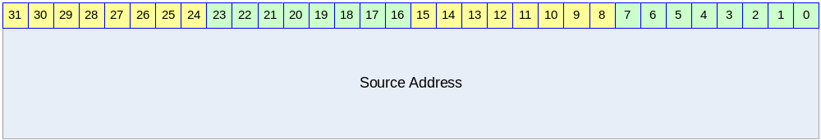

Table 9-43 Source Address Register Description
Bits | Name | R/W | Description | Init. value
[31:0] | Source Address | RW | 32bit Source Address  Control 레지스터의 SrcIncr bit가 ‘1’이면 매 전송된 byte수 만큼 증가한다. | 0000 0000h

Destination Address Register

Destination Address 레지스터는 말 그대로 복사가 일어날 Destination Address를 지칭하기 위한 레지스터이다.

Figure 9-49 Destination Address Register
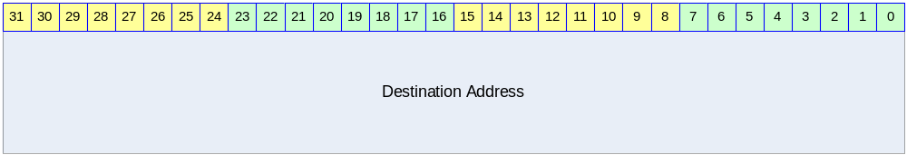

Table 9-6 Destination Address Register Description
Bits | Name | R/W | Description | Init. value
[31:0] | Destination Address | RW | 32bit Destination Address  Control 레지스터의 DstIncr bit가 ‘1’이면 매 전송된 byte수 만큼 증가한다. | 0000 0000h

Control Register

Control 레지스터는 현재 전송하고 있는 Descriptor의 data transfer의 동작을 규정하는 레지스터이다.

Figure 9-50 Control Register
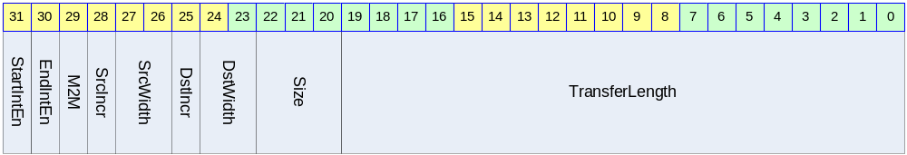

Table 9-44 Control Register Description
Bits | Name | R/W | Description | Init. Value
[31] | StartInEn | RW | Start Interrupt Enable Flag  0 : Start Interrupt를 masking함  1 : Start Interrupt를 발생시킴 | 0b
[30] | EndIntEn | RW | End Interrupt Enable Flag  0 : End Interrupt를 masking함  1 : End Interrupt를 발생시킴 1 | 0b
[29] | M2M | RW | Memory-to-Memory Transfer Flag  0 : DMA Request 신호로 DMA 동작  1 : DMA Request 신호 없이 DMA 동작  Memory에서 memory로 data를 전송하는 경우 외부의 DMA Request 신호와 관계 없이 전송이 계속된다. M2M bit가 ‘1’인 경우 외부 DMA Request 신호를 무시하고 DMA Request가 항상 assert되어 있는 것과 동일하게 DMA Controller가 동작하게 된다. | 0b
[28] | SrcIncr | RW | Source Address Increment Flag  1 : 매 transfer마다 Source Address 증가시킴  0 : 매 transfer마다 Source Address 증가안함 | 0b
[27:26] | SrcWidth | RW | Source Device의 BUS Width  00 : BYTE(8bit)  01 : HWORD(16bit)  10 : WORD(32bit)  11 : reserved  Source Device가 memory라면 반드시 WORD로 세팅해야 한다. | 00b
[25] | DstIncr | RW | Destination Address Increment Flag  1 : 매 transfer마다 Destination Address 증가시킴  0 : 매 transfer마다 Destination Address 증가안함 | 0b
[24:23] | DstWidth | RW | Destination Device의 BUS Width  00 : BYTE(8bit)  01 : HWORD(16bit)  10 : WORD(32bit)  11 : reserved  Destination Device가 memory라면 반드시 WORD로 세팅해야 한다. | 00b
[22:20] | Size | RW | Transfer Size  매 DMA Request마다 한번에 전송할 byte수  000 : 1 byte  001 : 2 byte  010 : 4 byte  011 : 8 byte  100 : 16 byte  101 : 32 byte  Other : reserved | 000b
[19:0] | TransferLength | RW | 전체 전송할 byte 수/현재 남아 있는 byte 수  20 bit이므로 하나의 Descriptor에서 1MB-1Byte 까지 전송할 수 있다.  매 data transfer마다 감소하게 되어 “현재 남아있는 전송할 byte 수”를 지칭하게 된다. | 00000h

Descriptor Register

Descriptor 레지스터는 새로 Loading될 Descriptor의 address를 담고 있는 레지스터이다.

Figure 9-51 Descriptor Register
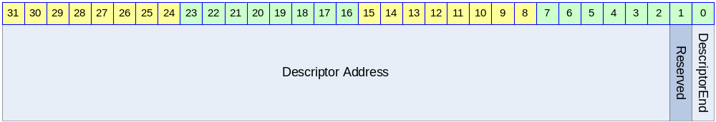

Table 9-45 Descriptor Register Description
Bits | Name | R/W | Description | Init. Value
[31:2] | Descriptor Address | RW | Load할 Descriptor Address의 상위 32bit  Descriptor Address는 32bit align 되어야 함.  DescriptorEnd bit가 ‘1’이면 어떠한 값이라도 관계 없다. | 0
[0] | DescriptorEnd | RW | Descriptor End Flag  0 : Descriptor Address가 VALID함  1 : Descriptor Address가 VALID하지 않음.  ‘1’로 세팅된 경우 현재 처리중인 Descriptor가 마지막 Descriptor임을 의미한다. | 0b

Status Register

Status 레지스터는 현재 DMA Channel의 동작 상황을 알려준다.

Figure 9-52 Status Register
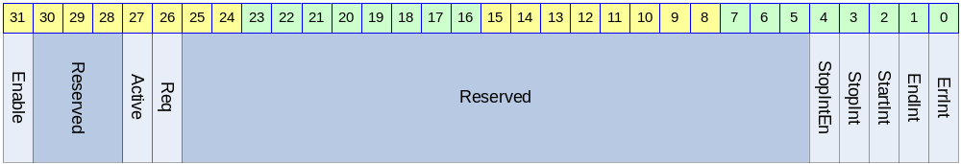

Table 9-46 Status Register Description
Bits | Name | R/W | Description | Init. Value
[31] | Enable | RW | Enable Flag  0 : DMA Channel Disabled  1 : DMA Channel Enabled  Channel이 Stop Interrupt나 Error Interrupt에 의해 disable되더라도 ‘0’으로 clear되지 않는다. | 0b
[27] | Active | R | Active Flag  0 : 현재 data transfer를 진행중이지 않음  1 : 현재 data transfer를 진행중임 | N/A
[26] | Req | R | DMA Request Status  1 : Device가 DMA Request를 assert 하고 있음  0 : Device가 DMA Request를 assert 하지 않음 | N/A
[4] | StopIntEn | RW | Stop Interrupt Enable Flag  0 : Stop Interrupt 발생을 disable함  1 : Stop Interrupt 발생을 enable함 | 0b
[3] | StopInt | RW | Stop Interrupt Status  0 : Stop Interrupt가 발생하지 않았음  1 : Stop Interrupt가 발생하였음  StopIntEn과 생관 없이 Stop interrupt 상황에서 ‘1’로 set된다. StopIntEn이 ‘0’이면 이 bit의 값과 관계 없이 interrupt가 발생하지 않는다. 이 bit가 ‘1’일 때는 Channel의 동작이 멈추게 되므로 Channel을 enable 시키기 위해서는 이 bit를 ‘0’으로 clear해 주어야 한다.  ‘1’을 write하면 clear되고 ‘0’을 write하는 것은 아무런 영향을 미치지 않는다. | 0b
[2] | StartInt | RW | Start Interrupt Status  0 : Start Interrupt가 발생하지 않았음  1 : Start Interrupt가 발생하였음  Control 레지스터의 StartIntEn이 ‘0’이면 이 bit는 ‘1’로 변하지 않는다.  ‘1’을 write하면 clear되고 ‘0’을 write하는 것은 아무런 영향을 미치지 않는다. | 0b
[1] | EndInt | RW | End Interrupt Status  0 : End Interrupt가 발생하지 않았음  1 : End Interrupt가 발생하였음  Control 레지스터의 EndIntEn이 ‘0’이면 이 bit는 ‘1’로 변하지 않는다.  ‘1’을 write하면 clear되고 ‘0’을 write하는 것은 아무런 영향을 미치지 않는다. | 0b
[0] | ErrInt | RW | Error Interrupt Status  0 : Error Interrupt가 발생하지 않았음  1 : Error Interrupt가 발생하였음  이 bit가 ‘1’일 때는 Channel의 동작이 멈추게 되므로 Channel을 enable 시키기 위해서는 이 bit를 ‘0’으로 clear해 주어야 한다.  ‘1’을 write하면 clear되고 ‘0’을 write하는 것은 아무런 영향을 미치지 않는다. | 0b

TIMER

Overview

총 4개의 32bit Timer를 제공한다.

Features

- Maximum period : PCLK duration * 2048 * (2^32-1)
- Minimum period : PCLK duration * 2

Block diagram

하나의 Timer의 하드웨어 구성은 다음과 같다.

Figure 10-53 Block Diagram
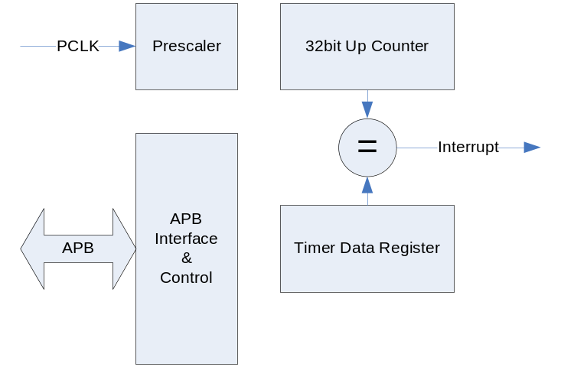

기본적으로 timer는 레지스터를 읽고 쓰기 위해서 APB Bus interface를 가지고 있다. APB BUS의 clock인 PCLK을 Prescaler를 이용하여 분주하게 되고 그 분주된 clock으로 32bit up counter가 동작하게 된다. 32 bit up counter의 값이 Timer Data 레지스터의 같은 값이 되면 positive edge 형식의 interrupt가 발생하게 되고 그 interrupt는 interrupt controller에 연결된다.

위와 같은 구조를 가지는 독립된 timer 4개가 병렬로 연결되어 있다.

Operation

다음과 같은 2 가지 모드로 동작이 가능하다.

Interval Mode

Interval Mode에서는 counter가 증가하여 timer data 레지스터에 저장된 값과 같아지면 interrupt가 생성되고 counter의 값은 자동으로 0으로 clear된다. 일정한 시간마다 interrupt의 발생을 원하면 이 mode를 사용하면 된다.

Match&Overflow Mode

Match&Overflow Mode에서는 counter가 증가하여 timer data 레지스터에 저장된 값과 같아지면 interval mode에서와 마찬가지로 interrupt가 생성된다. 하지만 counter값은 0으로 clear되지 않고, 계속 증가하게 된다. 증가가 계속되어 0xffff가 되면 다시 0으로 바뀌게 된다. Interval mode를 사용하는 경우 interrupt의 발생 주기가 interrupt service routine의 service latency보다 작은 경우 interrupt가 여러 번 발생하였는데도 한번으로 인식할 가능성이 생기게 된다. 이런 경우에는 Match&Overflow mode를 사용하게 되면 interrupt service routine이 interrupt발생 시점에서 얼마간의 시간이 흘렀는지 detect할 수 있고, Interrupt service routine에서 timer data 레지스터 값을 새로 write함으로써 다음에 발생할 interrupt의 시점을 제어할 수 있다.

Register Description

Registers

Table 10-47 Registers
Offset | Name | R/W | Description | Init. value
0000h | T0_TDAT | RW | (Timer0) Timer Data Register | FFFF FFFFh
0004h | T0_PRES | RW | (Timer0) Prescaler Register | XXXX X3FFh
0008h | T0_CTRL | RW | (Timer0) Control Register | XXXX XXX0h
000Ch | T0_CNT | R | (Timer0) Counter Register | 0000 0000h
0010h | T1_TDAT | RW | (Timer1) Timer Data Register | FFFF FFFFh
0014h | T1_PRES | RW | (Timer1) Prescaler Register | XXXX X3FFh
0018h | T1_CTRL | RW | (Timer1) Control Register | XXXX XXX0h
001Ch | T1_CNT | R | (Timer1) Counter Register | 0000 0000h
0020h | T2_TDAT | RW | (Timer2) Timer Data Register | FFFF FFFFh
0024h | T2_PRES | RW | (Timer2) Prescaler Register | XXXX X3FFh
0028h | T2_CTRL | RW | (Timer2) Control Register | XXXX XXX0h
002Ch | T2_CNT | R | (Timer2) Counter Register | 0000 0000h
0030h | T3_TDAT | RW | (Timer3) Timer Data Register | FFFF FFFFh
0034h | T3_PRES | RW | (Timer3) Prescaler Register | XXXX X3FFh
0038h | T3_CTRL | RW | (Timer3) Control Register | XXXX XXX0h
003Ch | T3_CNT | R | (Timer3) Counter Register | 0000 0000h

Timer Data Register (T0_TDAT/T1_TDAT/T2_TDAT/T3_TDAT)

Timer Data 레지스터는 counter의 값과 비교를 하기 위한 레지스터이다.

Figure 10-54 Timer Data Register
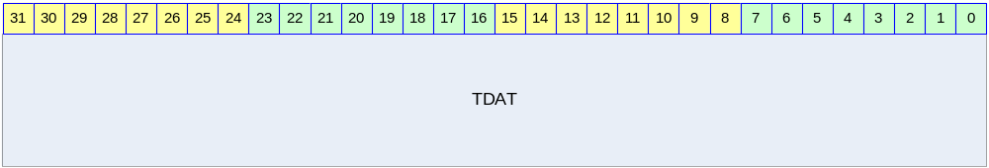

Table 10-48 Timer Data Register Description
Bits | Name | R/W | Description | Init. value
[31:0] | TDAT | RW | Timer Data 레지스터  TDAT과 32bit Counter값이 같으면 interrupt가 발생한다. | FFFFFFFFh

Timer Prescaler Register (T0_PRES/T1_PRES/T2_PRES/T3_PRES)

Timer Prescaler Register는 32bit Counter에 들어가는 clock의 속도를 조정하는 레지스터이다.

Figure 10-55 Timer Prescaler Register
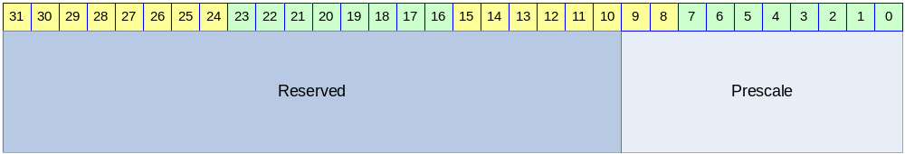

Table 10-49 Timer Prescaler Register Description
Bits | Name | R/W | Description | Init. value
[9:0] | Prescale | RW | 32bit Counter이 들어가는 clock의 속도를 결정 | 3FFh

32bit Counter에 들어가는 Clock의 속도는 다음과 같이 결정된다.
Clock = PCLK/(Prescale+1)
매 네번의 PCLK rise마다 32bit Counter가 1씩 증가하도록 만들고 싶으면 Prescale의 값을 3으로 정하면 된다.

Timer Control Register (T0_CTRL/T1_CTRL/T2_CTRL/T3_CTRL)

Timer Control 레지스터는 Timer의 동작 여부와 동작 mode를 결정하는 레지스터이다.

Figure 10-56 Timer Control Register
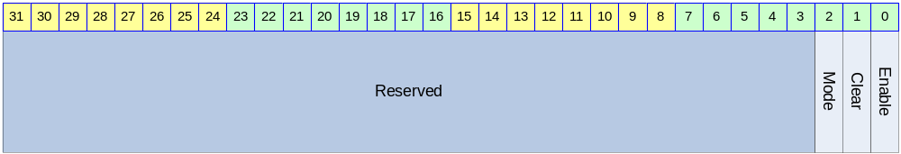

Table 10-50 Timer Control Register Description
Bits | Name | R/W | Description | Init. Value
[2] | Mode | RW | 동작 mode  0 : Interval mode  1 : Match&Overflow Mode | 0b
[1] | Clear | RW | Counter Clear  0 : 의미 없음  1 : Counter의 값을 0으로 초기화함  Clear bit가 1로 세팅되면 32 bit Counter의 값을 0으로 초기화하고 Timer Data 레지스터와 Timer Prescaler 레지스터의 값을 Reset값으로 바꾸게 된다. 1로 write되고 나면 timer가 동작하지 않으므로 0으로 반드시 다시 써 주어야 한다. | 0b
[0] | Enable | R/W | Timer Enable bit  0 : Not Enabled  1 : Enabled | 0b

Timer Counter Register (T0_CNT/T1_CNT/T2_CNT/T3_CNT)

Timer Counter 레지스터는 Read only 레지스터로 32bit Counter의 현재 값을 읽을 수 있는 레지스터이다.

Figure 10-57 Timer Counter Register
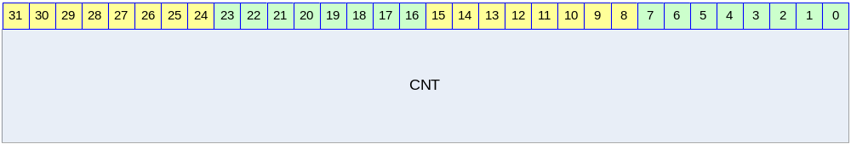

Table 10-51 Timer Counter Register Description
Bits | Name | R/W | Description | Init. Value
[31:0] | CNT | R | 32bit Counter의 현재 값 | 00000000h

Watch Dog Timer

Overview

Feature

- Support 16 bit Programmable interval down counter.
- Support clock division factor 16,32,64, and 128.
- Support 16 bit prescale counter.
- Support Interrupt Request
- Generation of Reset Output Signal

Block Diagram

Figure 11-58 Watch Dog Block Diagram
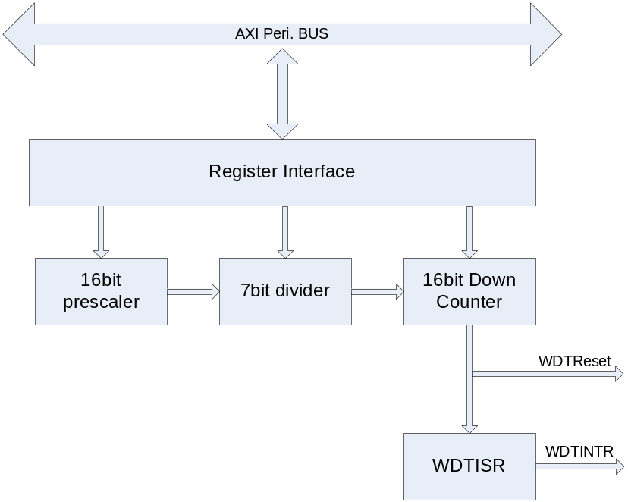

Operation

Chip이 소프트웨어나 다른 환경에 의해 오동작할 경우 전체 동작을 Reset 해주는 역할을 한다.
즉, 카운터 값이 설정된 값에 도달할 경우 Interrupt를 생성하게 되는데, 정상적인 상태에 있는 칩이라면 Interrupt 발생시 마다 카운터 값을 Reload 하여 전체 동작에 Reset를 걸지 않게 할 수 있지만, 반대의 경우라면 칩에 Reset이 걸리게 되어 있다.

Clock Prescaler Block

16bit Prescaler Count와 7Bit Clock Divider를 이용하여 다양한 PCLK Clock Divide가 가능하다.

Interrupt Generation Block

설정된 Prescaler Count와 7Bit Divide 값이 16bit Down Count 값에 도달하면 Interrupt를 생성하게 된다.
Interrupt Status가 Clear되기전까지 High Level을 유지한다.
Interrupt가 생성되기 위해서는 Control Register의 Interrupt Enable Bit를 Active 시켜야 한다.

Reset Output Generation

설정된 Prescaler Count와 7Bit Divide 값이 16bit Down Count 값에 도달하면 Interrupt와 함께 Watch Dog Reset을 생성하게 된다.
Reset이 생성되기 위해서는 Control Register의 Reset Enable Bit를 Active 시켜야 한다

Register Description

WDT Registers

Table 11-52 WDT Registers
Offset | Name | R/W | Description | Init. value
0000h | WDTCON | RW | WDT Control Register | 0000 0030h
0004h | WDTPSR | RW | WDT Prescale Register | 0000 FFFFh
0008h | WDTLDR | RW | WDT Load Register | 0000 FFFFh
000Ch | WDTCNT | RW | WDT Count Register | 0000 FFFFh
0010h | WDTISR | RW | WDT Interrupt Status Register | 0000 0000h

WDT Control Register

Figure 11-59 WDT Control Register Bits
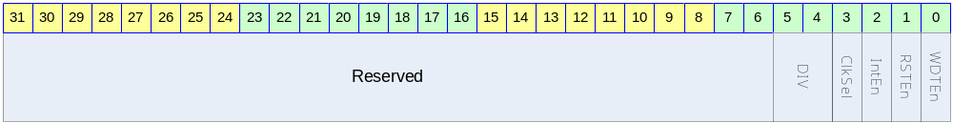

Table 11-53 WDT Control Register Description(Offset : 0000 0000h)
Bits | Name | R/W | Description | Init. value
[31:6] |  |  | Reserved | 0
[5:4] | DIV | RW | 0b00 : 16  0b01 : 32  0b10 : 64  0b11 : 128 | 11b
[3] | ClkSel | RW | 0 : Both Prescale and Divide Clock is used for Counting  1 : Only Prescal Clock is user for Counting | 0
[2] | IntEn | RW | 0 : WDT Interrupt Disable  1 : WDT Interrupt Enable | 0
[1] | RSTEn | RW | 0 : Reset Output Disabled  1 : Reset Output Enabled | 0
[0] | WDTEn | RW | WDT Enable  0 : WDT Disable  1 : WDT Enable | 0

WDT Prescale Register

Figure 11-60 WDT Prescale Register Bits
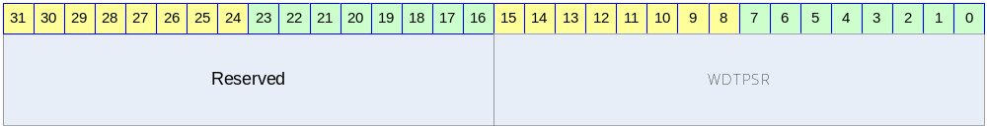

Table 11-54 WDT Prescale Register Description(Offset : 0000 0004h)
Bits | Name | R/W | Description | Init. value
[31:16] |  |  | Reserved | 0
[15:0] | WDTPSR | RW | Prescaler Value | ffffh

WDT Load Register

Figure 11-61 WDT Load Register Bits
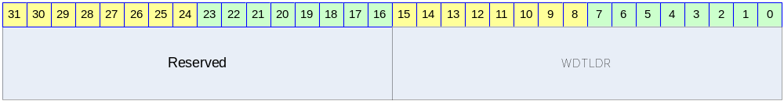

Table 11-55 WDT Load Register Description(Offset : 0000 0008h)
Bits | Name | R/W | Description | Init. value
[31:16] |  |  | Reserved | 0
[15:0] | WDTLDR | RW | Reload Value | ffffh

WDT Count Register

Figure 11-62 WDT Count Register Bits
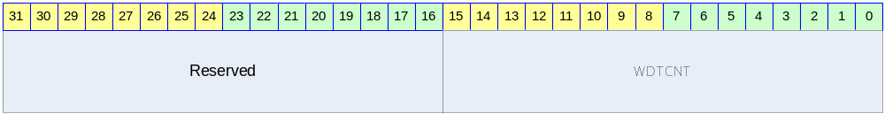

Table 11-56 WDT Count Register Description(Offset : 0000 000Ch)
Bits | Name | R/W | Description | Init. value
[31:16] |  |  | Reserved | 0
[15:0] | WDTCNT | R | Current WDT Count Value | ffffh

WDT Interrupt Status Register

Figure 11-63 WDT Interrupt Status Register Bits
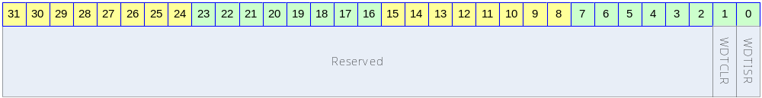

Table 11-57 WDT Interrupt Status Register Description(Offset : 0000 0010h)
Bits | Name | R/W | Description | Init. value
[31:2] |  |  | Reserved | 0
[1] | WDTCLR | W | Write 1, Cleared Interrupt
[0] | WDTISR | R | 0 : Interrupt Is asserted  0 : Interrupt Is not asserted

I2S

Overview

I2S Protocol은 Philips에서 개발한 stereo audio data를 전송하는 규약으로 많은 audio codec이 I2S protocol을 사용하고 있다. I2S protocol은 BCLK(bit clock), LRCLK(left/right channel detect signal), SD(Serial Audio Data) signal을 사용하여 audio data를 전송한다.
I2S controller는 I2S protocol을 사용하여 외부의 audio codec으로 audio data를 전송하거나 audio codec으로부터 audio data를 수신하는 기능을 한다. 즉, 사용자는 audio data를 play하거나 외부의 analog audio를 audio codec을 거쳐 record할 수 있다.

Features

- 8/16/24/32bit per sample support
- No audio PLL need
- Integrated Digital Oscillator
  - Fully programmable sampling rate(determined by SYS_CLK frequency)
  - MCLK(256*sampling rate) generation
    - Not support 384*sampling rate, 512*sampling rate
- Support normal I2S mode and MSB(=Left) justified mode
- Programmable LRCLK polarity
- Maximum 32x32bit FIFO for each transmission/receive
  - DMA request generation
- Master/slave configuration
  - BCLK output support only 64*sampling rate

Block diagram

전체적인 하드웨어 구성은 다음 그림과 같다.

Figure 12-64 I2S Controller Block Diagram
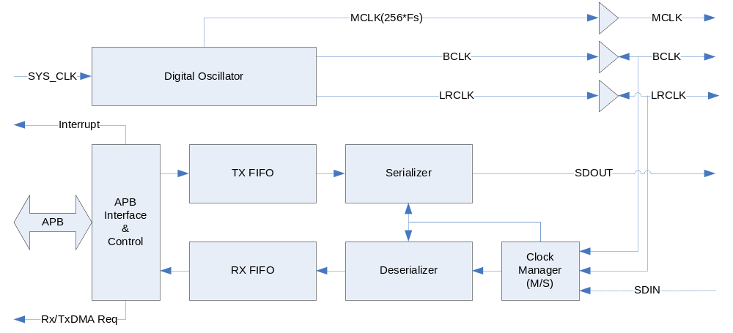

칩 외부 pin으로 I2S Protocol signal인 BCLK/LRCLK/SDOUT/SDIN이 연결되어 있고, 256배의 sampling rate를 출력하는 MCLK pin도 존재한다. 칩 내부로는 기본적으로 APB BUS interface를 이용하여 연결되고, 그 외로 Digital Oscillator의 입력 clock으로 SYS_CLK을 입력 받고, DMA request와 Interrupt request를 출력한다.

Signals

칩 외부로 연결되는 신호들은 다음과 같다.

Table 12-58 External Signals
Signal Name | Direction | Description | Init. value
MCLK | Output | 256배의 sampling rate의 clock을 외부로 출력 | N/A
BCLK | InOut | Bit Clock  Master로 configuration 되면 output이 되고  Slave로 configuration 되면 input이 된다. | N/A
LRCLK | InOut | Left/Right Channel Indicator  Master로 configuration 되면 output이 되고  Slave로 configuration 되면 input이 된다. | N/A
SDOUT | Output | Serial Data output | N/A
SDIN | Input | Serial Data Input | N/A

Operation

Digital Oscillator

Digital Oscillator는 SYS_CLK 입력을 바탕으로 MCLK/BCLK/LRCLK을 생성하는 동작을 한다. MCLK은 Master Clock으로 대부분의 I2S Codec이 요구하는 sampling rate의 256배에 해당되는 clock을 말한다. 이 MCLK의 생성을 위해서 보통의 경우에는 Audio PLL을 사용하지만 설계된 I2S Controller는 Audio PLL을 사용하지 않고 SYS_CLK을 분주하여 사용하여 생성하도록 되어있다. SYS_CLK을 단순히 정수배 분주를 하게 되면 정확한 주파수의 MCLK을 생성할 수 없기 때문에 DDS(또는 DTO) 알고리즘을 사용하도록 구성하였다.
Digital Oscillator의 동작은 I2S_CLKCTRL 레지스터의 MClkOn field에 의해 On/Off할 수 있다. 생성할 MCLK의 주파수는 I2S_CLKCTRL 레지스터의 DTORATIO field에 의해서 결정된다. DTORATIO field에서는 SYS_CLK의 주파수와 생성할 MCLK의 주파수의 비율을 적어주면 되는데 다음과 같은 식을 사용하면 된다.
DTORATIO = RoundToNearInteger[2^18*(MCLK의주파수/SYS_CLK의주파수)]
예를 들어 SYS_CLK으로 100MHz의 clock을 가하고 생성하고 싶은 MCLK이 12.288MHz(256*48KHz)라면 다음과 같은 식에 의해 DTORATIO에 32212를 적어주면 된다.
DTORATIO = RoundToNearInteger[2^18*(12.288MHz/100MHz)]
= RoundToNearInteger[262144*0.12288]
= RoundToNearInteger[32212.25472]
= 32212
이렇게 생성된 MCLK은 비교적 정교한 clock이지만 Audio PLL을 사용하여 생성하는 clock에 비해 몇가지 오차가 발생한다.

주파수 오차

DTORATIO값이 정수 값이므로 finite bit-length로 인한 주파수 오차가 발생한다. 또한 clock cycle time이 매 clock 동일하게 유지되지 않는다. 우선 finite bit-length로 인한 주파수 오차는 18bit의 DTORATIO를 사용하여 0.1%보다 작도록 설계되었으므로 큰 문제가 되지 않는다. 매 clock 달라질 수 있는 clock cycle time은 다음과 같이 계산할 수 있다.

우선 FrequencyRatio라는 값은 다음과 같이 정의하자.
FrequencyRatio = 2^18/DTORATIO
FrequencyRatio의 값은 ‘SYS_CLK의주파수/MCLK의주파수’와 finite bit-length로 인한 오차를 제외하고는 동일한 값을 가지게 된다. FrequencyRatio를 rounding하여 다음 두 값을 계산한다.
FrequencyRatio_Higher = FrequencyRatio보다 작지 않은 가장 작은 integer
FrequencyRatio_Lower = FrequencyRatio보다 크지 않은 가장 큰 integer
이 값으로 다음과 같은 값을 계산할 수 있다.
Minimum Cycle Time = FrequencyRatio_Lower*SYS_CLK의주기
Maximum Cycle Time = FrequencyRatio_Higher*SYS_CLK의주기

예를 들어 SYS_CLK이 100MHz(주기는 10ns)이고 MCLK이 12.288MHz라면 위에서 계산한대로 DTORATIO는 32212가 되므로 FrequencyRatio = 8.183… 이 된다.
Minimum Cycle Time은 80ns(8*10ns)가 되고 Maximum Cycle Time은 90ns(9*10ns)가 된다. 즉 특정 cycle은 80 ns가 되고 특정 cycle은 90 ns가 된다.

duty cycle

MCLK의 duty cyle이 정확하게 50%를 가지지 않는다. Duty cycle이 정확하게 50%가 되려면 FrequencyRatio의 값이 짝수 Integer값을 가지면 되지만 일반적인 경우 그럴 가능성은 매우 낮다. 이런 경우 Worst duty cycle은 다음과 같이 계산할 수 있다.
FrequencyRatio_Odd = FrequencyRatio와 가장 가까운 홀수 integer
Worst Duty Cycle(%) = 100* RoundToNearInteger[FrequencyRatio_Odd/2] / FrequencyRatio_Odd

동일한 예로 SYS_CLK이 100 MHz이고 MCLK이 12.288MHz라면 위에서 계산한 대로 FrequencyRatio는 8.183…이 되고 FrequencRatio_Odd는 9가 된다. 따라서 Worst Duty Cycle은 다음과 같다.
Worst Duty Cycle(%) = 100*4/9 = 44.44(%)
일반적인 Audio Codec은 MCLK의 duty cycle을 40%~60%를 요구한다.(CirrusLogic CS42L51과 같은 칩은 45%~55%를 요구하기도 한다.) 40%를 만족시키기 위해서는 SYS_CLK이 MCLK에 비해 적어도 5배 이상 동작해야 한다.(45%를 만족시키기 위해서는 11배 이상으로 동작해야 한다.)

BCLK과 LRCLK도 MCLK과 마찬가지로 주파수 오차와 duty cycle 오차가 생기게 된다. 이 경우도 동일한 방법으로 계산할 수 있다. 하지만 BCLK/LRCLK은 MCLK에 비해 훨씬 느리게 동작하므로 보통의 경우 그러한 오차가 큰 의미를 지니지는 않는다.

Master/Slave Configuration

I2S protocl에서 master라고 하면 BCLK과 LRCLK을 출력하는 device를 의미하고, slave는 BCLK과 LRCLK을 생성하지 않고 받기만 하는 device를 의미한다. I2S_CLKCTRL 레지스터의 ClkMS bit를 ‘1’로 하면 I2S Controller가 master로 동작하게 되고, ‘0’으로 하면 slave로 동작하게 된다. Master로 동작하는 경우에는 반드시 I2S_CLKCTRL 레지스터의 MClkOnㅇ ‘1’로 세팅되어야 한다.
만약 I2S Controller가 MCLK을 생성하여 외부의 I2S Codec에 MCLK을 공급하면서 I2S protocol상에서는 slave로 동작하고 싶은 경우에는 MClkOn을 ‘1’, MClkOE를 ‘1’로 하고 ClkMS를 ‘0’으로 세팅하면 된다.

Transmit 동작 : Audio Play

외부의 I2S DAC으로 PCM data를 transmit하는 동작은 serializer block이 수행하게 되는데 I2S_CTRL 레지스터의 하위 16bit에 의해 control된다. Serializer block은 enable되면 TX FIFO(Transmit FIFO)에서 data를 읽어서 SDOUT pin으로 PCM data를 serial로 전송을 하게 된다.

Enabling Sequence

Transmit을 enable시키기 위해서는 단순히 I2S_CTRL 레지스터의 하위 16bit을 원하는 값으로 세팅하면 초기화는 끝나게 된다. TX FIFO에 데이터가 없는 상황에서 TxEn bit가 ‘1’로 세팅된 경우 TX FIFO UnderRun Interrupt가 발생하게 된다. 초기에 이것을 피하기 위해서는 TX FIFO에 어느 정도 PCM data를 채운 상태에서 TxEn bit을 ‘1’로 세팅할 수도 있다.

Transmit data의 공급

외부 I2S DAC으로 전송할 PCM data는 TX FIFO에 채워져야 하는데 TX FIFO에 data를 채우는 데는 두 가지 방법을 사용할 수 있다. 우선 CPU가 직접 공급하는 방법이 있다. CPU가 polling하여 data늘 공급할 수 있는데 I2S_STATUS register에서 TxFifoLevel field를 보고 TX FIFO가 full이 아니라면 계속 TX FIFO에 값을 채울 수 있다. Interrupt를 사용하고 싶을 때는 I2S_CTRL 레지스터의 TxDMAIntEn bit를 ‘1’로 세팅해 주고 TxFifoTH field의 값을 적절히 세팅하면 TX FIFO의 Level이 (TxFifoTH+1)보다 작으면 interrupt가 발생하게 된다. 그 때 마다 CPU가 TX FIFO에 data를 write하면 된다.
또 한가지 방법은 DMA Controller를 사용하는 방법이다. I2S Controller는 TX FIFO의 Level이 (TxFifoTH+1)보다 작으면 무조건 Tx DMA Request 신호를 생성하게 된다. DMA Controller가 해당 signal을 받으면 DMA가 동작하도록 configuration해 두면 DMA Controller가 Memory에서 data를 읽어 TX FIFO에 자동으로 채워주게 된다.
참고로 DMA Controller를 사용하는 방법과 CPU가 직접 data를 TX FIFO에 채워주는 방법을 동시에 사용하는 것은 권장되지 않는다. TxDMAIntEn bit가 ‘1’로 세팅된 경우 Tx DMA Request상황(즉, TX FIFO의 Level이 TxFifoTH+1보다 작은 경우)에서 Interrupt가 발생하고 I2S_STATUS 레지스터의 TxDMA bit가 set되고 DMA Controller가 동작하게 된다. DMA Controller가 Service를 마치게 되면 TX FIFO의 Level이 TxFifoTH+1보다 작아져 다시 TxDMA bit가 ‘0’으로 clear된다. 이러한 상황이 발생하면 CPU는 interrupt를 받지만 interrupt handler가 I2S_STATUS 레지스터를 확인할 때는 이미 TxDMA bit가 clear될 수 있기 때문에 interrupt를 놓칠 수 있다. 따라서 DMA Controller를 사용하는 경우에는 TxDMAIntEn bit를 ‘0’으로 하는 것을 권장한다.

SDOUT 출력

TX FIFO에서 읽은 데이터가 SDOUT으로 차례로 출력되며 각 채널의 data가 모두 전송되고 BCLK의 toggle이 계속되는 경우에는 하위 bit를 ‘0’으로 출력하게 된다.

TX FIFO UnderRun Error

Serializer block은 I2S protocol상에서 Left Channel의 전송이 시작될 때 TX FIFO에서 data를 읽어오게 되는데, 이 때 TX FIFO에 data가 없으면 TX FIFO UnderRun Error가 발생되고, TX FIFO가 다시 채워질 때까지 SDOUT pin으로는 마지막으로 전송된 sample이 전송되게 된다. 만약 I2S_CTRL 레지스터의 TxWLen field가 24bit/32bit으로 세팅된 경우에는 TX FIFO에 적어도 두 개 이상의 32bit data가 있어야 UnderRun Error가 발생하지 않으며, 16bit/8bit의 경우에는 TX FIFO에 하나 이상의 data가 있을 때 UnderRun Error가 발생하지 않는다.
UnderRun Error가 발생하고 I2S_CTRL 레지스터의 TxFifoURIntEn bit이 ‘1’이고, I2S_STATUS레지스터의 EnTxFifoURInt bit이 ‘1’이면, I2S_STATUS 레지스터의 TxFifoURInt bit이 ‘1’로 set되면서 interrupt가 발생한다. I2S_STATUS 레지스터의 EnTxFifoURInt bit은 hardware state에 따라서 변하게 되는데, 다음과 같은 때 변하게 된다.
- Reset 상태에서는 0의 값으로 초기화 된다.
- TxReset이 assert될 때 0의 값으로 초기화된다.
- EnTxFifoURInt가 0이고 TxFIFO에 2 word 이상의 data가 들어 있으면 1로 바뀐다.
- TxFifoURInt가 ‘1’로 바뀌면 0으로 reset된다.
EnTxFifoURInt가 위와 같이 변하기 때문에 Transmit이 맨 처음 enable되고 Tx FIFO에 어떠한 data도 존재하지 않는 경우에는 TX FIFO UnderRun Error 상황이지만 Tx FIFO에 두 word 이상의 data를 채울 때 까지는 TxFifoURInt interrupt가 발생하지 않는다. 또한 TxFifoURInt interrupt가 일단 발생되면, TxFifoURInt bit을 clear하더라도 TxEn이 ‘1’인 경우 계속 TX FIFO UnderRun Error 상황인데 Tx FIFO에 2개 이상의 data를 write하는 시점까지는 TxFifoURInt interrupt의 발생이 연기된다.

Disabling Transmit

Transmit동작을 disable 시키고 싶으면 I2S_CTRL 레지스터의 TxEn bit를 ‘0’으로 clear해 주면 된다. TxEn bit가 ‘0’이 되면 더 이상 DMA Request는 생성되지는 않지만, TX FIFO에 남아 있는 data는 계속 출력이 되고 TX FIFO에 data가 모두 소진 될 때 동작이 끝나게 된다. 만약 I2S_CTRL 레지스터의 TxWLEN이 24bit/32bit이고 TX FIFO에 data가 1개만 남아 있는 경우에는 TX FIFO가 소진되 않고 TX FIFO UnderRun Error가 발생된다. 이 경우 Transmit을 강제로 disable 시키기 위해서는 I2S_CTRL 레지스터의 TxReset bit를 ‘1’로 write하면 된다. 이러한 경우를 피하기 위해서 DMA Controller는 항상 짝수개의 word 단위로 FIFO를 채우도록 setting하는 것을 권장한다.
Transmit이 disable되면 맨 마지막으로 출력된 sample이 계속 SDOUT pin으로 출력된다. 참고로 TxEn bit가 ‘0’이 되더라도 I2S_STATUS의 TxFifoURInt bit은 clear되지 않는다.
정리하면 다음과 같은 절차로 transmit을 disable시킬 수 있다.
(a) I2S_CTRL 레지스터의 TxEn bit를 ‘0’으로 clear
(b) I2S_STATUS 레지스터의 TxFifoLevel field를 보고 empty가 될 때까지 대기
(c) TxWLen이 24bit/32bit이고 TxFifoLevel field가 1에서 계속 변하지 않으면 TxReset bit를 ‘1’로 write하여 강제로 종료

TxReset

Transmit block의 state를 초기화하기 위해서 I2S_CTRL 레지스터의 TxReset bit를 ‘1’로 write해 주면 된다. TxReset bit를 ‘1’로 write하면 TX FIFO의 level이 0이 되고 TX FIFO에 들어있는 data는 flushing된다. 또한 맨 마지막으로 전송된 Left/Right sample은 모두 0으로 초기화된다. Transmit을 enable하기 전에 TxReset bit을 ‘1’로 write하여 state를 초기화해 주는 것을 권장한다.

Receive 동작 : Audio Record

외부의 I2S ADC를 통해서 audio data를 받는 일은 Deserializer block이 수행한다. Deserializer block은 enable되면 SDIN pin으로 들어오는 serial audio data를 RX FIFO에 채우는 동작을 수행하게 된다.

Enabling Sequence

Receive 동작을 enable시키기 위해서는 I2S_CTRL 레지스터의 상위 16bit를 세팅해주면 된다. RxEn bit가 ‘1’이 되고 Left channel data 입력이 시작되면 동작을 시작하게 된다. RxEn bit를 ‘1’로 세팅하기 전에 I2S_STATUS의 RxFifoORInt bit을 ‘0’으로 clear해 주는 것을 권장한다.

Receive data

외부 I2S ADC에서 전송한 PCM data는 Deserializer block이 받아 RX FIFO에 채워 넣게 되고, 그것을 읽어가는데는 두 가지 방법이 사용될 수 있다. 우선 CPU가 직접 읽어가는 방법이 있다. CPU가 polling을 통행 data를 읽어갈 수 있는데 I2S_STATUS 레지스터의 RxFifoLevel field의 값을 보고 RX FIFO가 empty가 아니라면 계속 RX FIFO에서 data를 읽어갈 수 있다. Interrupt를 사용할 수도 있는데 I2S_CTRL 레지스터의 RxDMAIntEn bit를 ‘1’로 세팅해 주고 RxFifoTh의 값을 적절히 세팅하면 RX FIFO의 Level이 RxFifoTH보다 커지면 interrupt가 발생하게 된다. 그 interrupt를 받을 때 마다 CPU가 RX FIFO에서 data를 read하면 된다.
또 한가지 방법은 DMA Controller를 사용하는 방법이다. I2S Controller는 RX FIFO의 Level이 RxFifoTH보다 커지면 Rx DMA Request 신호를 생성하게 된다. DMA Controller가 해상 신호를 받으면 DMA가 동작하도록 configuration하면 DMA Controller가 RX FIFO에서 data를 읽어 Memory로 전송하게 된다.
참고로 DMA Controller를 사용하는 방법과 CPU가 직접 data를 RX FIFO에서 읽어가는 방법을 동시에 사용하는 것은 권장되지 않는다. RxDMAIntEn bit가 ‘1’로 세팅된 경우 Rx DMA Request 상황(즉 RX FIFO의 Level이 RxFifoTH보다 큰 경우)에서 Interrupt가 발생하여 I2S_STATUS레지스터의 RxDMAInt bit이 ‘1’로 set 되는데, DMA Controller가 DMA service를 완료하여 RX FIFO의 Level이 RxFifoTH보다 작아지게 되면 자동으로 RxDMAInt bit이 ‘0’으로 clear된다. 따라서 Interrupt가 발생하고 CPU가 interrupt를 check하기 위해서 I2S_STATUS 레지스터를 읽었을 때 RxDMAInt bit를 올바르게 읽지 못할 가능성이 존재한다. 따라서 DMA Controller를 사용하는 경우에는 RxDMAIntEn bit를 ‘0’으로 하는 것을 권장한다.

RX FIFO OverRun Error

Deserializer block이 SDIN pin으로 serial audio data를 읽어왔는데 RX FIFO에 더 이상 저장할 공간이 남아 있지 않은 경우 RX FIFO OverRun Error가 발생한다. RX FIFO OverRun이 발생하면 입력 받은 sample을 저장하지 못하고 잃어버리게 되고 RX FIFO에 저장 공간이 생길 때까지 입력 받은 sample을 모두 잃어버리게 된다. I2S_CTRL 레지스터의 RxWLen이 24bit/32bit으로 configuration되어 있는 경우에는 RX FIFO에 저장할 수 있는 공간이 1 word가 남아 있더라도 left/right channel sample을 모두 저장할 수 없으므로 OverRun Error가 발생하게 된다.
RX FIFO OverRun Error 상황이고 I2S_CTRL 레지스터의 RxFifoORIntEn bit과 I2S_STATUS 레지스터의 EnRxFifoORInt bit이 모두 1인 경우 I2S_STATUS 레지스터의 RxFifoORInt bit이 ‘1’로 set되며 interrupt가 발생된다. EnRxFifoORInt bit은 hardware state를 나타내는 Read Only bit인데 이 hardware state는 다음과 같이 변하게 된다.
- Reset 상태에서는 1의 값으로 초기화 된다.
- RxReset이 assert될 때 1의 값으로 초기화된다.
- RxFifoORInt가 1로 바뀌면 0으로 reset된다.
- EnRxFifoORInt가 0이고 RxFIFO에 2 word 이상의 data를 저장할 여유가 있으면 1로 바뀐다.
EnRxFifoORInt bit이 위와 같이 변함으로 인해, RX FIFO OverRun Interrupt가 발생하게 되었을 때, 사용자가 RxFifoORInt를 0으로 clear하면 CPU나 DMA Controller가 RX FIFO에서 두 개 이상의 data를 읽어갈 때까지 Rx FIFO OverRun Interrupt가 추가로 발생하는 것을 막아주게 된다.

Disabling Receive

Receive 동작을 disable 시키기 위해서는 I2S_CTRL 레지스터의 RxEn bit을 ‘0’으로 clear해 주면 된다. RxEn bit가 ‘0’이 되면 더 이상 Rx DMA request가 발생하지 않으며, 입력 받은 sample을 더 이상 FIFO에 채우지 않게 된다. 따라서 RX FIFO에 남아 있는 data는 CPU가 직접 읽어가야 한다. 이 때 주의할 점은 RxEn bit가 ‘0’이 되기 전에 RX DMA Request가 발생하여 DMA Controller가 동작을 시작하였을 때는 DMA Controller의 동작이 끝날 때까지 기다렸다가 FIFO에서 data를 읽어가야 한다는 점이다. 정리하면 다음과 같은 절차로 Receive 동작을 disable 시킬 수 있다.
(a) I2S_CTRL 레지스터의 RxEn bit를 ‘0’으로 clear함
(b) DMA Controller를 사용하고 있었으면 DMA Controller를 disable함
(c) RX FIFO의 내용을 CPU가 읽어서 memory에 저장함

참고로 RxWLen이 24bit/32bit으로 configuration되었을 때는 맨 마지막 Left channel sample만 FIFO에 저장되고 Right channel sample이 저장되지 안은 상황에서 receive 동작이 중지 될 수도 있으므로 유의해야 한다.

RxReset

Receive block의 state를 초기화하기 위해서는 I2S_CTRL 레지스터의 RxReset bit를 ‘1’로 write해 주면 된다. RxReset bit을 ‘1’로 write하면 RX FIFO의 level이 0이 되고 RX FIFO에 들어 있는 data는 flushing된다. Receive를 enable하기 전에 RxReset bit을 ‘1’로 write하여 state를 초기화해 주는 것을 권장한다.

Interrupt

I2S Controller는 Active high level sensitive interrupt signal을 다음과 같은 경우에 생성한다.
- TxDMAIntEn이 ‘1’이고 TX DMA Request 상황
- RxDMAIntEn이 ‘1’이고 RX DMA Request 상황
- TxFifoURIntEn이 ‘1’이고 EnTxFifoURInt가 ‘1’이고 TX FIFO UnderRun Error 발생
- RxFifoORIntEn이 ‘1’이고 EnRxFifoORInt가 ‘1’이고 RX FIFO OverRun Error 발생

단, DMA Interrupt(TxDMAInt와 RxDMAInt)의 경우 DMA Controller가 동작할 때는 자동으로 interrupt가 low로 떨어지게 되므로 그것을 피하려면 TxDMAIntEn과 RxDMAIntEn을 ‘0’으로 setting해 주어야 한다.

Left-justified Mode/I2S Mode Selection

Transmit/Receive 각각 Left(MSB)-justified mode와 I2S compatible mode를 선택할 수 있다. Left-justified mode와 I2S compatible mode는 기본적으로 동일하고 Channel Selection Signal(LRCLK)이 transition한 다음에 처음에 전송되는 data가 어떤 channel에 속하는 지만 차이가 있다. (아래 그림 참조)

Figure 12-65 Left(MSB)-justified Mode and I2S compatible Mode
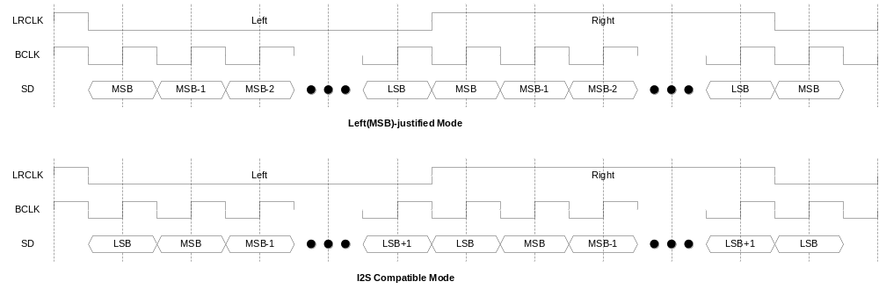

I2S_CTRL레지스터의 TxLJust bit, RxLJust bit에 의해 Transmit/Receive 동작이 configuration된다. 또한 I2S_CLKCTRL 레지스터의 LRClkInv bit를 변경하여 LRCLK의 polarity를 변경할 수 있다.

WordLength와 FIFO data

Transmit/Receive 각각 I2S_CTRL 레지스터의 TxWLen, RxWLen field에 의해 sample 하나의 sample의 bit width를 8bit/16bit/24bit/32bit으로 변경할 수 있다. FIFO는 32bit word 단위를 사용하므로 각 sample이 어떤 방식으로 FIFO에 저장되는지를 알아보면 다음과 같다.

8 bit/sample

8 bit/sample의 경우 다음과 같이 packing되어 32bit FIFO에 저장된다.
Figure 12-66 8 bit/sample data format
LeftSample/RigthSample은 각각 Left Channel Sample, Right Channel Sample을 의미하며, LeftSample0/RightSample0가 LeftSample1/RigthSample1에 비해 먼저 전송되고 Receive의 경우에는 먼저 받은 sample이 LeftSample0/RightSample0가 된다. 당연히 TX FIFO에 먼저 저장된 data부터 전송이 되고, Receive의 경우 먼저 받은 data들이 RX FIFO에 먼저 채워지게 된다.

16 bit/sample

16 bit/sample의 경우 다음과 같이 packing되어 32bit FIFO에 저장된다.
Figure 12-67 16 bit/sample data format
하위 16bit가 Left channel sample이며 상위 16bit가 Right channel sample이다.

24 bit/sample

24 bit/sample의 경우 다음과 같이 32bit FIFO에 저장된다.
Figure 12-68 24 bit/sample data format
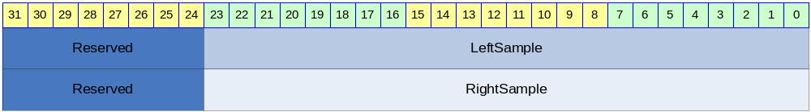

FIFO에는 Left Channel sample이 먼저 저장되고 Right Channel sample이 나중에 저장된다. Transmit의 경우 상위 8bit reserved 영역은 의미가 없고, Receive의 경우 Reserved 영역이 자동으로 sign extension되어 저장된다. 즉 Reserved 영역 8bit가 23번 bit와 같은 값으로 저장된다.

32 bit/sample

32 bit/sample의 경우 다음과 같이 32bit FIFO에 저장된다.
Figure 12-69 32 bit/sample data format
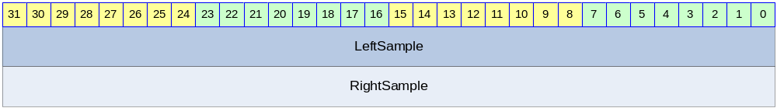

FIFO에는 32bit Left Channel sample이 먼저 저장되고 Right Channel sample이 나중에 저장된다.

Register Description

Registers

Table 12-59 Registers
Offset | Name | R/W | Description | Init. value
0000h | I2S_CLKCTRL | RW | Clock Control Register | 0000 0000h
0004h | I2S_CTRL | RW | Control Register | 0201 0201h
0008h | I2S_STATUS | RW | Status Register | 4500 0500h
000Ch | I2S_DATA | RW | FIFO | N/A

I2S_CLKCTRL Register

I2S_CLKCTRL 레지스터는 Digital Oscillator의 동작과 Master/Slave configuration을 control하는 레지스터이다.
Figure 12-70 I2S_CLKCTRL Register
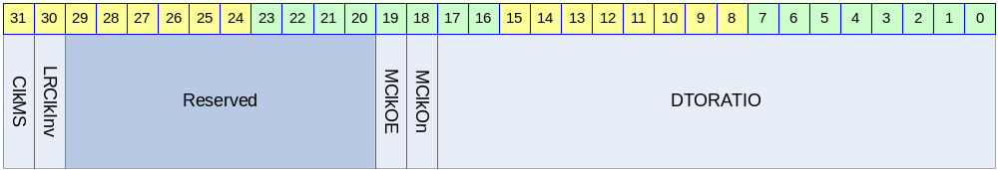

Table 12-60 I2S_CLKCTRL Register Description(Offset : 0000h)
Bits | Name | R/W | Description | Init. value
[31] | ClkMS | RW | LRCLK/BCLK의 master/slave mode 결정  0 : LRCLK/BCLK의 slave 모드로 동작  1 : LRCLK/BCLK의 master 모드로 동작 | 0b
[30] | LRClkInv | RW | LRCLK의 polarity  0 : LRCLK 정상(Left 0, Right 1)  1 : LRCLK Inverting(Left 1, Right 0) | 0b
[19] | MClkOE | RW | MCLK의 Output Enable 신호  0 : MCLK을 output pin으로 출력하지 않음  1 : MCLK을 output pin으로 출력함  MCLK output pin이 chip 전체의 GPIO와 mux될 수 있으므로 이 field는 변경될 가능성이 크다. | 0b
[18] | MClkOn | RW | Digital Oscillator의 동작을 On/Off 시킴  0 : Digital Oscillator가 동작하지 않음  1 : Digital Oscillator가 동작함 | 0b
[17:0] | DTORATIO | RW | 18bit DTO 비율  ‘2^18*MCLK의주파수/SYS_CLK의주파수’를 계산한 후 정수로 반올림한 값을 적어준다. MCLK을 생성하고 싶지 않으면 0을 write한다. | 0

ClkMS bid이 ‘1’이면 MClkOn bit은 반드시 ‘1’이어야 하고, DTORATIO field가 올바르게 setting되어야 한다. 참고로 MClkOn이 ‘1’이고 MClkOE가 ‘0’이면 MCLK을 출력하지는 않고, BCLK과 LRCLK을 생성하기 위해서만 사용하게 된다.

I2S_CTRL Register

I2S_CTRL 레지스터는 Serializer/Deserializer Block의 동작을 제어한다.

Figure 12-71 I2S_CTRL Register
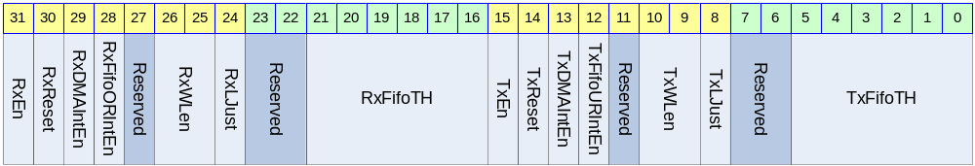

Table 12-61 I2S_CTRL Register Description(Offset : 0004h)
Bits | Name | R/W | Description | Init. value
[31] | RxEn | RW | Receive 동작의 Enable/Disable  0 : disable  1 : enable | 0b
[30] | RxReset | W | Receive hardware reset  1을 write하면 Receive 동작 관련 hardware를 초기화함  0을 write하는 것은 의미 없음 | 0b
[29] | RxDMAIntEn | RW | RX DMA request에 Interrupt발생을 enable함  0 : DMA Request Interrupt disable  1 : DMA Request Interrupt enable | 0b
[28] | RxFifoORIntEn | RW | RX FIFO OverRun Interrupt 발생을 enable함  0 : RX FIFO OverRun Interrupt disable  1 : RX FIFO OverRun Interrupt enable | 0b
[26:25] | RxWLen | RW | Receive 동작시 Word Length  00 : 8 bit/sample  01 : 16bit/sample  10 : 24bit/sample  11 : 32bit/sample | 01b
[24] | RxLJust | RW | Receive동작의 Left-justified mode와 I2S Mode 선택  0 : I2S compatible mode  1 : Left(MSB)-justified mode | 0b
[21:16] | RxFifoTH | RW | RX FIFO의 DMA request threshold  RX FIFO의 level이 RxFifoTH보다 크면 DMA Request가 생성된다. | 1
[15] | TxEn | RW | Transmit 동작의 Enable/Disable  0 : disable  1 : enable | 0b
[14] | TxReset | W | Transmit hardware reset  1을 write하면 Receive 동작 관련 hardware를 초기화함  0을 write하는 것은 의미 없음 | 0b
[13] | TxDMAIntEn | RW | TX DMA request에 Interrupt발생을 enable함  0 : DMA Request Interrupt disable  1 : DMA Request Interrupt enable | 0b
[12] | TxFifoURIntEn | RW | TX FIFO UnderRun Interrupt 발생을 enable함  0 : TX FIFO UnderRun Interrupt disable  1 : TX FIFO UnderRun Interrupt enable | 0b
[10:9] | TxWLen | RW | Transmit 동작시 Word Length  00 : 8 bit/sample  01 : 16bit/sample  10 : 24bit/sample  11 : 32bit/sample | 01b
[8] | TxLJust | RW | Transmit동작의 Left-justified mode와 I2S Mode 선택  0 : I2S compatible mode  1 : Left(MSB)-justified mode | 0b
[5:0] | TxFifoTH | RW | TX FIFO의 DMA request threshold  TX FIFO의 level이 TxFifoTH보다 작거나 같으면 DMA Request가 생성된다. | 1

I2S_STATUS Register

I2S_STATUS 레지스터는 I2S Controller의 동작 상황을 알려주기 위한 레지스터이다.

Figure 12-72 I2S_STATUS Register
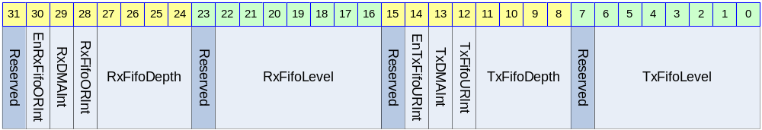

Table 12-62 I2S_STATUS Register Description(Offset : 0008h)
Bits | Name | R/W | Description | Init. Value
[30] | EnRxFifoORInt | R | RxFifo OverRun Interrupt Enable H/W State  0 : RxFifo OverRun Interrupt 발생 불가능  1 : RxFifo OverRun Interrupt 발생 가능  I2S_CTRL 레지스터의 RxReset에 ‘1’를 write하면 1로 바뀐다. | 1b
[29] | RxDMAInt | R | Receive DMA Request Interrupt  0 : DMA Request를 하고 있지 않음  1 : DMA Request를 하고 있음  Receive DMA Request를 하고 있으면 ‘1’이 되고 DMA Controller나 CPU가 RX FIFO를 읽어가면 자동으로 ‘0’으로 clear된다. I2S_CTRL의 RxDMAIntEn의 값과 관계 없이 변하고, RxDMAIntEn이 ‘1’이면 CPU로 interrupt를 보내게 된다. | 0b
[28] | RxFifoORInt | RW | Receive FIFO OverRun Interrupt 발생  0 : OverRun 상황 없었음  1 : OverRun 상황 있었음  이 bit는 I2S_CTRL 레지스터의 RxFifoORIntEn이 ‘1’일 때만 1로 set되고 이 bit가 1이면 CPU로 interrupt를 보내게 된다. CPU가 ‘1’을 write하여 clear할 수 있고, clear하기 전까지는 ‘0’으로 reset되지 않는다. | 0b
[27:24] | RxFifoDepth | R | Receive FIFO의 Depth  Maximum 6까지의 값을 가진다.  Receive FIFO는 2^RxFifoDepth개의 Entry를 가지게 된다. | 5h
[22:16] | RxFifoLevel | R | 현재 RX FIFO의 level로 0에서 2^RxFifoDepth의 값을 가진다. I2S_CTRL 레지스터의 RxReset에 ‘1’을 write하여 강제로 0으로 초기화할 수 있다. | 0
[14] | EnTxFifoURInt | R | TxFifo UnderRun Interrupt Enable H/W State  0 : TxFifo UnderRun Interrupt 발생 불가능  1 : TxFifo UnderRun Interrupt 발생 가능  I2S_CTRL 레지스터의 TxReset에 ‘1’를 write하면 0로 바뀐다. | 0b
[13] | TxDMAInt | R | Transmit DMA Request Interrupt  0 : DMA Request를 하고 있지 않음  1 : DMA Request를 하고 있음  Transmit DMA Request를 하고 있으면 ‘1’이 되고 DMA Controller나 CPU가 TX FIFO에 data를 채우면 자동으로 ‘0’으로 clear된다. I2S_CTRL의 TxDMAIntEn의 값과 관계 없이 변하고, TxDMAIntEn이 ‘1’이면 CPU로 interrupt를 보내게 된다. | 0b
[12] | TxFifoURInt | RW | Transmit FIFO UnderRun Interrupt 발생  0 : UnderRun 상황 없었음  1 : UnderRun 상황 있었음  이 bit는 I2S_CTRL 레지스터의 TxFifoURIntEn이 ‘1’일 때만 1로 set되고 이 bit가 1이면 CPU로 interrupt를 보내게 된다. CPU가 ‘1’을 write하여 clear할 수 있고, clear하기 전까지는 ‘0’으로 reset되지 않는다. | 0b
[11:8] | TxFifoDepth | R | Transmit FIFO의 Depth  Maximum 6까지의 값을 가진다.  Transmit FIFO는 2^TxFifoDepth개의 Entry를 가지게 된다. | 5h
[6:0] | TxFifoLevel | R | 현재 TX FIFO의 level로 0에서 2^TxFifoDepth의 값을 가진다. I2S_CTRL 레지스터의 TxReset에 ‘1’을 write하여 강제로 0으로 초기화할 수 있다. | 0
RxDMAInt와 TxDMAInt는 DMA Controller를 사용하는 경우 CPU의 동작과는 무관하게 toggle되므로 RxDMAIntEn, TxDMAIntEn을 모두 ‘0’으로 setting하여 CPU로 interrupt가 전달되지 않도록 하여야 한다.
RxFifoLevel의 maximum 값은 2^RxFifoDepth이고, 이 때 Receive FIFO가 full인 상태가 된다. TxFifoLevel의 maximum 값은 2^TxFifoDepth이고, 이 때 Transmit FIFO가 full인 상태가 된다. RxFifoLevel과 TxFifoLevel이 0인 경우 각 FIFO가 empty 상황임을 나타낸다.

I2S_DATA Register

I2S_DATA 레지스터는 TX FIFO와 RX FIFO를 access할 수 있는 레지스터로 Word(32bit) 단위로 access해야 한다.

Figure 12-73 I2S_DATA Register
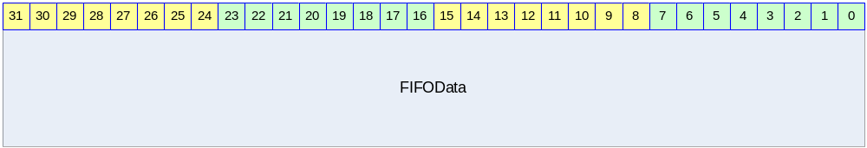

Table 12-63 I2S_DATA Register Description(Offset : 000Ch)
Bits | Name | R/W | Description | Init. Value
[31:0] | FIFOData | RW | Read의 경우 RX FIFO에서 data를 읽어서 return하고 Write의 경우 TX FIFO에 data를 write하게 된다. | N/A

TX FIFO가 full일 때 I2S_DATA에 data를 write하게 되면 write한 data는 FIFO에 write되지 않는다. RX FIFO가 empty일 때 I2S_DATA를 read하게 되면 0을 리턴한다.

I2C Master

Overview

Feature

- APB Interface
- 7/10bit Addressing
- HS-Mode Support
- Multi-Master Support
- Interrupt Signal Support

Block Diagram

Figure 13-74 I2C Block Diagram
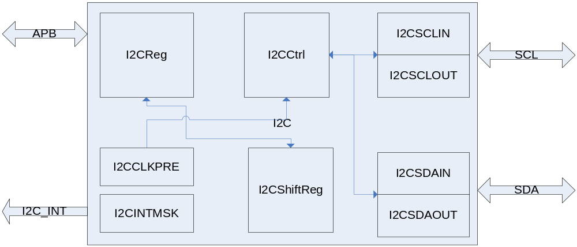

Operation

Overview

- 7/10bit addressing
- Clock Synchronization
- Arbitration
- HS-Mode

Signal Description

I2C Module Signal

Table 13-64 I2C Module Signal
Signal Name | Direction | Description | Init. Value
SDAo | Output | SDA line Output
SDAi | Input | SDA line Input
SCLo | Output | SCL line Output
SCLi | Iutput | SCL line Input
n_SDAEn | Output | SDA 3-State Buffer Enable
n_SCLEn | Output | SCL 3-State Buffer Enable
I2CInt | Output | I2C Interrupt Signal

Register Description

Registers

Table 13-65 Registers
Offset | Name | R/W | Description | Init. Value
0000h | I2CCON | RW | I2C Control Register | 0000 0000h
0004h | I2CSTA | RW | I2C Status Register | 0000 0000h
0010h | I2CDAT | RW | I2C Data Register | 0000 0000h

I2CCON (I2C Control) Register

Figure 13-75 I2CCON Register Bits
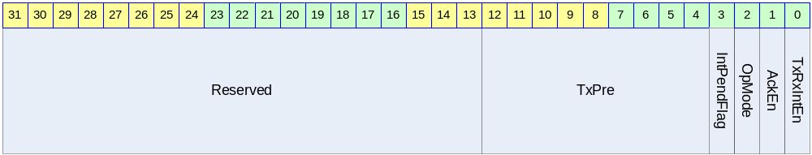

Table 13-66 I2CCON Register Description (Offset : 0000 0000h)
Bits | Name | R/W | Description | Init. Value
[12:4] | TxPre | R/W | I2C Clock Prescaler Value  Bus Clock Divide | 111111111
[3] | IntPendFlag | R/C | 1: Pending Status (READ)  Pending Clear (Write)  0: Not Pending (READ) | 0
[2] | OpMode | R/W | Operation Mode  1: Master Tx  0: Master Rx | 1
[1] | AckEn | R/W | Acknowledge Enable  1: Send ACK  0: Send NACK | 0
[0] | TxRxIntEn | R/W | Interrupt Enable  1: Interrupt Enable  0: Interrupt Disable | 0

I2CSTA (I2C Status) Register

Figure 13-76 I2CSTA Register Bits
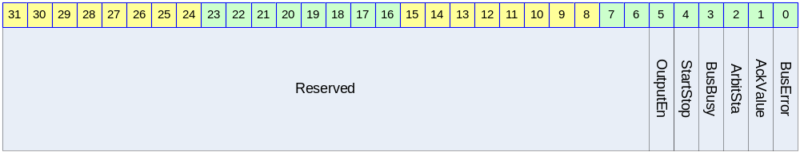

Table 13-67 I2CSTA Register Description (Offset : 0000 0004h)
Bits | Name | R/W | Description | Init. Value
[5] | OutputEn | R/W | //Reserved  1: Output Enable 0: Output Disable | 0
[4] | StartStop | W | Start/ Stop  1: Start 0: Stop  세팅되고 실행되면 자동으로 clear되는 구조 | ?
[3] | BusBusy | R | 1: Bus Busy  0: Bus not Busy  전송을 개시할 경우 이 bit를 보고 다른 mater가 사용을 하고 있는지 알 수 있다. | 0
[2] | ArbitSta | R | Arbitration Status  1: Arbitration Lost  0: Arbitration OK | 0
[1] | AckValue | R | Received Ack Value (Tx Mode일 경우에 유효)  1: Receive NACK  0: Receive ACK | 0
[0] | BusError | R | Bus Error Status  1: Bus Error (다른 사용 중에 start 시켰을 경우)  0: Bus no Error | 0

I2CDAT (I2C Data) Register

Figure 13-77 I2CDAT Register Bits
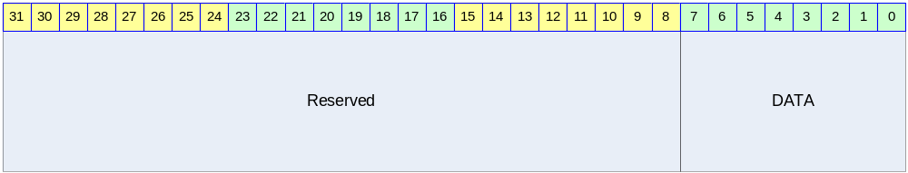

Table 13-68 I2CDAT Register Description (Offset : 0000 0008h)
Bits | Name | R/W | Description | Init. Value
[7:0] | I2C_DATA | RW | Send or Received Data  Tx로 사용될 때는 보낼 데이터를 쓰고  Rx로 사용할 때는 받은 데이터를 읽는 용도로 사용된다.  Rx모드가 아닐 때의 값은 유효하지 않음 | 0

Operation Sequence

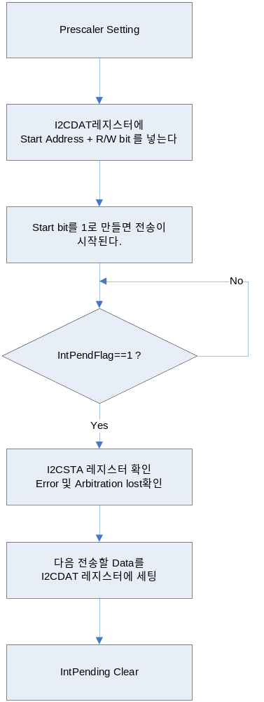

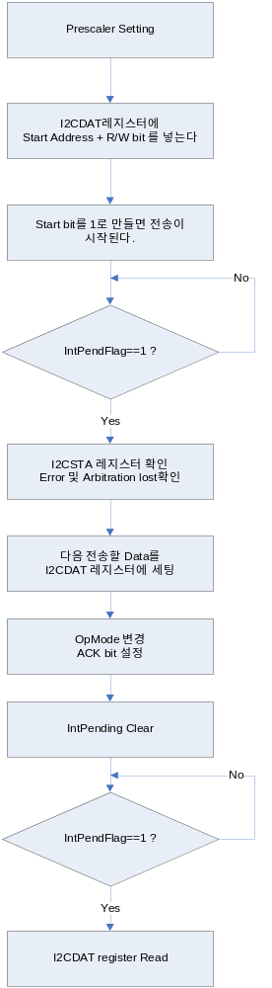

UART

Overview

Features

- Support 2 Channel
- Baudrate : up to 115200 bps
- 32 Byte FIFO for Tx/Rx(Channel 0)
- 8 Byte FIFO for Tx/Rx(Channel 1)
- Digital Frequency Synthesizer
- Receive Time Out
- Included Low pass filter at RxD Signal
- DMA Support for Channel 0

Figure 14-78 Block Diagram
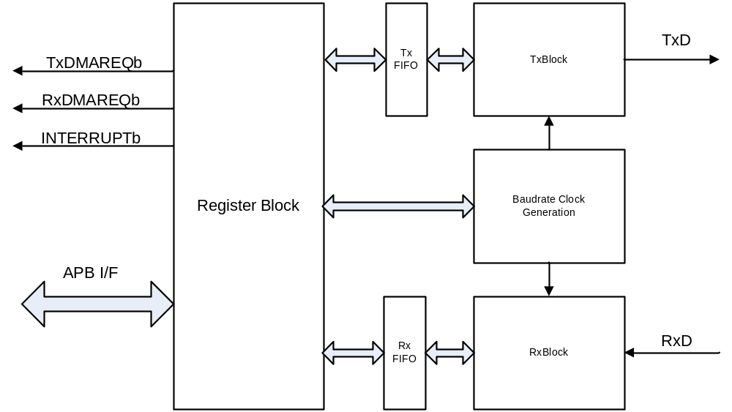

Register

Table 14-69 UART Register
Offset | Name | R/W | Description | Init. value
0x0000 | UART0CMD | RW | UART 0 Master command register | 0000 0000h
0x0004 | UART0STS | RW | UART 0 Status register | 0000 0000h
0x0008 | UART0BAUD | RW | UART 0 Buadrate Gen Register | 0000 0000h
0x000C | UART0TXDAT | W | UART 0 TxFIFO Write register | 0000 0000h
0x0010 | UART0RXDAT | R | UART 0 RxFIFO Read register | 0000 0000h
0x0014 | UART0RXTMOUT | RW | UART 0 Receive time out register | 0000 0000h
0x0040 | UART1CMD | RW | UART 1 Master command register | 0000 0000h
0x0044 | UART1STS | RW | UART 1 Status register | 0000 0000h
0x0048 | UART1BAUD | RW | UART 1 Buadrate Gen Register | 0000 0000h
0x004C | UART1TXDAT | W | UART 1 TxFIFO Write register | 0000 0000h
0x0050 | UART1RXDAT | R | UART 1 RxFIFO Read register | 0000 0000h
0x0054 | UART1RXTMOUT | RW | UART 1 Receive time out register | 0000 0000h

2 Channel의 UART는 동일한 기능을 제공한다. 각 Register 설명은 한 Channel에 대해서만 설명하기로 한다.

Master Command Register

Figure 14-79 Master Command Register
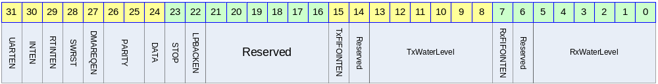

UART의 Master Command 레지스터이다. UART의 enable및 각종 제어 부분을 설정한다.

Table 14-70 Master Command Register Description
Bits | Name | R/W | Description | Init. Value
31 | Enable UART | R/W | UART 동작의 enable/disable  0 : disable  1 : enable | 0b
30 | Enable interrupt generation | R/W | UART의 인터럽트 발생을 Enable 혹은 Disable한다.  0 : Disable  1 : Enable | 0b
29 | Enable RT Out  Interrupt | R/W | UART의 Receive timeout interrupt를 Enable 혹은 Disable 한다.  0 : Disable  1 : Enable | 0b
28 | Software Reset | W | UART의 모든 상태를 Clear한다.  0 : no effect  1 : Software reset(auto cleared)  Software reset이 assert되면 Status 레지스터의 parity/frame/overrun/receive time out error bit과 interrupt status bit이 clear되고 TX Status가 idle로 돌아가며 TX FIFO가 Flush된다. | N/A
27 | Enable DMA Request | R/W | DMA Request를 Enable 혹은 Disable한다.  0 : Disable  1 : Enable | 0b
26:25 | Parity | R/W | UART의 Parity mode를 설정한다.  0x : None  10 : Even parity  11 : Odd parity | 00b
24 | Data bit | R/W | UART의 Databit를 설정한다.  0 : 7 bit  1 : 8 bit | 0b
23 | Stop bit | R/W | UART의 Stop bit를 설정한다.  0 : 1 Stop bit  1 : 2 Stop bit | 0b
22 | Enable Loopback | R/W | UART의 Loopback mode를 설정한다.  0 : Disable  1 : Enable | 0b
15 | TxFIFOINTEN | R/W | TxFIFO의 Interrupt를 Enable 여부를 설정한다.  0 : Disable  1 : Enable  TxFIFOINTEN이 1이고 TxFIFO의 Level이 TxWaterLevel보다 적거나 같으면 Interrupt가 발생하고 Status Register TxFIFOINT가 ‘1’로 set된다. | 0b
13:8 | Tx Water Level | R/W | TX FIFO의 Water Level을 설정한다.  TxFIFO에 Tx Water Level보다 많거나 같은 데이터가 있으면 인터럽트 혹은 DMA 요청이 설정에 따라서 발생한다. | 000000b
7 | RxFIFOINTEN | R/W | RxFIFO의 Interrupt를 Enable 여부를 설정한다.  0 : Disable  1 : Enable  RxFIFOINTEN이 1이고 RxFIFO의 Level이 RxWaterLevel보다 크면 Interrupt가 발생하고 Status Register RxFIFOINT가 ‘1’로 set된다. | 0b
5:0 | Rx Water Level | R/W | Rx FIFO의 Water Level을 설정한다.  RxFIFO에 Rx Water level보다 적은 데이터가 있으면 인터럽트 혹은 DMA 요청이 설정에 따라서 발생한다. | 000000b
주의 사항 : Software reset bit가 ‘1’이 값을 Master command register에 write하면 다른 field는 변경되지 않는다.

Status Register

Figure 14-80 Status Register
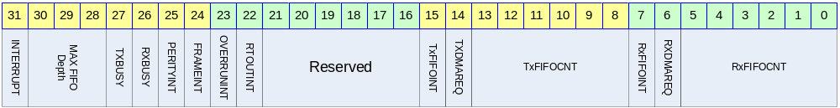

Table 14-71 Status Register Description
Bits | Name | R/W | Description | Init. Value
31 | INTERRUPT | R | UART에서 인터럽트가 발생하였는지 여부를 알려주는 레지스터  0 : None  1 : Interrupt Asserted | 0b
30:28 | MAX FIFO Depth | R | UART의 FIFO의 최대 Depth를 알려준다.  버전별로 틀리므로 이 레지스터를 읽어서 크기를 확인할 수 있다.  000 : FIFO None  001 : 8 depth  010 : 16 depth  011 : 32 depth  Others : Reserved | CH0:011b  CH1:001b
27 | TxBUSY | R | TxModule의 동작이 현재 전송 동작 중이라는 것을 알려준다.  0 : IDLE or wait tx fifo fill  1 : Transmit busy | 0b
26 | RxBUSY | R | Rx Module의 동작이 현재 수신 동작 중이라는 것을 알려준다.  0 : IDLE or wait state  1 : Receive Busy | 0b
25 | Parity Error interrupt | R/W | Rx Buffer에 수신된 데이터에  Parity Error가 발생하였음을 알려준다.  0 : none parity error  1 : parity error  1을 write하면 clear된다. | 0b
24 | Frame error interrupt | R/W | RxBuffer에 수신된 데이터에 Frame Error가 있음을 알려준다.  0 : none frame error  1 : frame error  1을 write하면 clear된다. | 0b
23 | Overrun error | R/W | Rx FIFO가 Overrun되었음을 알려준다.  0 : None overrun error  1 : Overrun error  1을 write하면 clear된다. | 0b
22 | Receive time out | R | Receive time out이 발생하였음을 알려준다.  0 : none time out  1 : Time out  이 bit만 clear시키고 싶으면 master command register 29번 bit를 clear하면 된다. | 0b
15 | TxFIFOINT | R | TxFIFO Interrupt 발생 여부를 알려준다.  0 : Tx FIFO Interrupt 발생 안함  1 : Tx FIFO Interrupt 발생 | 0b
14 | TxFIFO DMA Request | R | TxFIFO water level DMA request  0 : None request  1 : DMA Request | 0b
13:8 | TxFIFO count | R | Tx Buffer의 FIFO에 남아 있는 데이터의 개수를 확인할 수 있다. | 0
7 | RxFIFOINT |  | RxFIFO Interrupt 발생 여부를 알려준다.  0 : RxFIFO Interrupt 발생 안함  1 : RxFIFO Interrupt 발생
6 | RxFIFO Count | R | RxFIFO water level DMA request  0 : None request  1 : DMA Request | 0b
5:0 | RxFIFO Count |  | Rx Buffer의 FIFO에 수신된 데이터의 Count의 개수를 확인 할 수 있다. | 0

Baudrate Gen Register

Figure 14-81 Baudrate Gen Register
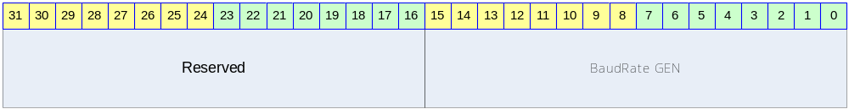

Table 14-72 Baudrate Gen Register Description
Bits | Name | R/W | Description | Init. Value
31:16 | Reserved
15:0 | Baudrate Gen | R/W | Baudrate generation clock value | 0000h

TxFIFO Write Register

Figure 14-82 TxFIFO Write Register
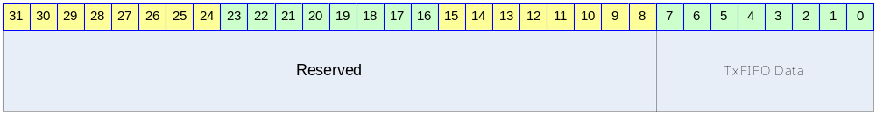

Table 14-73 TxFIFO Write Register Description
Bits | Name | R/W | Description | Init. Value
31:8 | Reserved |  |  | N/A
7:0 | TxFIFO Data | W | TxFIFO Data | N/A

RxFIFO Read Register

Figure 14-83 RxFIFO Read Register
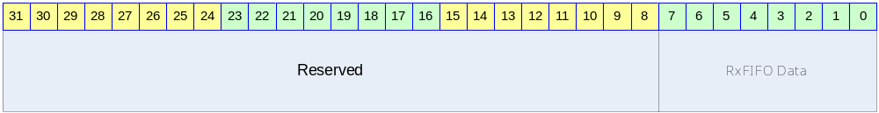

Table 14-74 RxFIFO Read Register Description
Bits | Name | R/W | Description | Init. Value
31:8 | Reserved |  |  | N/A
7:0 | RxFIFO Data | R | RxFIFO Data | 00h

Receive Time Out Count Register

Figure 14-84 Receive Time Out Count Register
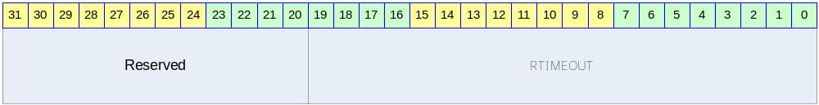

Table 14-75 Receive Time Out Count Register
Bits | Name | R/W | Description | Init. Value
31:20 | Reserved |  |  | N/A
19:0 | RTIMEOUT | R/W | Receive Time Out | 00000h

Operation

Baudrate Clock Generation

UART는 PCLK을 Digital Synthesizer로 분주하여 Rx/Tx의 속도를 결정하게 되는데 다음과 같이 계산된 값을 Baudrate Gen 레지스터에 적어 주어야 한다.

Baudrate Gen Value = RoundtoNearInteger[2^16*(Baudrate*16)/50MHz]

예를 들어 115200 bps를 만들고 싶으면
Baudrate Gen Value = RoundtoNearInteger[2^16*(115200Hz*16)/50MHz]
= RoundToNearInteger[65536*115200*16/50000000]
= RoundToNearInteger[2415.9191]
= 2416

2416의 값을 Baudrate Gen 레지스터에 적어주면 된다.

Low Pass Filter

RXD 입력단에 Low pass Filter를 내장하여 외부 신호의 Noise에 강한 특성을 가지고 있다.

Figure 14-85 Low Pass Filter at RxD
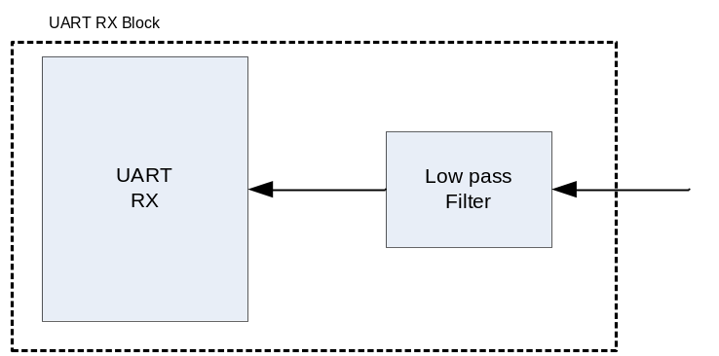

Startbit에서 noise가 발생하여도 bit time의 23.5%까지는 noise로 인식을 하게 된다. 그 이상의 비율로 signal이 detect되면 그것은 올바른 signal로 인식하게 된다.
내부의 start signal 판별 회로에 의해서 한번 더 filtering됨으로써 전체적으로 안정적인 동작을 수행할 수 있다.

DMA/Interrupt Water Level

Channel 0은 32 Depth의 FIFO을 Rx/Tx 각각 가지고 있고, Channel 1은 8 Depth의 FIFO를 Rx/Tx 각각 가지고 있다. FIFO에 저장된 data의 개수에 의해서 DMA Request가 발생하거나 Interrupt가 발생하게 된다. Rx/Tx 각각 FIFO Interrupt enable bit(RxFIFOINTEN/TxFIFOINTEN)을 가지고 있고, Interrupt 발생 여부를 알 수 있는 flag(RxFIFOINT/TxFIFOINT)가 있다. DMA mode로 동작시킬 때(Enable DMA Request가 1이고 DMA Controller를 activation시킨 경우)는 Rx/Tx FIFO의 level이 DMA 상황에 따라서 변하므로 RxFIFOINTEN과 TxFIFOINTEN을 ‘1’로 세팅하지 말아야 한다.

Figure 14-86 FIFO Water Level
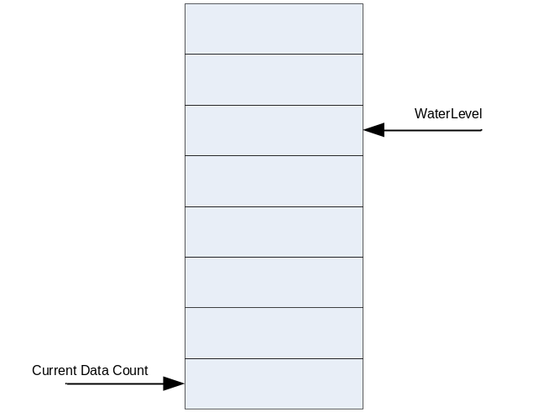

Figure 14-87 DMA/Interrupt Generation Logic
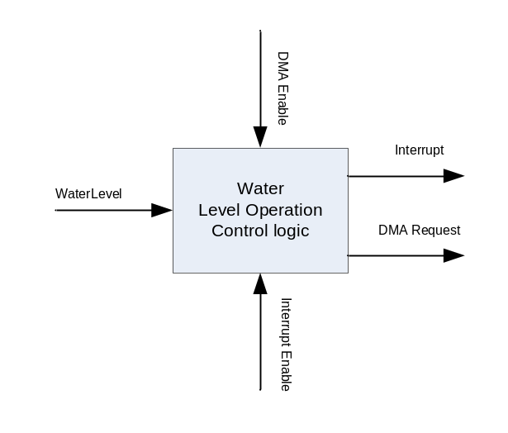

Tx의 경우 Water Level보다 FIFO의 data 개수가 적거나 같으면 event가 발생하는데, 이 event는 DMA가 활성화 되어 있는 경우 DMA Request를 생성하고 그렇지 않으면 interrupt를 발생시킨다.
Rx의 경우 Water Level보다 FIFO의 data 개수가 많아지면 event가 발생하는데, 이 event는 DMA가 활성화 되어 있는 경우 DMA Request를 생성하고 그렇지 않으면 interrupt를 발생시킨다.
Interrupt 신호는 Active High Level triggered signal을 사용한다.

Receive Time Out Interrupt

Receive Time Out은 RXD 핀으로 데이터가 일정 시간 동안 수신되지 않는 경우 발생하게 된다. 이 기능을 활성화시키기 위해서는 Master command 레지스터의 29번 bit를 1로 세팅하면 된다.
Time Out이 걸리는 시간은 Receive Time Out Count 레지스터의 값에 의해 결정되는데, 일단 활성화되면 수신이 되지 않은 시간을 16배의 baudrate clock으로 count하게 된다.
이 counter의 값이 Receive Time Out Count 레지스터의 값과 같아지면 Receive Time Out Interrupt가 발생한다.

Loopback Mode

UART의 기능을 테스트하기 위해서 송신 데이터가 그대로 수신 데이터로 수신되는 모드이다. 이 기능은 Master command 레지스터의 22번 bit를 1로 세팅하여 활성화시킬 수 있다. 단 loopback mode에서도 송신데이터는 외부 핀으로 전송된다.

GPIO

Overview

32bit GPIO port를 가지는 GPIO Controller를 두 개 제공한다.

Features

- 32bit GPIO x 2
- Interrupt Generation
  - Active high/low level interrupt
  - Positive/Negative edge interrupt
  - Both edge interrupt

Operation

GPIO Operation

GPIO 동작은 다음과 같은 block diagram으로 이해할 수 있다. 사용자는 출력하고 싶은 data가 있으면 GPIO_OUT 레지스터에 값을 쓰고, GPIO_OE 레지스터에 출력 pin에 해당 하는 bit를 ‘1’로 write해 주면 tri-state buffer가 enable되어 외부 PAD로 출력이 이루어지게 된다. GPIO port로 입력 받은 signal은 GPIO_IN 레지스터를 읽음으로써 detect할 수있다.

Figure 15-88 GPIO Operation Block Diagram
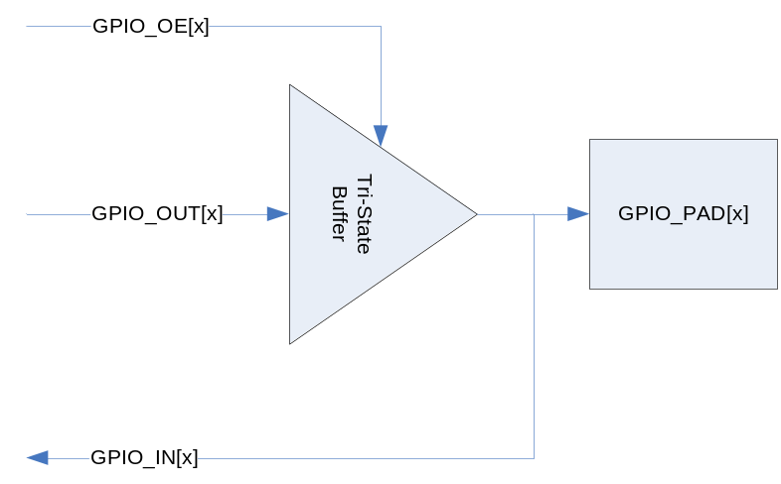

Interrupt Operation

외부에서 PAD에서 입력되는 신호를 detect하여 Interrupt Controller로 interrupt를 발생시킬 수 있다.

Figure 15-89 Interrupt Operation Block Diagram
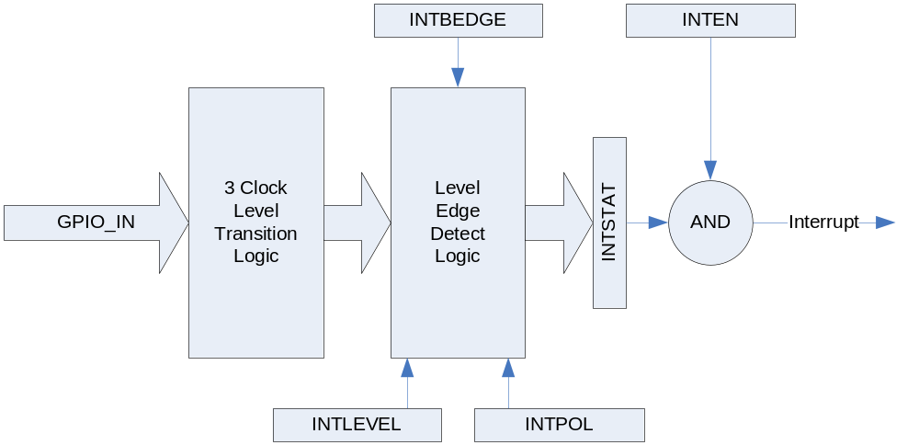

위의 그림과 같이 GPIO PAD에서 오는 GPIO_IN 신호는 3 Clock Level Transition Logic을 지나게 된다. 3 Clock Level Transition Logic은 PAD에서 들어오는 노이즈를 걸러내는 일을 하는데, 총 3 APB Clock Cycle 동안 GPIO_IN이 stable한 경우에 그것을 올바른 신호로 인식하고, GPIO_IN이 3 cycle보다 작은 시간 동안 변하는 경우에는 노이즈로 인식하여 입력 신호가 바뀌었다고 판단하지 않게 된다. 처리가 끝난 신호는 Level/Edge Detect Logic에 인가 되어 Level/Edge의 detect 결과가 INTSTAT 레지스터로 출력 된다. 그 후에 INTSTAT 레지스터와 INTEN 레지스터를 bitwise AND하고 그 결과값이 0이 아니면 active high level interrupt가 생성되게 된다. Level/Edge Detect Logic은 INTLEVEL/INTPOL/INTBEDGE 레지스터에 의해서 control되는데 우선 INTLEVEL은 Level interrupt인지 edge interrupt인지를 결정하게 된다. INTLEVEL[x]가 1이면 GPIO[x]에 입력되는 signal은 level interrupt로 처리되고 0이면 edge interrupt로 처리된다. INTBEDGE는 interrupt가 both edge에서 동작하도록 하는 레지스터이다. INTBEDGE[x]가 1이면 GPIO[x]에 입력되는 signal의 rising edge와 polling edge 양쪽에서 interrupt가 생성된다. 단 이때는 INTLEVEL[x]가 0이어야 하고 INTLEVEL[x]가 1이면 INTBEDGE[x] 값은 무시된다. INTPOL는 GPIO에 인가되는 interrupt signal의 polarity를 정하게 된다. INTPOL[x]가 1이면 active high(edge의 경우 rising edge)가 되고 0이면 active low(edge의 경우 polling edge)가 된다. INTLEVEL[x]가 0이고 INTBEDGE[x]가 1이면 both edge를 detect하는 것이므로 INTPOL[x]는 무시된다.

Interrupt Operation Example

- GPIO PAD[x]에서 받는 신호가 high level에서 interrupt 생성을 워하는 경우
INTLEVEL[x] : 1로 세팅
INTPOL[x] : 1로 세팅
INTEN[x] : 1로 세팅

- GPIO PAD[x]에서 받는 신호의 falling edge에서 interrupt 생성을 원하는 경우
INTLEVEL[x] : 0로 세팅
INTPOL[x] : 0로 세팅
INTBEDGE[x] : 0로 세팅
INTSTAT[x] : 0으로 clear함
INTEN[x] : 1로 세팅

- GPIO PAD[x]에서 받는 신호의 rising/falling edge 모두에서 interrupt생성을 원하는 경우
INTLEVEL[x] : 0로 세팅
INTBEDGE[x] : 1로 세팅
INTSTAT[x] : 0으로 clear함
INTEN[x] : 1로 세팅

Register Description

Registers

Table 15-76 Registers
Offset | Name | R/W | Description | Init. value
0000h | GPIO0_OE | RW | (GPIO0) Output Enable Register | 0000 0000h
0004h | GPIO0_IN | R | (GPIO0) Input Register | N/A
0008h | GPIO0_OUT | RW | (GPIO0) Output Register | 1234 5678h
000Ch | GPIO0_INTSTAT | RW | (GPIO0) Interrupt Status Register | N/A
0010h | GPIO0_INTEN | RW | (GPIO0) Interrupt Enable Register | 0000 0000h
0014h | GPIO0_INTLEVEL | RW | (GPIO0) Interrupt Level/Edge Selection Register | 0000 0000h
0018h | GPIO0_INTPOL | RW | (GPIO0) Interrupt Polarity Register | 0000 0000h
001Ch | GPIO0_INTBEDGE | RW | (GPIO0) Interrupt Both Edge Register | 0000 0000h
0020h | GPIO1_OE | RW | (GPIO1) Output Enable Register | 0000 0000h
0024h | GPIO1_IN | R | (GPIO1) Input Register | N/A
0028h | GPIO1_OUT | RW | (GPIO1) Output Register | 1234 5678h
002Ch | GPIO1_INTSTAT | RW | (GPIO1) Interrupt Status Register | N/A
0030h | GPIO1_INTEN | RW | (GPIO1) Interrupt Enable Register | 0000 0000h
0034h | GPIO1_INTLEVEL | RW | (GPIO1) Interrupt Level/Edge Selection Register | 0000 0000h
0038h | GPIO1_INTPOL | RW | (GPIO1) Interrupt Polarity Register | 0000 0000h
003Ch | GPIO1_INTBEDGE | RW | (GPIO1) Interrupt Both Edge Register | 0000 0000h

GPIO Output Enable Register (GPIO0_OE /GPIO1_OE)

GPIO Output Enable 레지스터는 GPIO PAD의 tristate buffer를 enable하기 위한 레지스터이다.

Figure 15-90 GPIO Output Enable Register
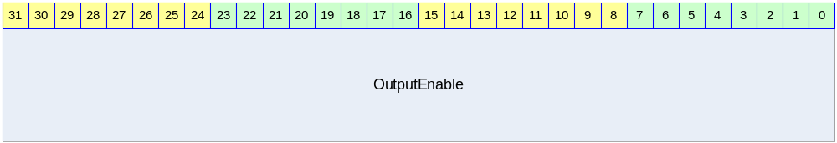

Table 15-77 GPIO Output Enable Register Description
Bits | Name | R/W | Description | Init. value
[31:0] | OutputEnable | RW | GPIO Output Enable  각 bit가 1이면 해당 GPIO PAD에 GPIO_OUT 레지스터의 해당 bit가 출력된다.  0이면 해당 GPIO PAD가 tristate 상태가 된다. | 0000 0000h

GPIO Input Register (GPIO0_IN/GPIO1_IN)

GPIO Input 레지스터는 GPIO PAD에 인가된 signal을 읽을 수 있는 레지스터이다.

Figure 15-91 GPIO Input Register
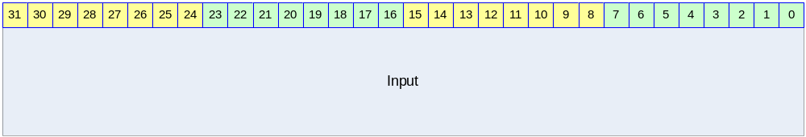

Table 15-78 GPIO Input Register Description
Bits | Name | R/W | Description | Init. value
[31:0] | Input | R | GPIO Input  GPIO PAD에 인가된 값을 읽을 수 있다.  Input[x]가 1이면 해당 GPIO PAD에 high level의 voltage가 인가되었음을 나타낸다. | N/A

GPIO Output Register (GPIO0_OUT/GPIO1_OUT)

GPIO Output 레지스터는 GPIO PAD에 출력될 값을 저장하고 있는 레지스터이다.

Figure 15-92 GPIO Output Register
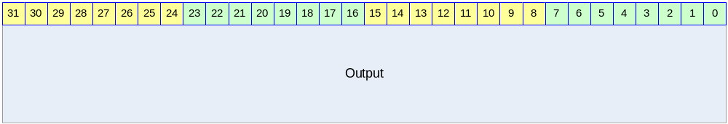

Table 15-79 GPIO Output Register Description
Bits | Name | R/W | Description | Init. Value
[31:0] | Output | RW | GPIO Output  OuputEnable[x]가 1이고 Output[x]가 1이면 해당 GPIO PAD에 high level에 해당하는 전압이 인가된다. OutputEnable[x]가 1이고 Output[x]가 0이면 해당 GPIO PAD에 low level에 해당하는 전압이 인가된다.  OutputEnable[x]가 0이면 Output[x]는 아무런 의미가 없다. | 0b

GPIO Interrupt Status Register (GPIO0_INTSTAT/GPIO1_INTSTAT)

GPIO PAD로 입력 받은 interrupt status를 의미하는 레지스터이다.

Figure 15-93 GPIO Interrupt Status Register
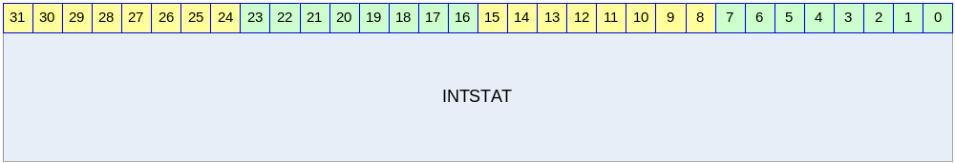

Table 15-80 GPIO Interrupt Status Register Description
Bits | Name | R/W | Description | Init. Value
[31:0] | INTSTAT | RW | GPIO Interrupt Status  1 : Level or Edge detected  0 : Level or Edge not detected  Level/Edge detect 상황이 반영되는 register이다. 1을 write하면 해당 bit가 0으로 clear되고 0을 write하는 것은 의미가 없다. | 0000 0000h

위의 동작설명에서 보았듯이 INTSTAT의 bit는 INTEN와는 아무런 상관 없이 변하게 된다. 즉 GPIO PAD에 인가되고 있는 signal에 변화가 생기게 되면 해당 bit의 INTSTAT이 변하게 된다. Interrupt는 INTSTAT과 INTEN의 bitwise AND의 결과 32bit 값이 0이 아니면 발생하게 된다. 어떤 bit 때문에 interrupt가 생성되었는지 알고 싶으면 사용자는 INTEN와 INTSTAT을 bitwise AND한 32bit data에 대해서 0이 아닌 bit를 찾아야 한다. Edge interrupt의 경우 interrupt service routine에서 해당 bit를 0으로 clear하는 것으로 Interrupt Acknowledge를 하며 된다. Level interrupt는 별도의 interrupt acknowledge를 할 필요는 없고 interrupt를 assert한 외부 device에서 해당 interrupt를 clear하는 것으로 모든 처리가 끝나게 된다.

GPIO Interrupt Enable Register (GPIO0_INTEN/GPIO1_INTEN)

GPIO PAD로 입력 받은 interrupt status를 의미하는 레지스터이다.

Figure 15-94 GPIO Interrupt Enable Register
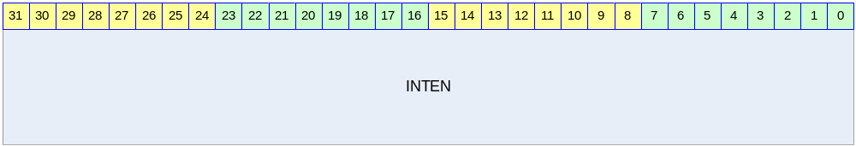

Table 15-81 GPIO Interrupt Enable Register Description
Bits | Name | R/W | Description | Init. Value
[31:0] | INTEN | RW | GPIO Interrupt Enable  1 : Interrupt Enable  0 : Interrupt Disable  어떤 bit를 1이면 INTSTAT의 해당 bit가 1로 바뀔 때 interrupt가 생성된다. | 0000 0000h

GPIO Interrupt Level/Edge Selection Register (GPIO0_INTLEVEL/GPIO1_INTLEVEL)

GPIO PAD로 입력 받을 interrupt 신호의 형태가 level trigger 인지 edge trigger인지 선택하는 레지스터이다.

Figure 15-95 GPIO Interrupt Level/Edge Selection Register
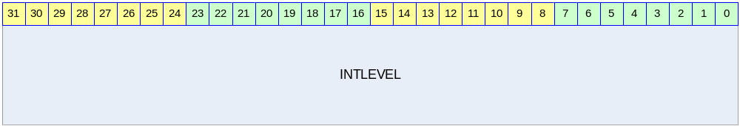

Table 15-82 GPIO Interrupt Level/Edge Selection Register
Bits | Name | R/W | Description | Init. Value
[31:0] | INTLEVEL | RW | GPIO Interrupt Level/Edge Selection  1 : Level trigger mode  0 : Edge trigger mode | 0000 0000h

GPIO Interrupt Polarity Register (GPIO0_INTPOL/GPIO1_INTPOL)

GPIO PAD에 가해지는 signal로 interrupt를 detect하는 경우 그 interrupt 신호가 active high인지 active low인지 결정하는 레지스터이다.

Figure 15-96 GPIO Interrupt Polarity Register
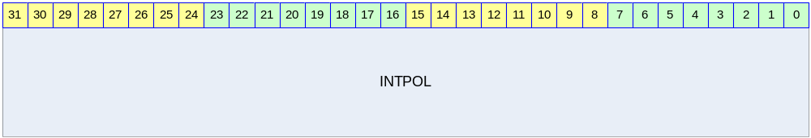

Table 15-83 GPIO Interrupt Polarity Register Description
Bits | Name | R/W | Description | Init. Value
[31:0] | INTPOL | RW | GPIO Interrupt Polarity Selection  1 : active high(rising edge)  0 : active low(falling edge) | 0000 0000h

GPIO Interrupt Both Edge Register (GPIO0_INTBEDGE/GPIO1_INTBEDGE)

GPIO PAD에 인가되는 signal의 양쪽 edge(즉 rising edge, falling edge 모두)에서 interrupt를 생성할 것인지 결정하는 레지스터이다.

Table 15-84 GPIO Interrupt Both Edge Register
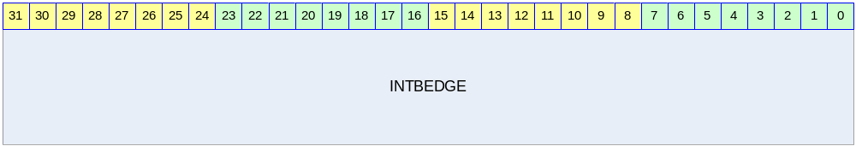

Table 15-85 GPIO Interrupt Both Edge Register Description
Bits | Name | R/W | Description | Init. Value
[31:0] | INTBEDGE | RW | GPIO Interrupt Both Edge  1 : interrupt when both edge  0 : interrupt when single edge  INTLEVEL의 특정 bit 위치의 값이 1인경우 해당 위치의 INTBEDGE bit는 아무런 의미가 없다. | 0000 0000h

SPI

Overview

Serial Peripheral Interface
Serial 통신을 하는 방법의 하나로 Master에서 나오는 SPI CLOCK과 MOSI (Master Output Slave Input), MISO(Master Input Slave Output)과 SS(Slave Select)신호로 구성이 된다.
통신은 Master가 Clock을 내보내는 것으로 송수신이 이루어진다

Master
Clock을 내보내는 쪽을 지칭한다.
Slave
Master에서 보내온 Clock에 따라 Data를 송수신 하는 모듈을 말한다. Master는 여러 Slave 중에서 하나의 Slave를 선택하기 위해서 SS핀을 사용하기도 한다.
정확한 송수신을 위해서 Master와 Slave간의 Clock Polarity와 Clock Phase가 서로 같아야만 한다. 그렇지 않으면 엉뚱한 데이터 값을 읽고 쓰게 된다

Feature

- 1 Channel SPI (SPI0 and SPI1)
- Master/Slave Mode Support
- Receive Time Out Interrupt Support for DMA Remain Value
- DMA Support (Tx 8depth, Rx 8depth)
- SPI0 is Support DMA and FIFO Feature
- SPI1 is Not Support DMA and FIFO Feature

Block Diagram

Figure 16-97 SPI Controller Block Diagram
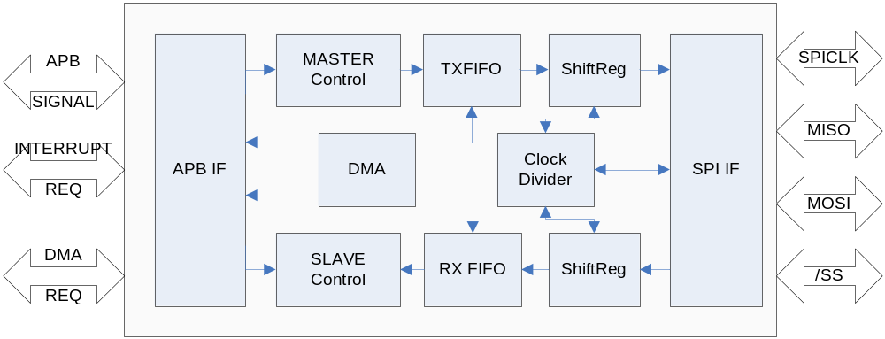

SPI Channel 는 Rx FIFO와 Tx FIFO는 각각 8 depth를 가지고 있다. Rx와 Tx 각각 DMA Unit으로 DMA Request를 보낼 수 있다. DMA는 FIFO Level에 따라 Setting이 이루어 진다.
Rx FIFO에 Data를 일정 Cycle이상 읽어가지 않을 경우 Timeout Interrupt를 발생시킬 수도 있다.
SPI Channel 1은 FIFO를 가지고 있지 않으며, DMA 역시 지원하지 않는다. Interrupt Source도 Tx Buffer Empty와 Rx Buffer Full만 지원한다.

Operation

Overview

APB BUS를 사용하고 있으며 Master Mode 및 Slave Mode를 지원한다.
SPI0는 DMA를 지원하며 지원하는 DMA Level을 선택할 수 있다. 각 DMA 및 Interrupt는 FIFO Level Setting으로 조절 가능하다.

Timing

다음은 SPI Mode Setting과 Wave Form을 나타내었다.

Figure 16-98 SPI Timing (CPOL=0, CPHA=0)
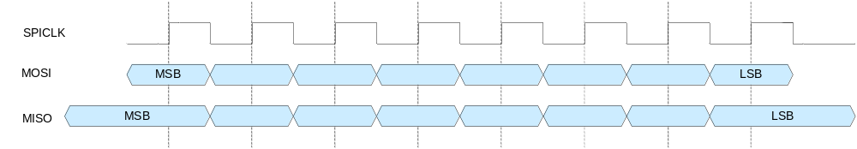

Figure 16-99 SPI Timing (CPOL=0, CPHA=1)
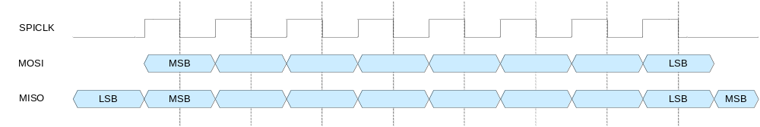

Figure 16-100 SPI Timing (CPOL=1, CPHA=0)
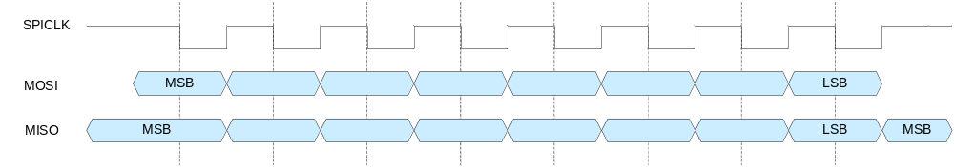

Figure 16-101 SPI Timing (CPOL=1, CPHA=1)
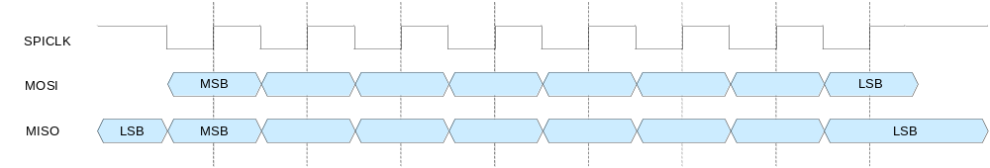

Signal Description

SPI BUS Signal

Table 16-86 SPI BUS Signal
Signal Name | Direction | Description | Init. Value
MISO | InOut | Master Input Slave Output
MOSI | InOut | Master Output Slave Input
CLK | InOut | Master Output Clock Slave Input Clock
/SS | InOut | Slave Select

Register Description

Registers

Table 16-87 Registers
Offset | Name | R/W | Description | Init. Value
0000h | SPICON | RW | SPI Control register | 0000 0000h
0004h | SPIPRE | RW | SPI Prescaler register | FFFF FFFFh
0008h | SPISTA | RW | SPI Status Register
000Ch | SPIINTDMA | RW | SPI Interrupt DMA setting Register
0010h | SPIINTSTA | RW | SPI Interrupt Status Register
0014h | SPITxDAT | RW | SPI Tx Data register | 0000 0000h
0018h | SPIRxDAT | R | SPI Rx Data Register

SPI Control Register

Figure 16-102 SPI Control Register Bits
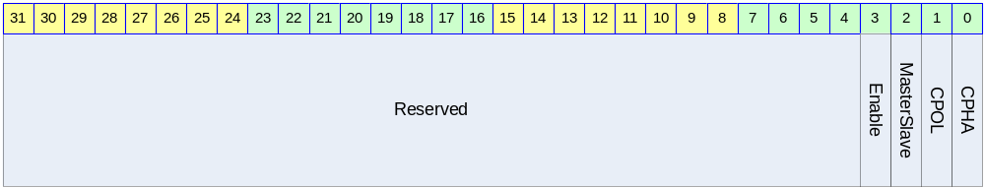

Table 16-88 SPI Control Register Description (Offset : 0000 0000h)
Bits | Name | R/W | Description | Init. Value
[3] | Enable | RW | Enable  0: SPI Disable  1: SPI Enable | 0
[2] | MasterSlave | RW | Master or Slave Select  0: Master  1: Slave | 0
[1] | CPOL | RW | Clock Polarity Setting  0:  1: | 0
[0] | CPHA | RW | Clock Phase Setting  0:  1: | 0

SPI Prescaler Register

Figure 16-103 SPI Prescaler Register Bits
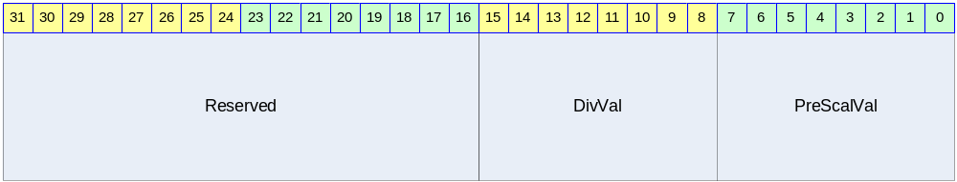

Table 16-89 SPI Precaler Register Description (Offset : 0000 0004h)
Bits | Name | R/W | Description | Init. Value
[15:8] | DivVal | RW
[7:0] | PreScalVal | RW | Prescaler Setting  PCLK/(DIV*(PreScalVal+1)) | 1111b

SPI Status Register

Figure 16-104 SPI Stauts Register Bits
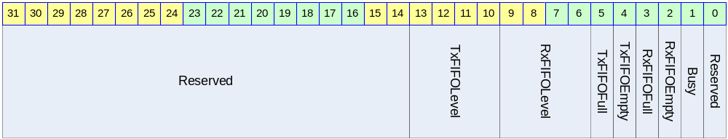

Table 16-90 SPI Status Register Description(Offset : 0000 0008h)
Bits | Name | R/W | Description | Init. Value
[13:10] | TxFIFOLevel | R | Present Tx FIFO Level  (현재 Tx FIFO내에 남아있는 데이터양을 나타낸다.)
[9:6] | RxFIFOLevel | R | Present Rx FIFO Level  (현재 Rx FIFO내에 남아있는 데이터양을 나타낸다.)
[5] | TxFIFOFull | R | 1: Tx FIFO Full  0: Tx FIFO Not Full
[4] | TxFIFOEmpty | R | 1: Tx FIFO Empty  0: Tx FIFO Not Empty
[3] | RxFIFOFull | R | 1: Rx FIFO Full  0: Rx FIFO Not Full
[2] | RxFIFOEmpty | R | 1: Rx FIFO Empty  0: Rx FIFO Not Empty
[1] | Busy | R | 1: SPI Bus Transferring  0: SPI Bus Not Transferring

SPI Interrupt & DMA control Register

Figure 16-105 SPI Interrupt & DMA Register Bits
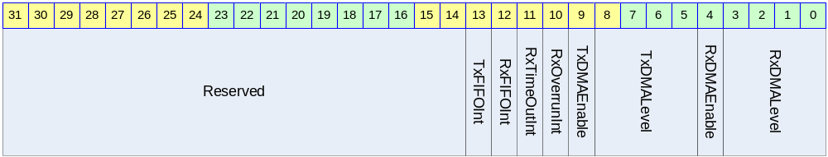

Table 16-91 SPI Interrupt & DMA Register Description(Offset : 0000 0008h)
Bits | Name | R/W | Description | Init. Value
[13] | TxFIFOIntEn | RW | TxFIFO Interrupt Enable  1: Enable 0: Disable  (이 Interrupt는 TxFIFOFillLevel이 TxDMALevel 설정 값 이하 일 경우 발생한다.) | 0
[12] | RxFIFOIntEn | RW | RxFIFO Interrupt Enable  1: Enable 0: Disable  (이Interrupt는 RxFIFOFillLevel이 RxDMALevel에 설정한 값 이상 일 경우 발생한다.) | 0
[11] | RxTimeOutIntEn | RW | RxTimeOut Interrupt Enable  1: Enable 0: Disable  (Receive FIFO에 Data가 있는 상태에서 일정 time이내에 Data를 읽어가지 않을 경우 발생한다) | 0
[10] | RxOverrunIntEn | RW | RxOverrun Interrupt Enable  1: Enable 0: Disable | 0
[9] | TxDMAEnable | RW | Tx DMA Request Enable  1: Tx DMA Enable 0: Rx DMA Disable | 0
[8:5] | TxDMALevel | RW | Tx DMA Request Level  (DMA request를 내보낼 FIFO 용량을 설정한다.  미리 전송하고자 하는 data양을 알고 있기에 FIFO의 남은 Level을 보고 request를 보내면 된다) | 1
[4] | RxDMAEnable | RW | Rx DMA Request Enable  1: Rx DMA Enable 0: Rx DMA Disable | 0
[3:0] | RxDMALevel | RW | Rx DMA Request Level  (Rx의 경우 FIFO가 일정 Level이상 data가 있을 때 DMA request를 보내므로 FIFO Remain Data처리에 유의할 필요가 있다.) | 1

SPI Interrupt Status Register

Figure 16-106 SPI Interrupt Status Register Bits
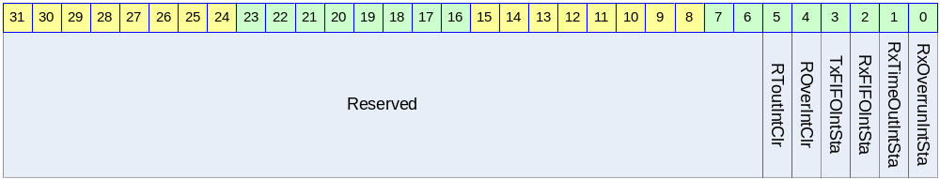

Table 16-92 SPI Interrupt Status Register Description(Offset : 0000 0008h)
Bits | Name | R/W | Description | Init. Value
[5] | RToutIntClr | C | Receive Time out Interrupt Clear  1: Receive Time Out Interrupt가 clear됨  0: 아무 영향 없음
[4] | ROverIntClr | C | Receive Overrun Interrupt Clear  1: Receive Overrun Interrupt가 clear됨  0: 아무 영향 없음
[3] | TxFIFOIntSta | R | TxFIFO Interrupt Status  1: Interrupt Generated  0: Interrupt Not Generated  (이 Interrupt는 TxFIFOCnt값이 TxDMALevel 이하 일 경우 발생한다.) | 0
[2] | RxFIFOIntSta | R | RxFIFO Interrupt Status  1:Interrupt Generated  0: Interrupt Not Generated  (이 Interrupt는 RxFIFOCnt값이 TxDMALevel 이상 일 경우에 발생한다.) | 0
[1] | RxTimeOutIntSta | R | RxTimeOut Interrupt Status  1: Interrupt Generated  0: Interrupt Not Generated | 0
[0] | RxOverrunIntSta | R | RxOverrun Interrupt Status  1: Interrupt Generated  0: Interrupt Not Generated | 0

SPI Tx Data Register

Figure 16-107 SPI Tx Data Register Bits
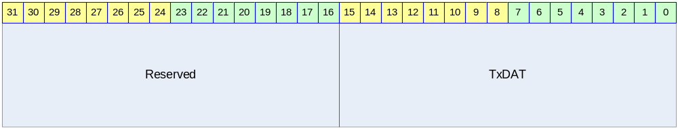

Table 16-93 SPI Tx Data Register Description(Offset : 0000 0008h)
Bits | Name | R/W | Description | Init. Value
[15:0] | TxDAT | RW | SPI Tx Data  (읽기의 경우 제일 마지막에 Write한 값이 읽힌다)

SPI RxData Register

Figure 16-108 SPI Rx Data Register Bits
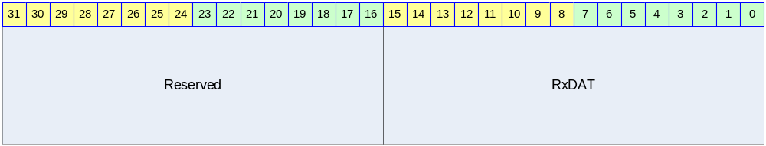

Table 16-94 SPI Rx Data Register Description(Offset : 0000 0008h)
Bits | Name | R/W | Description | Init. Value
[15:0] | RxDAT | R | SPI Rx Data

MultiICE

MultiICE pin connections

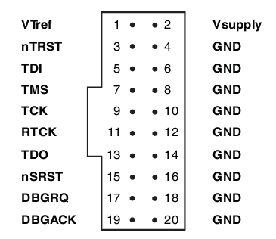

Signals

Signal Name | I/O | Description
VTref | I | Target reference voltage.  RTCK와 TDO의 logic-level의 기준 전압을 알려준다.
Vsupply | I | MultiICE의 target보드쪽에서의 공급 전원.
nTRST | O | JTAG reset
TDI | O | JTAG data output to target cpu
TMS | O | JTAG test mode signal
TCK | O | JTAG JTAG test clock
RTCK | I | Return test clock
TDO | I | JTAG data input from target cpu
nSRST | I/O | All system is reset.  이 신호는 option으로 사용비중은 높으나 필수 신호는 아니다.
DBGRQ | O | Debug request. Not used in the MultiICE.
DBGACK | I | Debug acknowledge. Not used in the MultiICE.

JTAG

JTAG signals

- TRST : Jtag reset. Negative active
- TCK : Jtag clock. Rising edge에서 TDI와 TDO가 유효하다.
- TDI : data input
- TDO : data output

Figure 1-1은 JTAG 의 wave form을 보여준다. TDI나 TDO는 TCK의 rising edge에서 유효하다.

Figure 17-109 JTAG signal standard wave
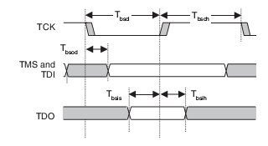

JTAG State Machine

Figure 17-110 JTAG State Machine
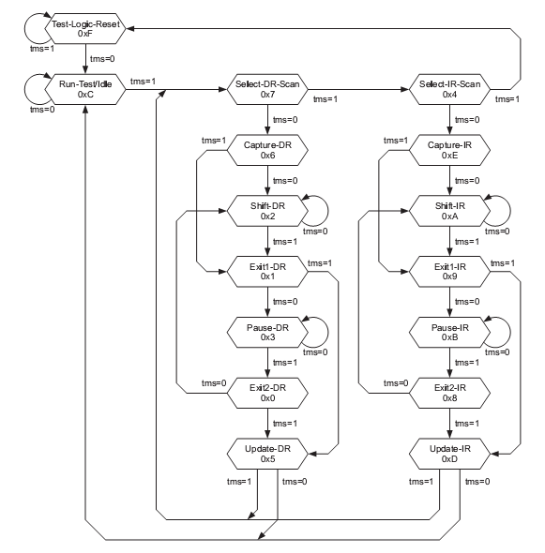

Figure 25-2는 tap controller의 state diagram이다.
State는 TMS의 값에 따라 천이하게 된다.
TDI나 TDO의 마지막 bit에서 다음 state로 천이하기 위한 TMS값을 넣어야 한다. 그렇지 않으면 TDI나 TDO에 원하지 않는 bit가 하나 추가된다.

어느 state에서나 TMS를 1로하고 TCK를 5번 주면 Test-Logic-Reset상태에 도착하게 된다.

Using JTAG

Figure 17-111 JTAG interface 회로
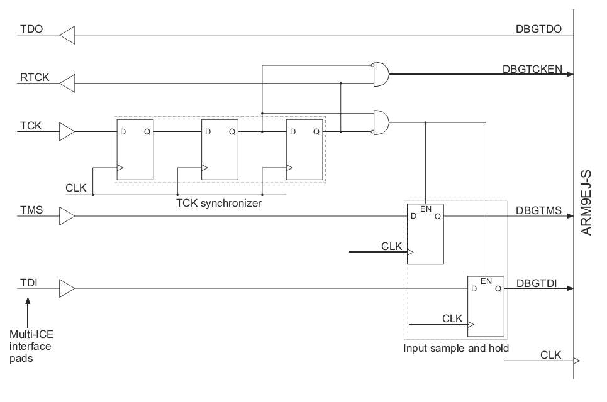

Jtag_sync.v에서 Figure 1-3과 같은 회로를 추가하여 JTAG interface를 구성해야 한다. Figure 1-1에서 보는 바와 같이 TMS와 TDI를 F.F.으로 TCK의 rising edge직후 latch한 뒤, ARM 내부에서는 TCK의 falling edge에서 사용한다.
따라서 TCK의 high구간 만큼 delay되어 사용되는 현상이 발생한다. 그러므로 TCK는 TDI의 invalid data구간에서는 low를 유지하다가 TDI에 data를 실으면 TCK를 high로 올렸다가 바로 low로 내리는 것이 좋다.
Figure 1-4은 Figure 1-3의 waveform을 보여준다.
TDI나 TMS의 sample timing과 ARM내부에서 sampling한 값을 사용하는 timing과는 4 system clock만큼 차이가 난다.

Figure 17-112 ARM JTAG Waveform
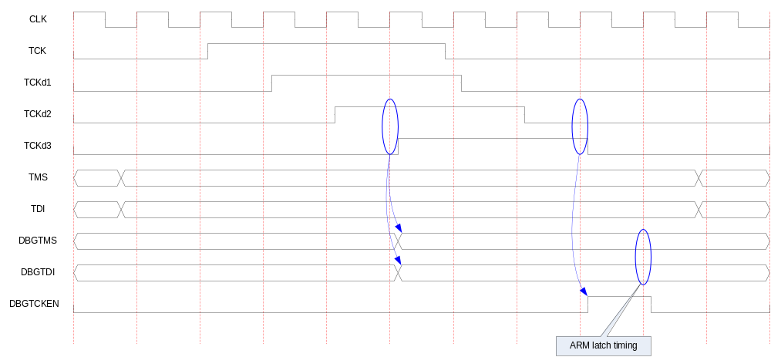

ARM JTAG

Instruction Register

JTAG의 동작을 결정한다. 동작은 Table 26-1에 기술되어 있는 것 중 하나를 선택할 수 있다.

Table 18-95 JTAG Instructions
Instruction | Binary code | Hex code
EXTEST | 0000b | 0h
SAMPLE/PRELOAD | 0011b | 3h
SCAN_N | 0010b | 2h
INTEST | 1100b | Ch
IDCODE | 1110b | Eh
BYPASS | 1111b | Fh
RESTART | 0100b | 4h

EXTEST

Chip boundary scan chain을 이용하여 chip 외부를 직접 control할 수 있는 모드.
DBGSDIN으로 JTAG에서 받은 serial data를 pad로 출력하고, DBGSDOUT으로 마지막 pad의 serial data를 받는다.

SAMPLE/PRELOAD

INTEST나 EXTEST시 JTAG의 state 천이에 의해서 sampling이나 update가 불가능하기 때문에 별도의 JTAG instruction을 둔다.

SCAN_N

Scan chain을 선택.
5bit register

Scan Chains

Table 18-96 Scan chains
Scan chain number | Function
0 | Reserved
1 | Debug
2 | EmbeddedICE-RT programming
3 | External boundary scan
4-15 | Reserved
15-31 | Unassigned

Scan chain 1

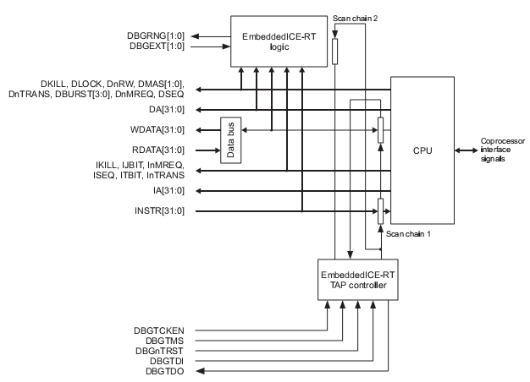

ARM9 TRM p31

Bit number | Function | R/W
[66:35] | RDATA/WDATA[0:31] | RW
[34] | Unused
[33] | WPTANDBKPT | W
[32] | SYSSPEED | W
[31:0] | Instruction[31:0] | W

Scan chain 2

Bit number | Function | R/W
[37] | Read/Write control | W
[36:32] | Address[4:0] | W
[31:0] | Data[31:0] | RW

Scan chain 6

Bit number | Function | R/W
[39] | Read/Write control | W
[38:32] | Address[6:0] | W
[31:0] | Data[31:0] | RW

Scan chain 15

Access CP15 registers

Bits | Function
[47] | 1 = Write  0 = Read
[46:44] | Opcode_1 of MRC/MCR instruction.
[43:41] | Opcode_2 of MRC/MCR instruction.
[40:37] | CRn of MRC/MCR instruction.
[36:33] | CRm of MRC/MCR instruction.
[32] | When written :  1 = initiate new access  0 = NOP  When read :  1 = access complete  0 = access incomplete
[31:0] | Data value

EmbeddedICE-RT

- Two Breakpoint or Watchpoint
- 각 watchpoint는 mask register로 조건을 선택할 수 있다.
- Instruction memory interface나 data memory interface를 감시

Overview

Figure 19-113 EmbeddedICE-RT macrocell overview
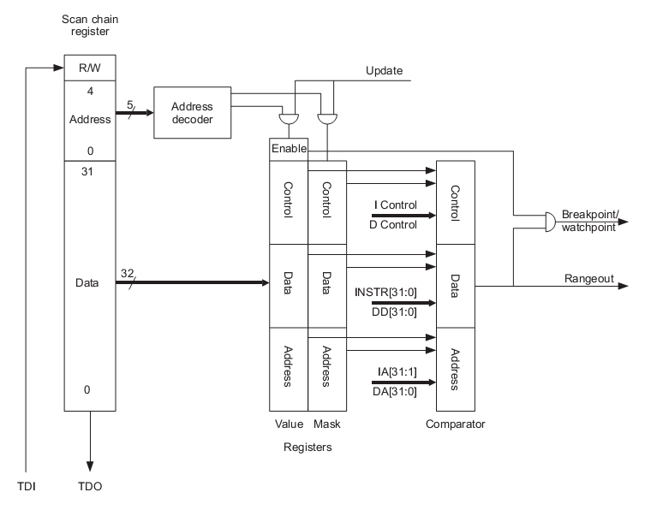

Scan chain은 총 38bit이며 다음과 같이 구성되어 있다.
- R/W : read or write 선택
- Address : target register를 선택
- Data : target register의 data

Registers

Table 19-97 EmbeddedICE-RT Registers
Address | Width | Function | Type
00000b | 6 | Debug control | Read/Write
00001b | 5 | Debug status | Read-only
00010b | 8 | Vector catch control | Read/Write
00100b | 6 | Debug communications control | Read-only
00101b | 32 | Debug communications data | Read/Write
01000b | 32 | Watchpoint 0 address value | Read/Write
01001b | 32 | Watchpoint 0 address mask | Read/Write
01010b | 32 | Watchpoint 0 data value | Read/Write
01011b | 32 | Watchpoint 0 data mask | Read/Write
01100b | 9 | Watchpoint 0 control value | Read/Write
01101b | 8 | Watchpoint 0 control mask | Read/Write
10000b | 32 | Watchpoint 1 address value | Read/Write
10001b | 32 | Watchpoint 1 address mask | Read/Write
10010b | 32 | Watchpoint 1 data value | Read/Write
10011b | 32 | Watchpoint 1 data mask | Read/Write
10100b | 9 | Watchpoint 1 control value | Read/Write
10101b | 8 | Watchpoint 1 control mask | Read/Write

Debug control register

Figure 19-114 Debug control register format
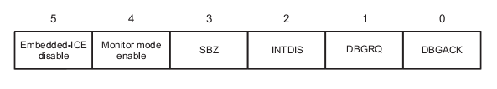

Table 19-98 Debug control register bit functions
Bit number | Name | Function
[5] | EmbeddedICE disable | if 1, enable address and data comparison logic.  If 0, disabled.
[4] | Monitor mode enable | if 1, monitor mode debug, else Halt mode debug.
[3] | Reserved | Must be zero
[2] | INTDIS | Interrupt disable control signal
[1:0] | DBGRQ, DBGACK | CPU의 DBGRQ와 DBGACK를 강제로 enable시킨다.

Interrupt는 INTDIS이나 DBGACK가 active되면 disable된다.

Debug status Register

Figure 19-115 Debus status register format
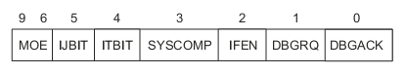

Bit number | Name | Function
[9:6] | MOE | Method of Entry information.  Debug mode로 전환된 원인의 종류를 알려준다.
[5] | IJBIT | IJBIT status of processor status
[4] | ITBIT | ITBIT status of processor status
[3] | SYSCOMP | Memory access가 완료됨을 인식.
[2] | IFEN | Interrupt enable status
[1:0] | DBGRQ, DBGACK | EDBGRQ, DBGACK status

MOE[3:0] | Meaning
0000b | No debug entry(since last restart or debug reset)
0001b | Breakpoint from EICE unit 0
0010b | Breakpoint from EICE unit 1
0011b | Soft breakpoint(BKPT instruction)
0100b | Vector catch breakpoint
0101b | External breakpoint
0110b | Watchpoint from EICE unit 0
0111b | Watchpoint from EICE unit 1
1000b | External watchpoint
1001b | Internal debug request
1010b | External debug request
1011b | Debug re-entry from system speed access

Figure 19-116 Debug control and debug status register structure
